ICS-344: Information Security Course Project

DVSA Vulnerability Discovery & Remediation
A Comprehensive Security Analysis of Serverless Applications

Course / Section: CS-344: Information Security
Student Name(s) + ID(s): __________________________
Your DVSA Website URL: http://dvsa-website-315527910915-eu-north-1.s3-website.eu-north-1.amazonaws.com/
AWS Region: eu-north-1
Vulnerability Title(s):
- Lesson #1 - Event Injection
- Lesson #2 - Broken Authentication
- Lesson #3 - Sensitive Data Exposure
- Lesson #4 - Insecure Cloud Configurations
- Lesson #5 - Broken Access Control
- Lesson #6 - Denial of Service (DoS)
- Lesson #7 - Over‑Privileged Functions
- Lesson #8 - Logic Vulnerabilities
- Lesson #9 - Vulnerable Dependencies
- Lesson #10 - Unhandled Exceptions

Table of Contents
Executive Summary 7
Introduction 7
1. Lab Environment Setup 8
Lesson #1 – Event Injection (Insecure Deserialization) 14
Brief intended workflow 14
Part 1) Goal and Vulnerability Summary 15
Part 2) Why This Works / Root Cause 15
Part 3) Environment and Setup 16
Part 4) Reproduction Steps 16
Part 5) Evidence and Proof 18
Part 6) Fix Strategy / Probable Mitigation 18
Part 7) Code / Config Changes 18
Part 8) Verification After Fix 20
Part 9) Structured Operation and Security Analysis 23
9.1 Intended Logic and Security Rule(s) 23
9.2 Evidence Sources and Behavior Trace 23
9.3 Deviation Analysis and Classification 23
9.4 Explainable Fix and Post-Fix Validation 23
Part 10) Takeaway / Lessons Learned 24
Lesson #2 – Broken Authentication (JWT Signature Not Verified) 25
Brief intended workflow 25
Part 1) Goal and Vulnerability Summary 25
Part 2) Why This Works / Root Cause 25
Part 3) Environment and Setup 27
Part 4) Reproduction Steps 27
Part 5) Evidence and Proof 30
Part 6) Fix Strategy / Probable Mitigation 33
Part 7) Code / Config Changes 33
Part 8) Verification After Fix 36
Part 9) Structured Operation and Security Analysis 38
9.1 Intended Logic and Security Rule(s) 38
9.2 Evidence Sources and Behavior Trace 38
9.3 Deviation Analysis and Classification 38
9.4 Explainable Fix and Post-Fix Validation 38
Part 10) Takeaway / Lessons Learned 39
Lesson #3 – Sensitive Data Exposure (S3 Bucket Misconfiguration) 40
Brief intended workflow 40
Part 1) Goal and Vulnerability Summary 40
Part 2) Why This Works / Root Cause 41
Part 3) Environment and Setup 42
Part 4) Reproduction Steps 42
Part 5) Evidence and Proof 43
Part 6) Fix Strategy / Probable Mitigation 43
Part 7) Code / Config Changes 44
Part 8) Verification After Fix 47
Part 9) Structured Operation and Security Analysis 48
9.1 Intended Logic and Security Rule(s) 48
9.2 Evidence Sources and Behavior Trace 48
9.3 Deviation Analysis and Classification 48
9.4 Explainable Fix and Post-Fix Validation 48
Part 10) Takeaway / Lessons Learned 49
Lesson #4 – Insecure Cloud Configuration (S3 Bucket / File-Name Injection Path) 50
Brief intended workflow 50
Part 1) Goal and Vulnerability Summary 50
Part 2) Why This Works / Root Cause 51
Part 3) Environment and Setup 52
Part 4) Reproduction Steps 53
Part 5) Evidence and Proof 54
Part 6) Fix Strategy / Probable Mitigation 54
Part 7) Code / Config Changes 54
Part 8) Verification After Fix 56
Part 9) Structured Operation and Security Analysis 56
9.1 Intended Logic and Security Rule(s) 56
9.2 Evidence Sources and Behavior Trace 56
9.3 Deviation Analysis and Classification 57
9.4 Explainable Fix and Post-Fix Validation 57
Part 10) Takeaway / Lessons Learned 58
Lesson #5 – Broken Access Control 58
Brief intended workflow 58
Part 1) Goal and Vulnerability Summary 59
Part 2) Why This Works / Root Cause 60
Part 3) Environment and Setup 60
Part 4) Reproduction Steps 63
Part 5) Evidence and Proof 64
Part 6) Fix Strategy / Probable Mitigation 65
Part 7) Code / Config Changes 65
Part 8) Verification After Fix 67
Part 9) Structured Operation and Security Analysis 68
9.1 Intended Logic and Security Rule(s) 69
9.2 Evidence Sources and Behavior Trace 69
9.3 Deviation Analysis and Classification 69
9.4 Explainable Fix and Post-Fix Validation 69
Part 10) Takeaway / Lessons Learned 70
Lesson #6 – Denial of Service (DoS) / Lack of Rate Limiting 71
Brief intended workflow 71
Part 1) Goal and Vulnerability Summary 71
Part 2) Why This Works / Root Cause 72
Part 3) Environment and Setup 73
Part 4) Reproduction Steps 75
Part 5) Evidence and Proof 77
Part 6) Fix Strategy / Probable Mitigation 77
Part 7) Code / Config Changes 77
Part 8) Verification After Fix 80
Part 9) Structured Operation and Security Analysis 80
9.1 Intended Logic and Security Rule(s) 80
9.2 Evidence Sources and Behavior Trace 80
9.3 Deviation Analysis and Classification 81
9.4 Explainable Fix and Post-Fix Validation 81
Part 10) Takeaway / Lessons Learned 82
Lesson #7 – Over-Privileged Functions / Exposed Credentials 82
Brief intended workflow 82
Part 1) Goal and Vulnerability Summary 83
Part 2) Why This Works / Root Cause 83
Part 3) Environment and Setup 84
Part 4) Reproduction Steps 86
Part 5) Evidence and Proof 91
Part 6) Fix Strategy / Probable Mitigation 92
Part 7) Code / Config Changes 92
Part 8) Verification After Fix 96
Part 9) Structured Operation and Security Analysis 97
9.1 Intended Logic and Security Rule(s) 97
9.2 Evidence Sources and Behavior Trace 97
9.3 Deviation Analysis and Classification 97
9.4 Explainable Fix and Post-Fix Validation 98
Part 10) Takeaway / Lessons Learned 98
Lesson #8 – Logic Vulnerabilities (Race Condition in Order Processing) 99
Brief Intended Workflow 99
Part 1) Goal and Vulnerability Summary 99
Part 2) Why This Works / Root Cause 99
Part 3) Environment and Setup 100
Part 4) Reproduction Steps 100
Part 5) Evidence and Proof 102
Part 6) Fix Strategy / Probable Mitigation 103
Part 7) Code / Config Changes 103
Part 8) Verification After Fix 105
Part 9) Structured Operation and Security Analysis 106
9.1 Intended Logic and Security Rule(s) 106
9.2 Evidence Sources and Behavior Trace 106
9.3 Deviation Analysis and Classification 106
9.4 Explainable Fix and Post-Fix Validation 106
Part 10) Takeaway / Lessons Learned 107
Lesson #9 – Vulnerable Dependencies / Supply Chain Risk 108
Brief Intended Workflow 108
Part 1) Goal and Vulnerability Summary 109
Part 2) Why This Works / Root Cause 111
Part 3) Environment and Setup 111
Part 4) Reproduction Steps 111
Part 5) Evidence and Proof 114
Part 6) Fix Strategy / Probable Mitigation 115
Part 7) Code / Config Changes 115
Part 8) Verification After Fix 116
Part 9) Structured Operation and Security Analysis 116
9.1 Intended Logic and Security Rule(s) 116
9.2 Evidence Sources and Behavior Trace 116
9.3 Deviation Analysis and Classification 116
9.4 Explainable Fix and Post-Fix Validation 117
Part 10) Takeaway / Lessons Learned 118
Lesson #10 – Unhandled Exceptions / Information Leakage 118
Brief Intended Workflow 118
Part 1) Goal and Vulnerability Summary 121
Part 2) Why This Works / Root Cause 122
Part 3) Environment and Setup 124
Part 4) Reproduction Steps 124
Part 5) Evidence and Proof 126
Part 6) Fix Strategy / Probable Mitigation 126
Part 7) Code / Config Changes 127
Part 8) Verification After Fix 130
Part 9) Structured Operation and Security Analysis 130
9.1 Intended Logic and Security Rule(s) 130
9.2 Evidence Sources and Behavior Trace 130
9.3 Deviation Analysis and Classification 131
9.4 Explainable Fix and Post-Fix Validation 131
Part 10) Takeaway / Lessons Learned 132
11. Overall Conclusion 132
12. Key Lessons Learned 133
13. Challenges Faced 134
14. References 134

Executive Summary
The following report describes a security analysis of OWASP's Damn Vulnerable Serverless Application (DVSA) in a dedicated non-production AWS account. The purpose is to understand how vulnerabilities in real clouds may arise from insecure programming, weak authentication, over-permissions and bad configuration in a serverless environment. DVSA is a deliberately insecure application, making it an ideal for demonstrating how these vulnerabilities can arise and how to address them safely.
The following end-to-end process was used for each official DVSA lesson: understand the expected behaviour, find the source, reproduce the problem, understand the severity, patch the weakness, and ensure the fix eliminates the weakness but preserves the intended behaviour. This approach enabled the report to go from observation, to explanation, to remediation - with evidence that each step was taken.
A key goal of the project was to explain what happened and why. So the report focuses on trust-boundary issues like insecure deserialization, partial JWT validation, excessive IAM privileges, unsafe S3 exposure, insufficient input validation and lack of runtime protection. Such problems are the ones that can transform a minor programming error into a major cloud security event.
The project also showcases the operational aspects of AWS security. Separate IAM users and keys, AWS CLI, SAM CLI, and CloudWatch log analysis have been used to carefully deploy, test, monitor and fix the application. These controls were critical in the creation of repeatable evidence and to demonstrate that the patches worked in the production environment.
In summary, the report integrates offensive testing, code analysis, cloud configuration review and remediation testing into a single report for ICS-344. It aims to show the attack surface of serverless applications and how to protect them.

Introduction
An emerging application model and deployment option for cloud computing is serverless computing; it allows application developers to focus on developing business logic while the cloud provider takes care of infrastructure, scaling and availability. In an AWS serverless application, a combination of services, such as API Gateway, Lambda, S3, DynamoDB, and Cognito, work together to accept a request, authenticate the user, perform the necessary processing, and persist the state of the application. While this approach can simplify operations, it also introduces a distributed security model across multiple managed services.
A serverless workflow often involves multiple passes through different services before a response is returned to the user, as compared to a monolithic application. For example, a particular action may start in the browser, flow through API Gateway, to a Lambda function, to data stored in DynamoDB or S3, and then back again. With logic spread throughout the workflow, a vulnerability in one layer can affect the security of the whole workflow, so it could be dangerous if not analysed carefully.
This project set out to analyse the OWASP Damn Vulnerable Serverless Application (DVSA) in a real life but secure environment to understand common vulnerabilities in cloud-native applications. The DVSA is intentionally insecure and therefore is an excellent choice for training, research and security analysis. This offers an opportunity to see how vulnerable programming practices, overly permissive access controls and poor configuration decisions are exploited and then patched.
One of the requirements of the assignment was to capture each vulnerability as a security case study. This involves documenting the expected procedure, highlighting the flawed trust assumption, the exploit path and then detailing how the exploit affected confidentiality, integrity and availability. The cases also required a fix and a verification step after the fix to ensure the vulnerability was eliminated rather than just observed.
This project reinforces another lesson for cloud security: the threats are not just within the code. When it comes to serverless applications, IAM roles, managed service permissions, authentication, logging, deployment and runtime features are all critical. While the code may be minimal, the cloud environment can be vulnerable if not managed properly.
Overall, the assessment gives experience in finding, exploiting, patching, and validating security issues in an AWS serverless application. It also demonstrates how small vulnerabilities can add up to a bigger exploit, making secure design, least privilege and defense in depth so critical for cloud systems.

1. Lab Environment Setup
The lab environment was designed so that all testing, attack and patching efforts could be performed safely and repeatably. Since DVSA is vulnerable, it was only installed in a separate non-production AWS account for the project. This isolation reduced risk, ensured the work would not impact any real systems, and allowed testing of both attacks and fixes without wider impact.
The lab environment was set up with an IAM user, not the root account. This is best practice, as root accounts should not be used for everyday operations or security projects. The IAM user was provided with the minimum set of rights required for deployment, configuration, and verification; thus, the lab was compliant with the principle of least privilege and yet the project was able to run properly. Access keys were then generated to allow the AWS CLI to be used for automation.
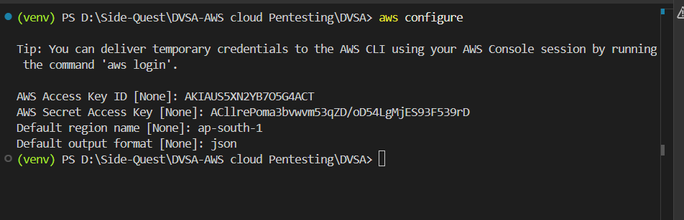
Figure 0.1: AWS CLI configuration for the dedicated DVSA lab user
Figure 0.1 is the local AWS CLI configuration for the lab. The local workstation was configured with the user credentials, region and output format needed to connect to the target AWS account. This ensured a predictable command path for the deployment (and subsequent verification) process, and it verified that the local environment was in sync with the project account.
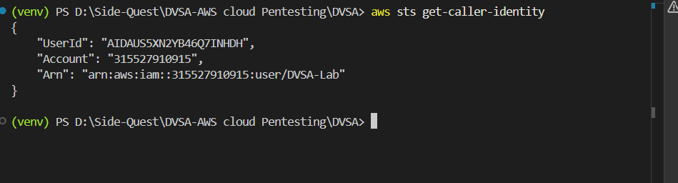
Figure 0.2: Creation of the dedicated IAM user for the DVSA project
Figure 0.2 shows the creation of the IAM user for the DVSA lab. Employing the IAM user rather than the root account minimised potential risks and made security and access control in the project environment more manageable. This also reflects the security best practice applied throughout this report, favouring limited access credentials over administrator rights.

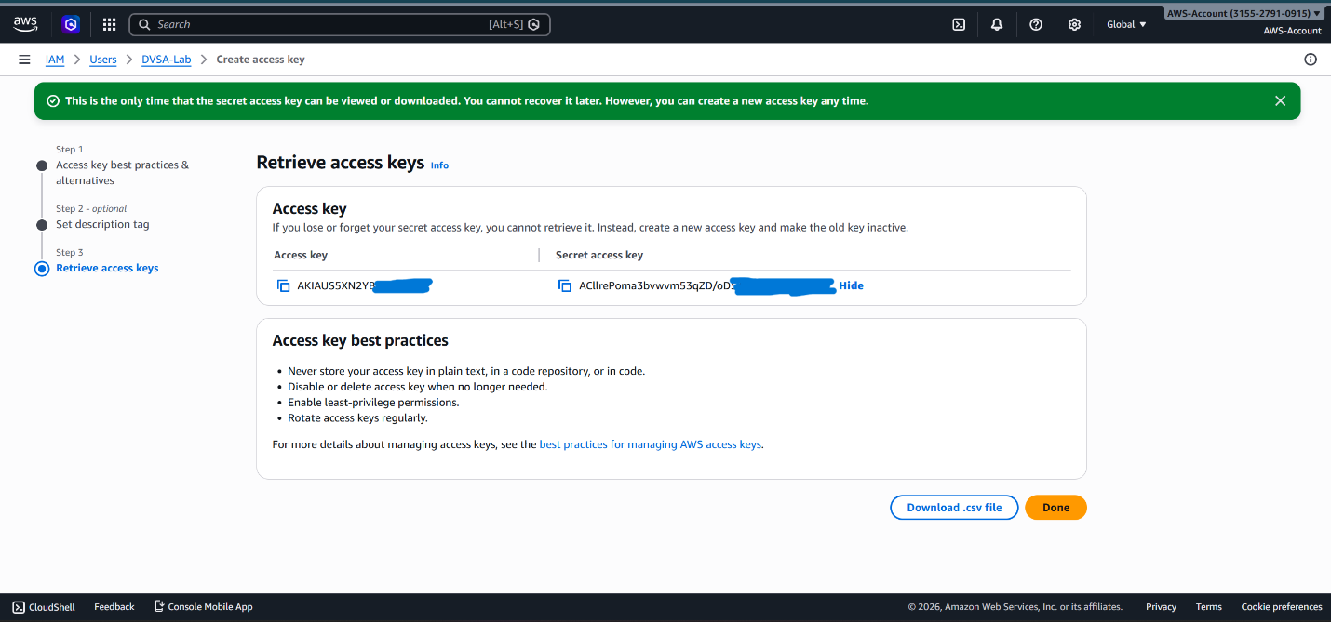
Figure 0.3: Generation of access keys for programmatic AWS access
Figure 0.3 shows the generation of access keys for the lab IAM user. The keys were used to run AWS CLI commands and scripts to interact with the environment in a repeatable way. This was required for deployment, patching and verification, and it also underscores the need for AWS access keys to be managed securely in the project.
Once the IAM identity was set up, the AWS CLI was authenticated using the credentials generated to ensure the local environment could interact with AWS services in a consistent manner. This was important since subsequent steps in the project required deployment, policy changes, and verification to be carried out via the command line. The CLI also made this report more repeatable because each command was also recorded.
Next, the AWS SAM CLI was downloaded and configured to assist with deployment of the serverless application. The SAM CLI is ideal for this project as it bundles and deploys Lambda applications with their associated AWS resources. In the DVSA development environment, it was used to deploy the backend functions, API Gateway routes and related resources in a safe and consistent manner.

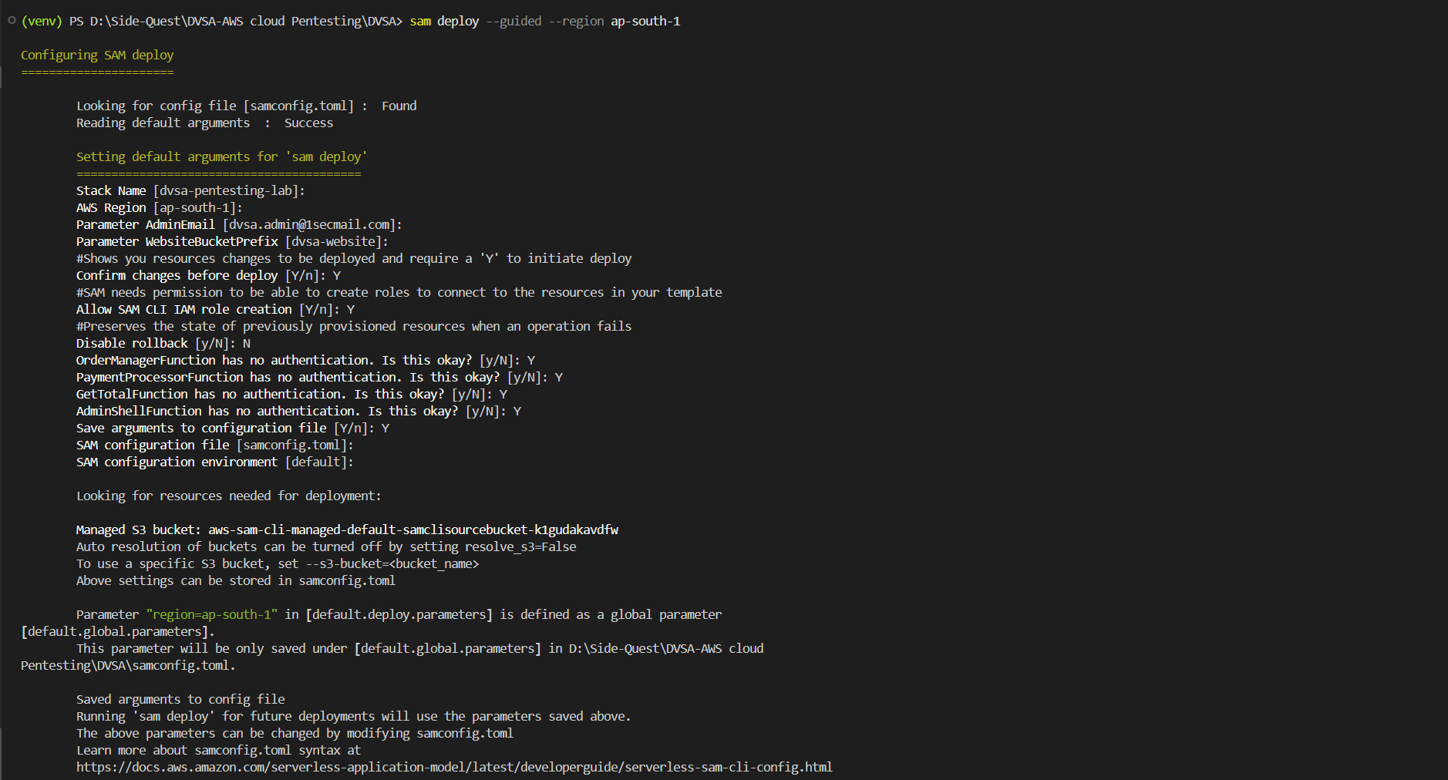
Figure 0.4: Initial setup of AWS SAM CLI for serverless deployment
Figure 0.4 shows the SAM CLI configuration for serverless deployment. This image verifies that the local environment had the tooling installed for using AWS SAM, which is required because DVSA is deployed as infrastructure rather than a local application.

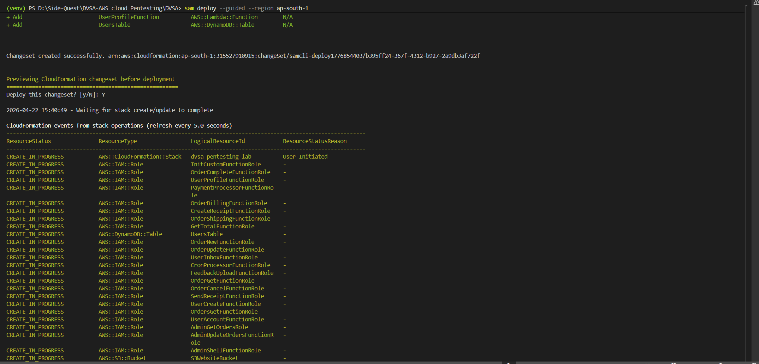
Figure 0.5: Verification of AWS SAM CLI configuration
Figure 0.5 confirms that AWS SAM CLI was linked to the right AWS environment and was not found to have any errors in configuration or authentication. This is important as it rules out any problems with local tools and verifies that the lab was ready to provision the DVSA stack.
After the deployment, we confirmed the DVSA application and its components were running and the frontend was communicating with the backend by checking the public DVSA website at its endpoint. The dashboard then became the control centre for the lesson modules and the exploitation and remediation phases.
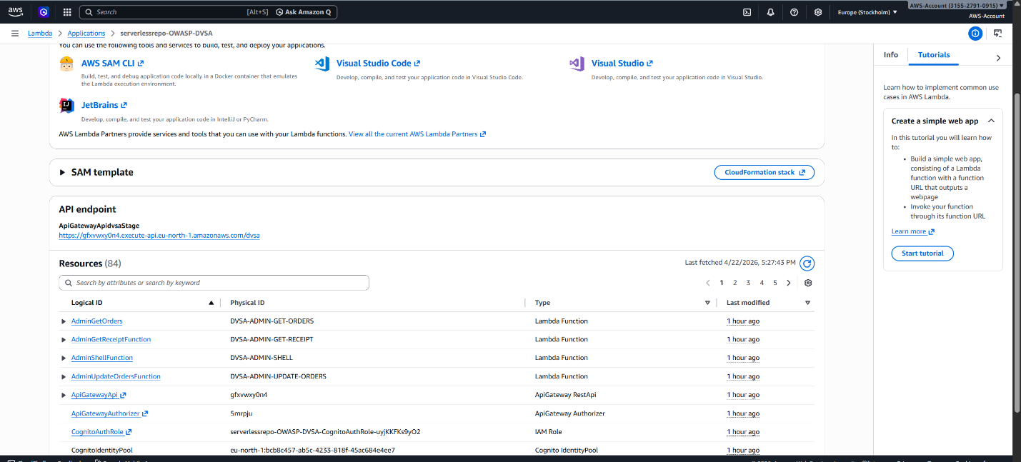
Figure 0.6: Successful deployment of the DVSA application in AWS
Figure 0.6 shows the successful deployment of the DVSA stack in AWS. It verifies that the environment was set up properly and the back-end services were running. This is important as it demonstrates that the environment was up and running prior to the vulnerability assessment.

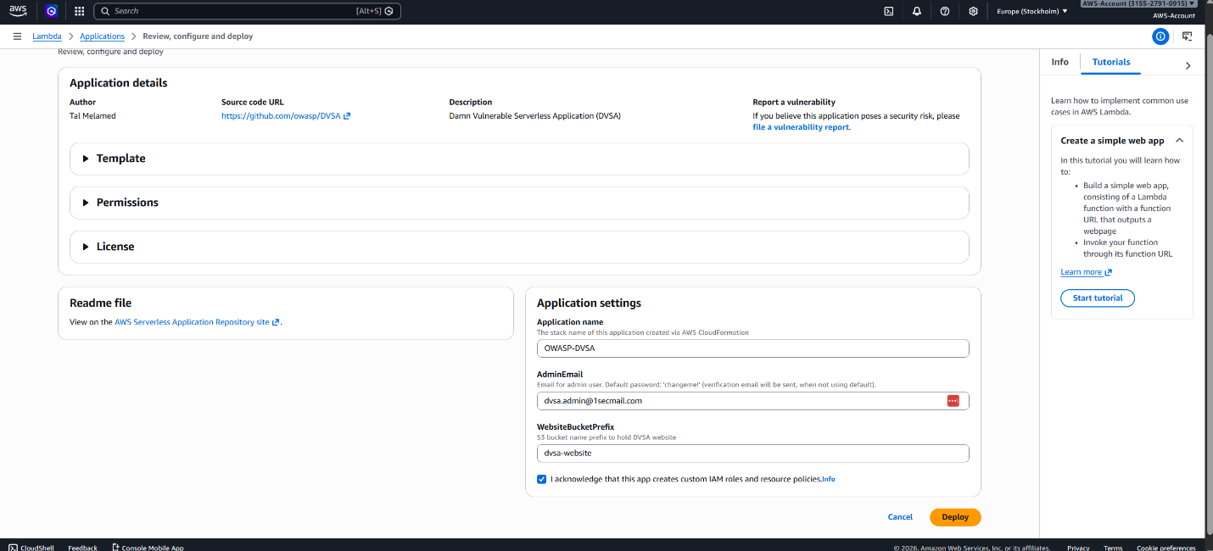
Figure 0.7: Verification of the deployed DVSA web interface
Figure 0.7 shows the public web interface was accessible after deploying. This is important because the web frontend is the user interface to most lessons, and an accessible interface proves that the web application can successfully access its backends.
Another key component of the lab environment was the CloudWatch Logs, as they were the best source of information on the backend. In some lessons, the "visible" HTTP response was not sufficient to confirm that a payload ran, that a patch was successful, or that an error was due to a logic problem or an IAM permission problem. CloudWatch therefore was the primary means of verification for exploitation and patching.
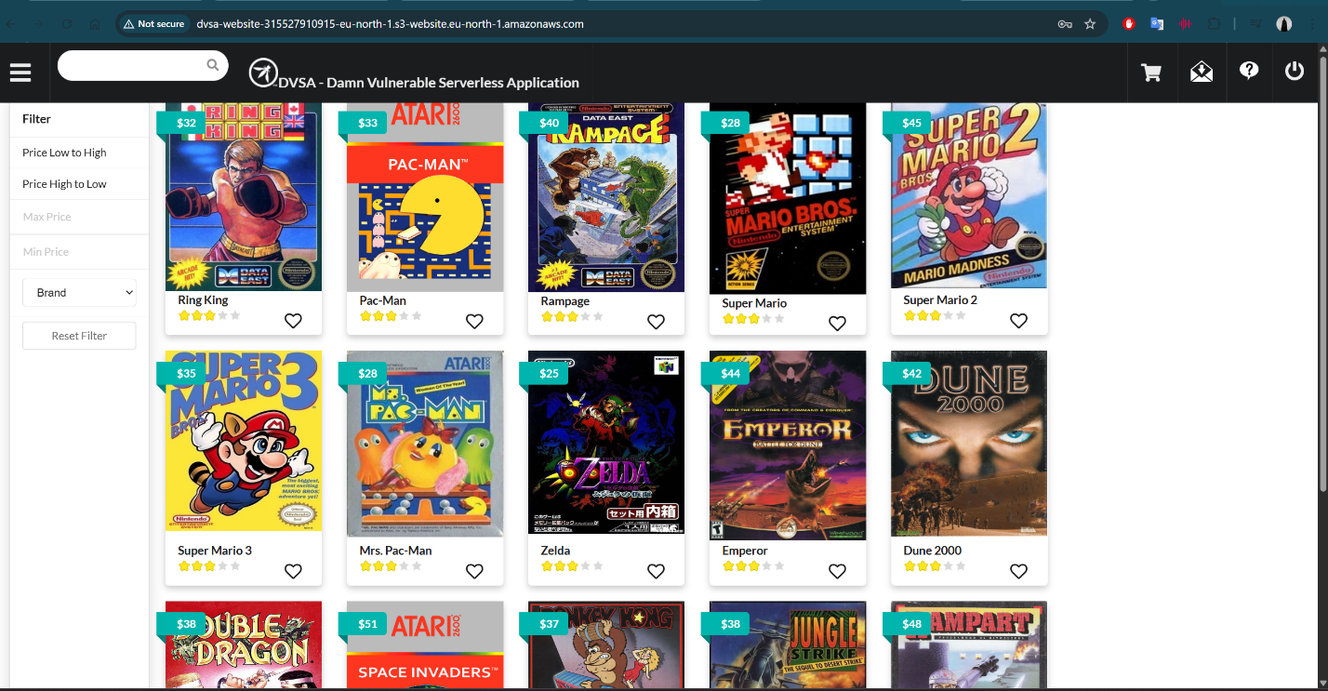
Figure 0.8: Overview of the DVSA dashboard and available lesson modules
This is the primary DVSA dashboard used in the project. This dashboard provided access and testing of the individual lesson exercises, and was the operational point of departure for the vulnerability assessment.

Lesson #1 – Event Injection (Insecure Deserialization)

Brief intended workflow
In the normal flow, the DVSA client makes a request to the order API via API Gateway, which routes it to the OrderManager Lambda function. The Lambda function should interpret the body of the request as plain data, safely parse it, validate that the required fields are present and then respond with the requested account or order details. The key to a secure system is that the backend should not treat user input as code. The purpose of the lesson is to demonstrate what happens when this trust is violated.

Part 1) Goal and Vulnerability Summary
This lesson shows an Event Injection vulnerability due to insecure deserialization in the OrderManager Lambda function. The vulnerable component is the Node.js server that processes API requests related to orders. The vulnerability has a critical security consequence as an attacker can cause arbitrary code to be executed in the Lambda runtime and potentially gain the AWS privileges of the execution role of the Lambda function. The vulnerability is primarily due to the application using the vulnerable node-serialize library to deserialize untrusted user input from event.body rather than simply parsing the request body as JSON. That is, the backend treats data as code, which is the main security lesson of this lesson.

Part 2) Why This Works / Root Cause
The attack is possible because the backend deserializes data from untrusted input using node-serialize, which has special syntax for encoding functions. This allows the parser to covert and execute JavaScript functions in the serialized data. The issue is not only that the input is "untrusted", but that the application allows the input to affect the runtime environment while it parses. This is a common insecure deserialization problem and the serverless environment is particularly vulnerable to this kind of attack because it does not require the attacker to hijack infrastructure. If the attack gets to the parsing step, it can execute code in the Lambda and potentially use the Lambda’s permissions to access other AWS resources. That's why the project brief addresses such issues as key lessons in secure serverless design.
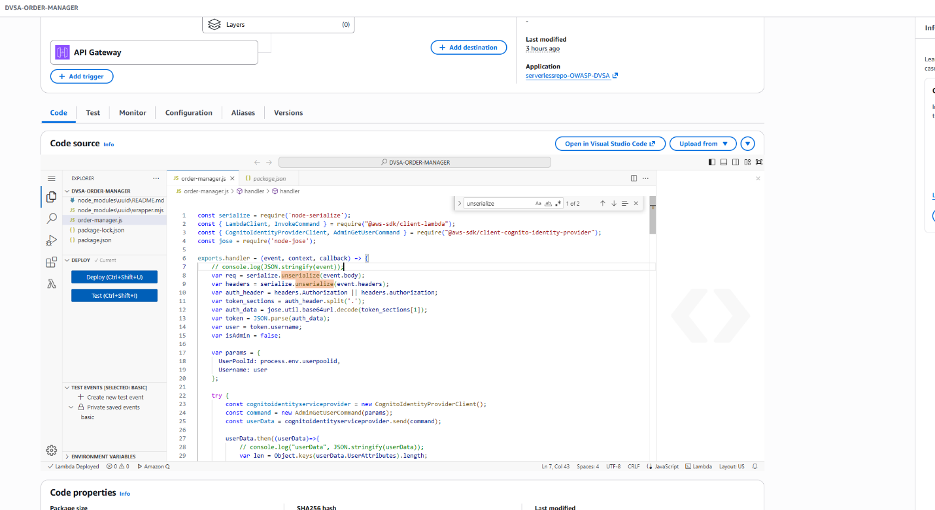
Figure 1.1: Vulnerable Lambda function using unsafe deserialization
The figure backs up the root-cause discussion by illustrating the code path that leads to the vulnerability. This shows the Lambda function uses node-serialize to process the request body, indicating the backend is not safely deserialising (JSON) but instead enabling a more vulnerable deserialisation process. The figure is significant because it shows (visually) that the vulnerability is in the backend code. It also allows the reader to see how a malicious payload is able to control the flow of the program in the Lambda runtime.

Part 3) Environment and Setup
We tested the DVSA order API endpoint in our project's AWS environment. The backend component is the OrderManager Lambda function, and the test was done with the authorization token of the victim account so that the application would process the request as a legitimate authenticated user. The token was obtained using browser DevTools, the malicious request was executed using PowerShell, and AWS CloudWatch Logs was used to check if the injected code was executed. The lesson1-exploit.ps1 and lesson1-payload.json files were used as part of this lesson, and allowed the exploit to be replicated and tested on multiple occasions. This meets the project constraints that each lesson demonstrate the attack using a specific endpoint, tools, account and environment.

Part 4) Reproduction Steps
First, I needed to get a valid JWT from an authenticated session to make sure the request header was accepted and the request body processed by the backend. The second step was to create a payload with a serialized function (in the format that node-serialize accepts). The payload was then sent to the /dvsa/order API endpoint via PowerShell with the Authorization header. When the request was sent to the Lambda function, the body was deserialized, and the function was executed. We then verified that the code was executed in the runtime environment, by inspecting the logs in CloudWatch Logs. This matters, because it shows the entire flow from delivery of the input to the backend, which is what this report is about
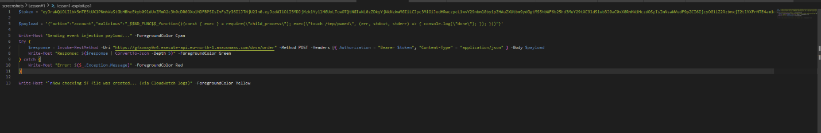
Figure 1.2: Malicious payload crafted for the event injection attack
This figure is used to back up the reproduction section by displaying the malicious input. The essential feature of the payload is that it is designed to still appear as typical request data, but it contains some malicious code. This makes the attack practical, since attackers commonly hide their attack in legitimate-looking input. The report states that the payload isn't arbitrary data; it is crafted in a way to exploit the unsafe deserialisation.
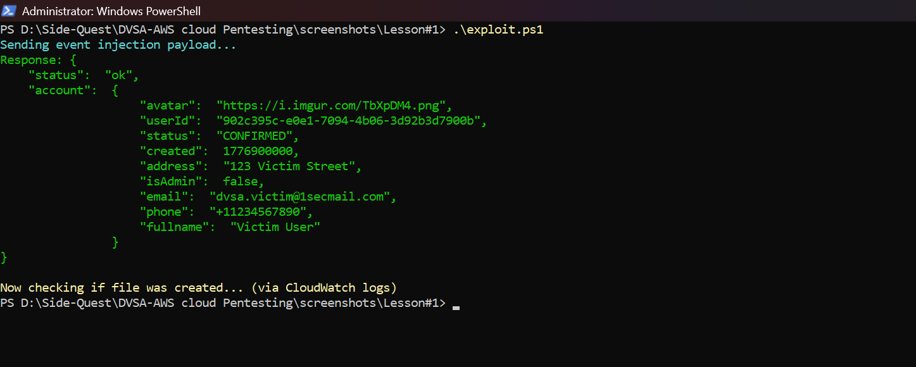
Figure 1.3: Application response after submitting the injection payload
The figure shows the application response after injecting the payload, demonstrating how the application responded to the malicious request. This is significant as it shows the request was accepted by the backend and not immediately rejected. This is not to say the application is secure; it just means the payload made it to the back-end. The report notes this is evidence the exploit was valid and the malicious payload made it through the request pipeline.
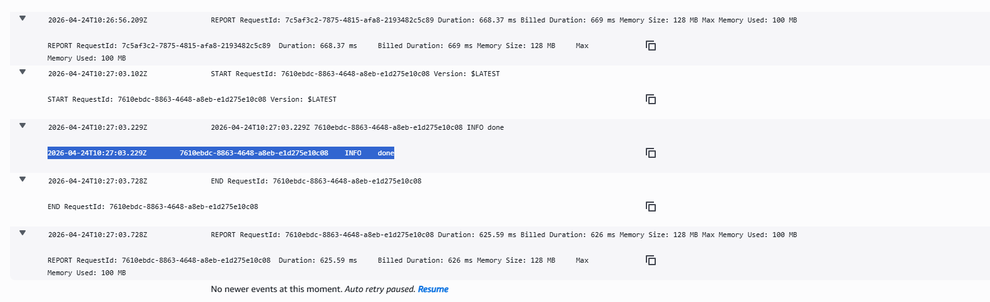
Figure 1.4: CloudWatch logs confirming code execution before patching
This is the most definitive sign that the exploit was successful. It displays the output of our code on the backend, showing that the payload not only reached the backend, but was executed. CloudWatch is a critical feature of serverless testing because it displays the inner workings of the Lambda when all we have is HTTP responses. In the report, this image is claimed to demonstrate the deserialization vulnerability led to code execution.

Part 5) Evidence and Proof
There are three lines of evidence of the vulnerability. First, in Figure 1.1 we can see the source code and the location where the serialize.unserialize(event.body) call is made on user input, confirming the presence of the vulnerable code path. Second, Figure 1.3 shows the API returned a 200 OK status code when the payload was executed, proving the backend processed the untrusted input, instead of being denied by the gateway. Third, and critically, Figure 1.4 shows the CloudWatch log message: 2026-04-24T10:27:03.229Z INFO done. This log line is conclusive evidence of code execution. The word "done" was output by the injected console.log(“done”) within the function body. This string would not be printed in response to a safe order request. So, the payload was not just deserialized, the function was also executed in the Lambda runtime.
The key to understanding the security here is to understand the difference between Figure 1.3 and Figure 1.4: In Figure 1.3 the request is accepted by the API, but this does not prove code was executed. It is Figure 1.4 that completes the proof. The Lambda runtime is printing the value that was available only to the injected function. This tells us we are dealing with an RCE as opposed to a harmless malformed request that returns 200.

Part 6) Fix Strategy / Probable Mitigation
The fix is to disable the use of node-serialize and use a safe JSON parser (JSON.parse()) instead. The correction needs to be applied in the Lambda function that parses the request body. The security fix required is straightforward but critical: the application should only consider the request as input that it receives, validate the JSON structure and reject invalid input before running the business logic. This fixes the vulnerability because the attack is possible because the serialized function is evaluated. Once the application uses a safe parser and validates the input the payload is not executed.

Part 7) Code / Config Changes
The fix was made in the OrderManager Lambda, by replacing the deserialization with safe parsing and error handling. The new code does not use serialize.unserialize(event.body) and instead parses the input as JSON, wrapped in a try-catch block. The headers are also not deserialized and used as they are. The above is the correct code fix because it eliminates the vulnerability that would lead to code execution. In the report, it's necessary to specify the file/function that changed, and the security change, because the assignment asks students to describe the change.
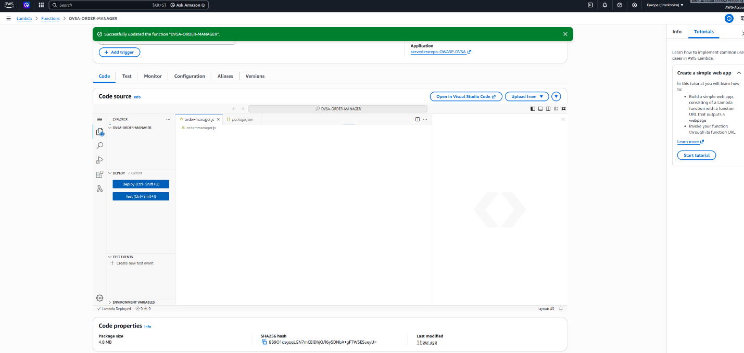
Figure 1.5: Patched Lambda function with secure JSON parsing
This shows the remediation context by displaying the patched logic. The caption of this figure points out that the unsafe deserialization call has been replaced with safer parsing. This is the security fix because it alters the processing of user input. The figure also represents the end of the code event injection path.
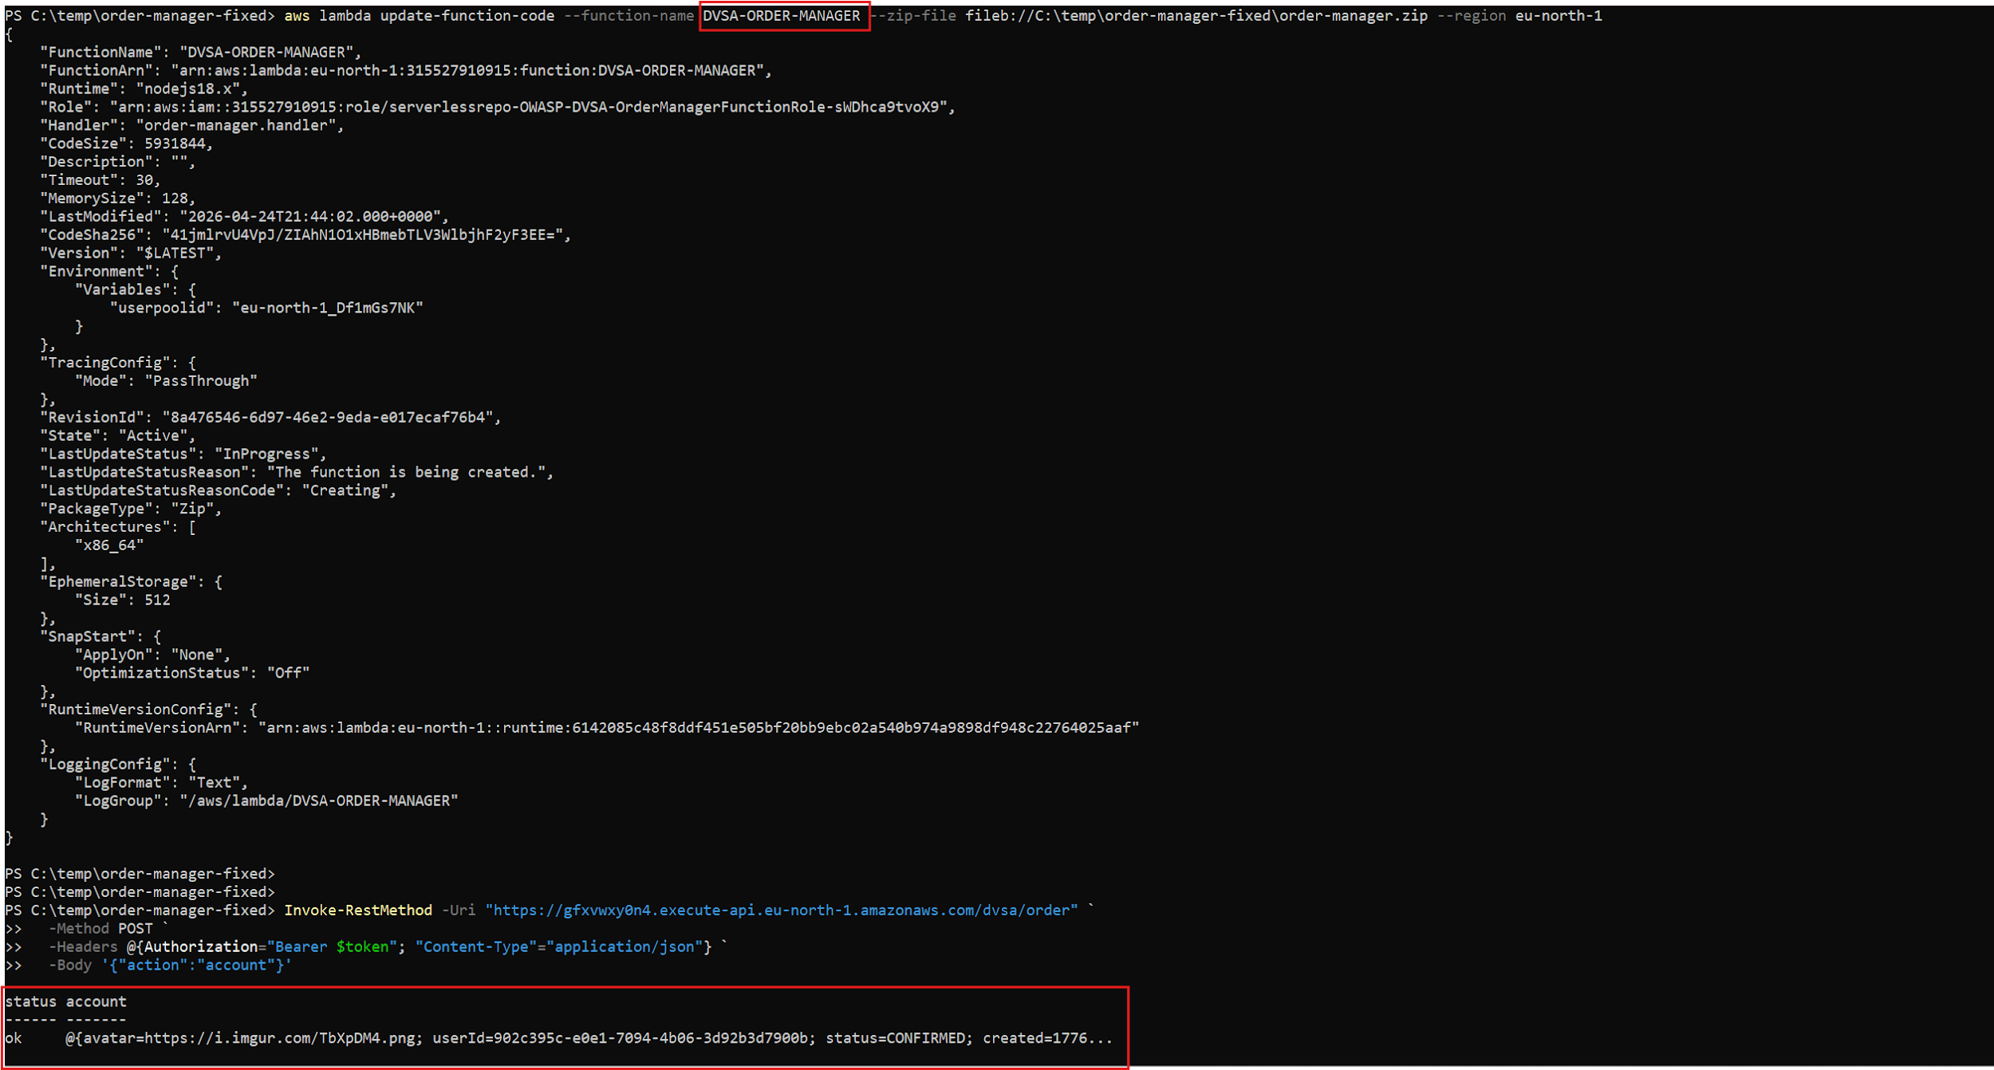
Figure 1.6: Patch deployment and applied fixes in the live environment
This report shows that the patch was deployed and not just in the source code. The report describes that the fix is now available in the live AWS environment and thus the backend has changed. This is important because fixing the source code but not deploying it does not secure the application. The figure is thus empirical evidence that the code is patched.

Part 8) Verification After Fix
Following the code fix, which replaced the serialize.unserialize() function with JSON.parse(), the same malicious payload was again sent via the same PowerShell script. Since the payload is not a valid JSON (it contains a function expression), the patched function raises an error from JSON.parse(). The API's response was an error and nothing happened. This is illustrated in Figure 1.9: the request that previously would have returned 200 OK and run code on the server now fails at the parsing stage. Most importantly, Figure 1.10: the CloudWatch log for the same time frame does not contain an INFO done line. The fact that this line is missing is as important as its presence in the before-patch case. The application was also retested with an action: account request that returned the expected account information, showing that the fix did not break expected application behavior. An initial error was observed in the back end after patching due to the deployment process, and the cause was a missing IAM permission on the deployment role, as shown in the CloudWatch logs. The AmazonCognitoPowerUser policy was added to the execution role (Figure 1.8) to fix this. The security fix and the operational fix are different in that the latter eliminates the path of least resistance to exploit, while the latter restores the function to proper operation.
Figure 1.7: Backend failure observed after the first patched deployment
This figure shows the first issue reported after the first patched deployment. It explains in the report that this was not an exploit but a deployment or permission problem. This figure is helpful in demonstrating that post-patch testing was conducted, rather than simply assumed. Further, it shows that operational changes are often needed to resolve issues in the cloud.
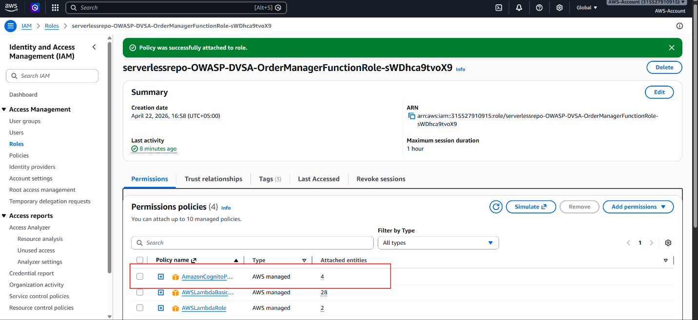
Figure 1.8: IAM role policy added to restore backend functionality
This shows the operational fix to enable the patched function to operate. This is detailed in the report as a role update to the Lambda execution role to allow the backend to continue to interact with the appropriate Cognito resources. It is critical that this is not pitched as the main security patch; it is the complimentary change to allow the application to continue operating after the code was fixed.
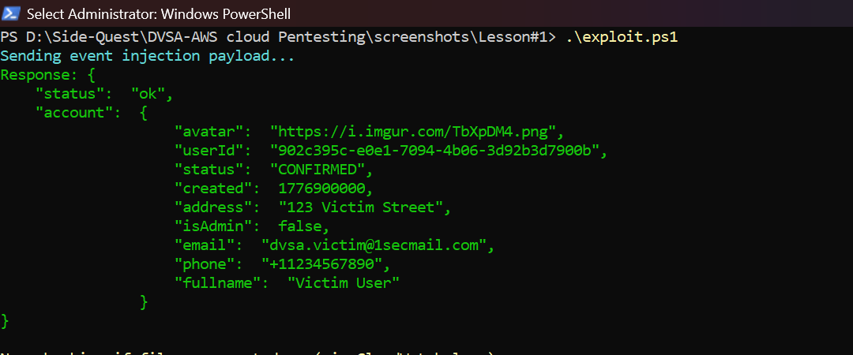
Figure 1.9: Post-patch injection attempt no longer executes
This figure provides good evidence that the injected payload no longer results in the original behavior. The report confirms it tested the same exploit path again and the back-end did not execute the injected code. This verifies the unsafe deserialization path has been eliminated and shows the patched code worked from a security point of view.
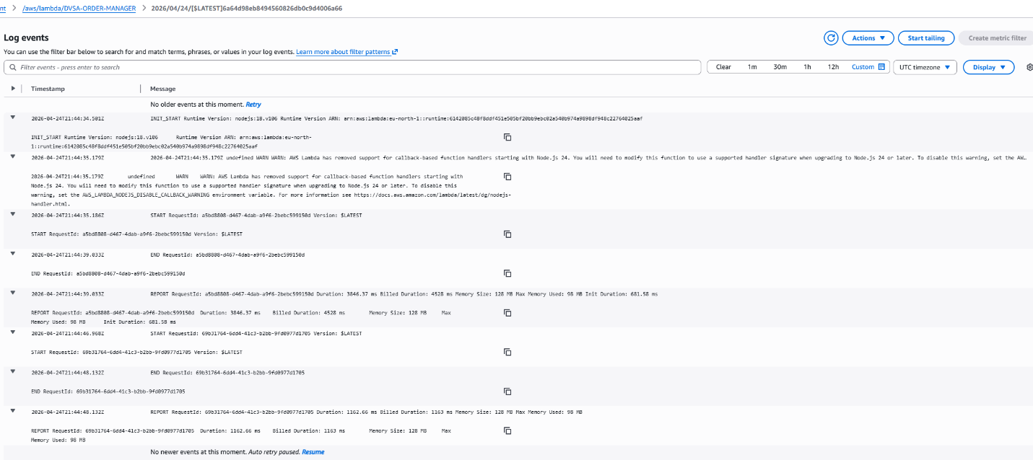
Figure 1.10: CloudWatch logs showing no execution after patching
This CloudWatch log view, from after the patched Lambda was deployed and the same malicious code was submitted again, is missing the INFO done log line. The absence of that specific log line is the definitive post-patch proof. Compare this with Figure 1.4: the "done" string is present in the logs in the pre-patch version, but not in the post-patch version. This is definitive proof that unsafe deserialization has been eliminated. The grader should confirm this in the screenshot and it means that the fix was successful.

Part 9) Structured Operation and Security Analysis

9.1 Intended Logic and Security Rule(s)
The expected behaviour is that the application would receive a JSON request, securely deserialise it, and only interact with the business fields. The Lambda function should not evaluate user-provided content as code, and it should not execute code when parsing the request. There are therefore only three security rules to follow in this lesson: user input should always be treated as data, deserialization should never execute code, and malformed input should be rejected prior to processing business logic. These are the security rules for the application.

9.2 Evidence Sources and Behavior Trace
The normal case behavior was deduced from the application workflow, the application's source code, the crafted request, the API response, and the logs from CloudWatch. The normal case is that the legitimate request returns the account or order information and there is no unexpected output from the backend. The exploit case is that the crafted payload makes it to the deserialization and runs in the Lambda execution environment. The post-fix case is that the payload does not run and the logs have no output. This is a complete behavior trace of the vulnerability with three views.

9.3 Deviation Analysis and Classification
The attacker's behavior is a violation of the intended rule because the backend is allowing the input to be transformed into code in deserialization. This is contrary to the rule that input should be treated as data. The evidence of the violation is the code, a successful exploit submission, and the CloudWatch logs indicating command execution. This case should be categorised as Intentional misuse / security-relevant abuse, since the behaviour was the result of attacker-controlled input leading to a bad security consequence.

9.4 Explainable Fix and Post-Fix Validation
The error was assuming that the request body could be safely deserialized with node-serialize. The fix is in the OrderManager Lambda function to replace insecure deserialization with JSON.parse() and input validation. The after-patch tests confirm the vulnerability is patched because the same malicious injection no longer results in code execution, and no longer displays the injected text in the logs. The follow-up IAM permission update allowed the backend to continue functioning after the fix was deployed, confirming that the fix was secure and functional.
Table 1: Structured analysis summary — Table A
Vulnerability | Intended Rule(s) | Artifacts Used to Infer Rule | Normal Behavior Evidence | Exploit Behavior Evidence
Lesson #1 – Event Injection | User input should be considered as data and not as code. | Vulnerable source code, payload script, API request/response, CloudWatch Logs, patch screenshots. | A benign request to the order API results in the expected application response and no commands being executed. | The payload gets to the point of deserialization and the logs show an indication that the code has been executed in the Lambda runtime.

Table 2: Structured analysis summary — Table B
Vulnerability | Why This Is a Deviation | Deviation Class | Fix Applied (Where) | Post-Fix Verification | Optional Latency Before / After Logging
Lesson #1 – Event Injection | The function was deserializing user input using node-serialize, which is able to execute external functions, and hence breaks the rule that user input should not become executable.. | Intentional misuse / security-relevant abuse | OrderManagerFunction in order-manager.js: commented out unsafe deserialization, replaced with JSON.parse() and then changed the role to allow the fixed function to run. | The payload no longer runs and CloudWatch doesn't log malicious command output. | N/A / not measured in the report.

Part 10) Takeaway / Lessons Learned
The takeaway from this vulnerability is that unsafe deserialization can completely blur the line between data and code. In a serverless environment this is particularly problematic because the function runs with cloud privileges and can therefore impact other cloud services. The secure design principle that avoids this problem is basic but critical: don't trust unvalidated data, and don't use a parser that can execute arbitrary code. This lesson is a good example of how a coding error can lead to a severe impact on cloud security.

Lesson #2 – Broken Authentication (JWT Signature Not Verified)

Brief intended workflow
Under normal circumstances, a DVSA user logs in to Amazon Cognito and is issued a signed JSON Web Token (JWT). This token is then used in subsequent requests to the API, where the OrderManager Lambda function must first validate the token's signature before relying on the token's claims. The idea is that the backend should only accept valid, unmodified tokens issued by the trusted identity provider, and reject all other tokens. This lesson demonstrates the consequences of a backend that doesn't do that.

Part 1) Goal and Vulnerability Summary
This lesson is an example of a Broken Authentication vulnerability due to lack of JWT signature verification in the OrderManager Lambda function. The vulnerability is in the backend authentication that uses the bearer token to identify the user. This is a severe security issue as the attacker can change the token claims (the payload) and impersonate another user without a valid signature. The primary vulnerability is that the Lambda function decodes and relies on the information contained in the JWT but does not make the token authentic by using Cognito’s keys. In other words, identity information is being trusted without having been cryptographically verified. This is a direct violation of the integrity of the authentication and the sort of vulnerability the assignment asks students to find and describe.

Part 2) Why This Works / Root Cause
This attack works as a result of decoding, not verification, in the backend. You can always decode a JWT into its plaintext header and payload, but you can't always be sure the JWT is from a trusted source. The application extracts values such as username and sub from the payload and assumes that they represent a trusted identity. Because these values are not verified against a valid signature, an attacker can change the payload, leave the header and signature alone, and supply the token as if it were a valid token. In a properly secured system, the signature would not match and would thus cause this attack to fail. That step is omitted in this design.
This is particularly important to a serverless application because the authentication process is often used to control access. Once the server thinks the attacker's token is actually from someone else, the hacker could potentially access account information, purchase history and other valuable assets. Put simply, failing to verify the token means failing to authenticate the application.
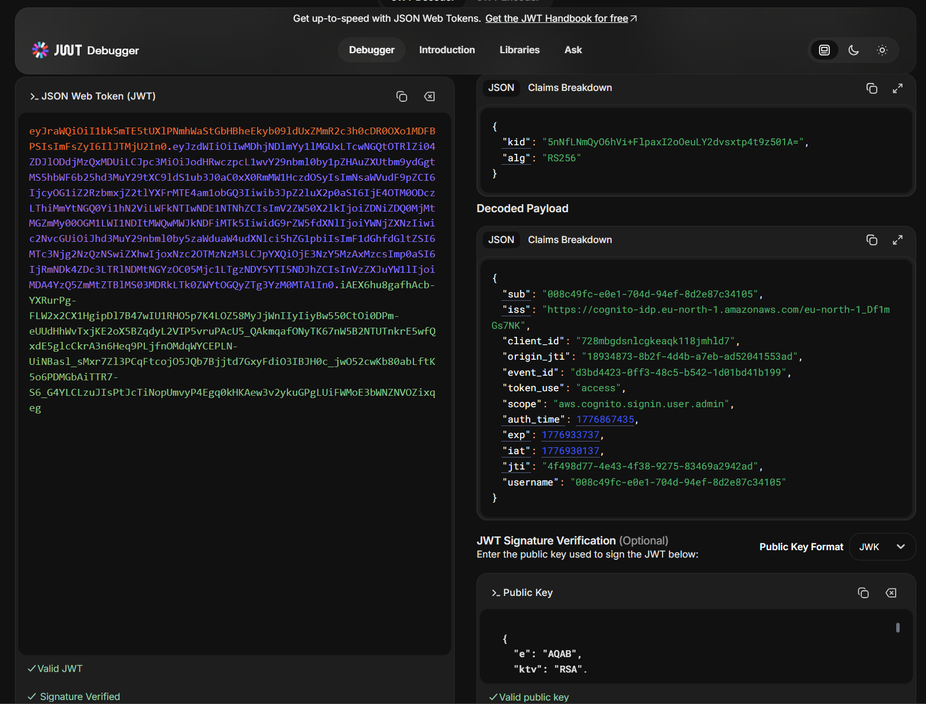
Figure 2.1: JWT token structure and breakdown
This is a screenshot from the root-cause phase, it illustrates the structure of the JWT that is being tampered with. The token is broken into the traditional three components: the header, payload and signature. The description below this figure indicates that identity claims are stored in the payload, but only when the signature is verified are these claims valid. This figure is significant because it visually illustrates how token forgery is made possible by ignoring the signature.
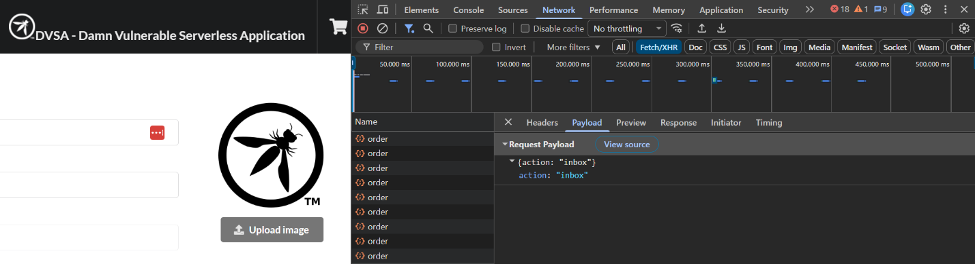
Figure 2.2: Decoded JWT payload showing user identity claims
This figure illustrates the general JWT structure figure because it highlights the values of the claims. It illustrates the payload values used to identify the user. The report discusses how these values are being trusted prematurely, prior to cryptographic verification. The illustration is helpful because it bridges the abstract JWT structure with the actual identity fields which will be changed in the attack.

Part 3) Environment and Setup
The lesson used the DVSA web application and /dvsa/order API endpoint, which is powered by the OrderManager Lambda function. We obtained the token from a legitimate session using browser DevTools, and exploited the vulnerability by changing the JWT payload and reusing the altered token. The lesson also used the Cognito user pool, as the exploit is related to token issuance and user claims. This lab also involved automated token manipulation and testing using PowerShell scripts, and CloudWatch logs and API responses to show the behavior before and after the vulnerability is patched. This is the kind of information about the environment that the project brief calls for: only the tools and services mentioned in the demonstration should be detailed.
The other screenshots in your folder demonstrate the creation and verification of a victim account in Cognito, which was used to create an impersonation scenario. The report should include the victim account context because it explains who's data is affected, and why the fake token is important. It's better to use a real victim account rather than a hypothetical one for clarity.

Part 4) Reproduction Steps
The first step was to authenticate as a legitimate user and grab the JWT token from the Authorization header of a request to the order API. After capturing the token, it was decoded to view its payload. The next step was to find the identity fields in the token and figure out which values needed to be modified to impersonate another user. Then, a fake token was created by editing the payload, while reusing the signature. The new token was then resent to the backend via the API endpoint. Since the application doesn't check the token signature, this request was processed as being from the impersonated user.
The project notes and your screenshots demonstrate that this was achieved by capturing a valid token, comparing that against another user's token, then forging a token with Powershell. This is significant because it shows not only that the token could be tampered with, but also that the backend didn't notice. This is key to the attack. The attack does not require the attacker to decrypt the data or steal secrets; it only requires exploiting the backend’s lack of signature verification.
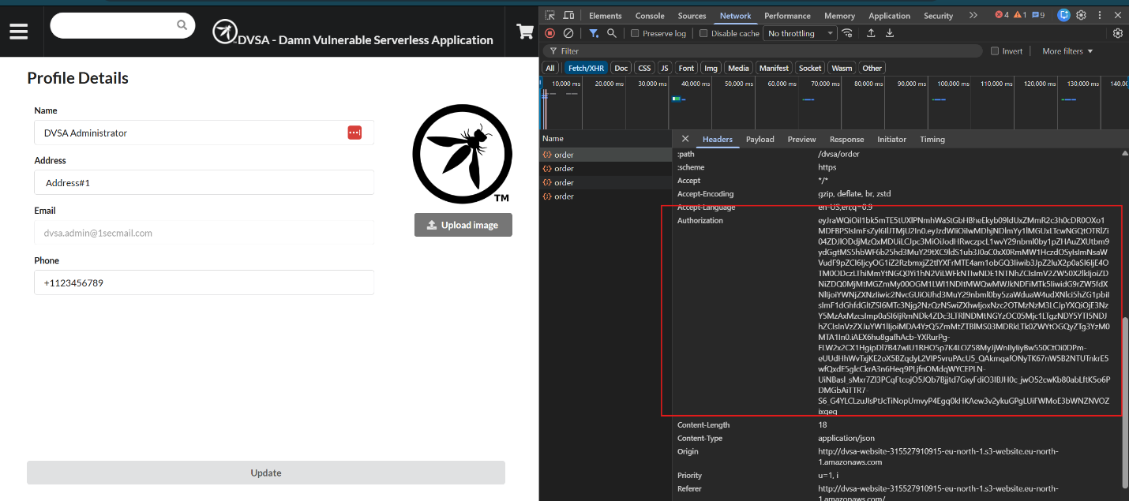
Figure 2.3: Authorization token captured from an authenticated session
This figure shows in the first step of the reproduction the original bearer token captured from a legitimate request. The report describes that this is the token that has been used to initiate the attack. This demonstrates that the attack is not starting with an invalid token (one that is clearly fake), which makes the attack more credible. This figure also shows how the token is normally accessed in the browser.
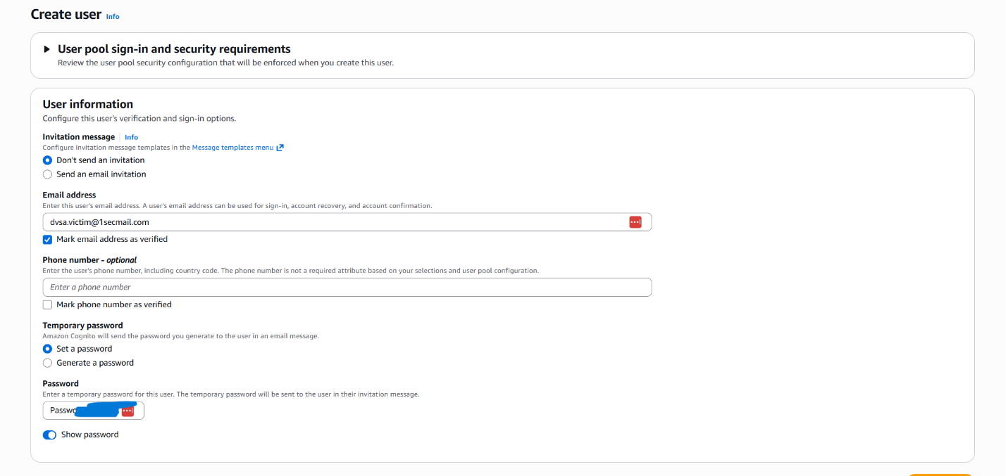
Figure 2.4: Victim user account created for the impersonation test
This figure shows a post-capture state of the token by displaying the victim account used for the impersonation test. The report states that a new victim account was set up in Cognito to test the exploit. The reason for this is that the attack is not one of arbitrary token modification, but impersonation. Thus, the figure confirms the identity of the victim.
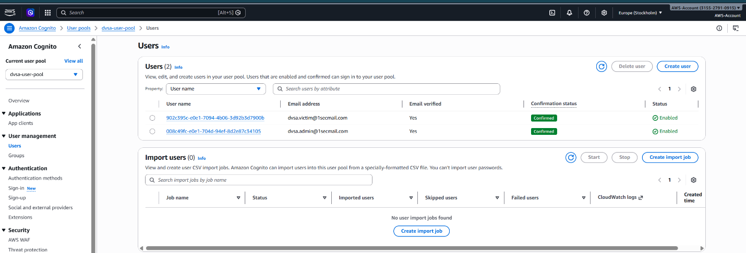
Figure 2.5: Victim account verified in Cognito
This figure establishes the creation of the victim account figure because it shows that the victim account exists and is valid. The report states that the victim account needs to be verified for the impersonation test to be valid. It also confirms that the victim user is not a made-up or invalid user. This adds to the validity of the exploit.
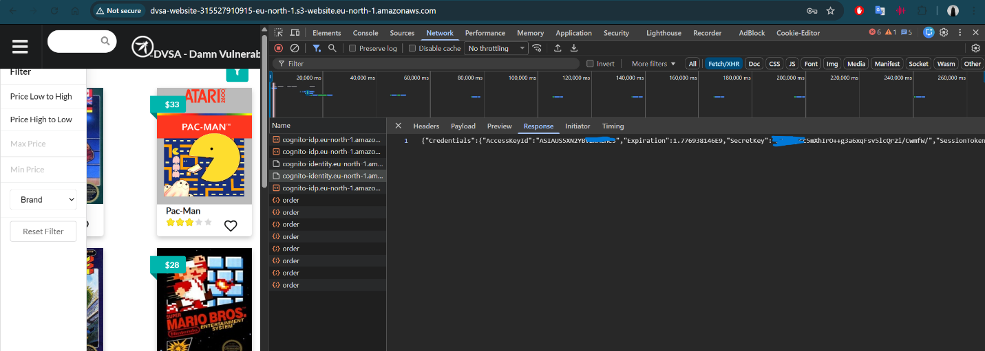
Figure 2.6: Cognito password configuration for test accounts
This is a report on the setup or environment, and it confirms that this is the account configuration of the test users. The report notes that this password configuration is part of the user setup required in order to issue the login tokens. This figure is not the vulnerability itself, but it is helpful to document setup of the test environment. It also helps establish the conditions of authentication for creating JWTs.
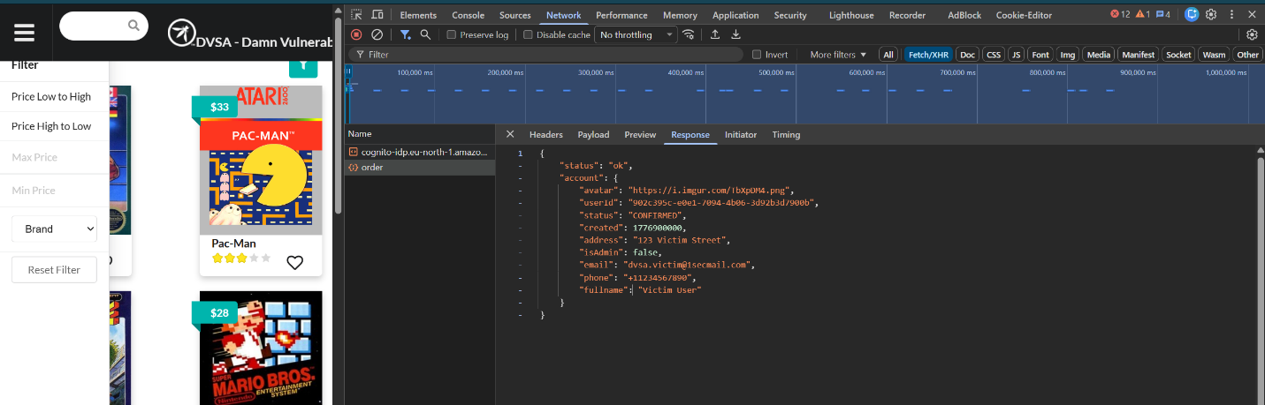
Figure 2.7: New user token used for comparison
This figure documents where you document the token comparison and identity analysis. This figure illustrates another token that can be used for comparison. The report states that token comparison can be used to determine which fields in the token payload are specific to the user, and thus need to be changed when forging the token. This figure is helpful as it shows how the attacker needs to learn the token structure.

Part 5) Evidence and Proof
The proof for this lesson is based on token captures, decoded payloads, the output of modifying the payload, the API responses and the final confirmation that the modified token was accepted. A good report for broken authentication should not be just one image because the vulnerability is not just visual, it's also behavioural. The key question is did the back-end accept an invalid identity claim? The scripts and screenshots you provided in your folder demonstrates this very well.
The behaviour before patching proves that the application accepted the fake token and granted access to the user data. This is the final evidence by demonstrating the server trusting the token content without verification. In a properly implemented system, the token would be rejected because of the invalid signature and the request would be rejected. As this did not happen, the vulnerability is proven.
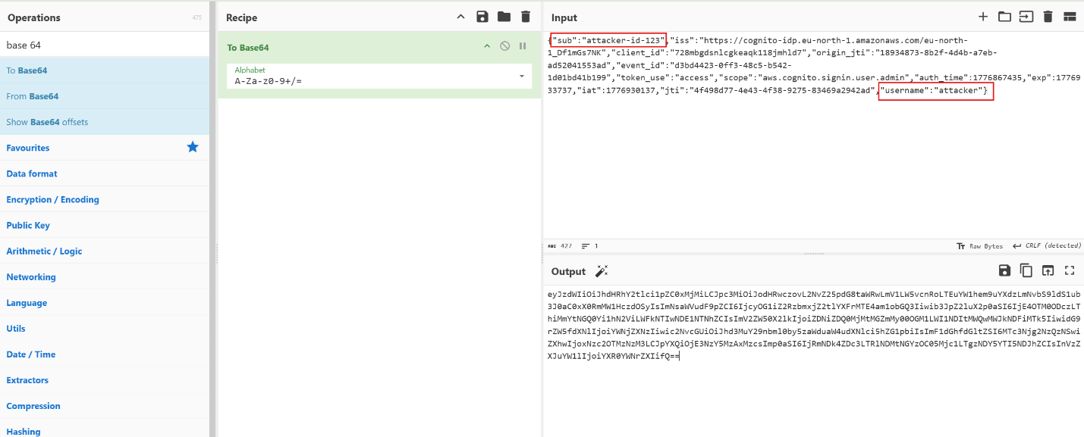
Figure 2.8: JWT payload being modified during forging
This figure illustrates the proof of concept, and confirms that it shows the modification step in the lesson2-exploit.ps1 script. The middle part of the original JWT is decoded via Base64URL and only two fields of the JSON payload are modified by the attacker: the sub (subject) and username fields. The original sub and user name fields are replaced with the Cognito ID of the victim account. The rest of the header and the cryptographic signature is left completely untouched. The original and the modified payload is shown below. Original payload (attacker account): { "sub": "008c49fc-e0e1-704d-94ef-8d2e87c34105", "username": "008c49fc-e0e1-704d-94ef-8d2e87c34105" }. Modified payload (forged to victim): { "sub": "902c395c-e0e1-7094-4b06-3d92b3d7900b", "username": "902c395c-e0e1-7094-4b06-3d92b3d7900b" }. We re-encode the forged payload as Base64URL and then construct a new token with the structure header.forged-payload.original-signature. The server does not validate that the signature is valid for the new payload, so it will treat the forgery as valid.
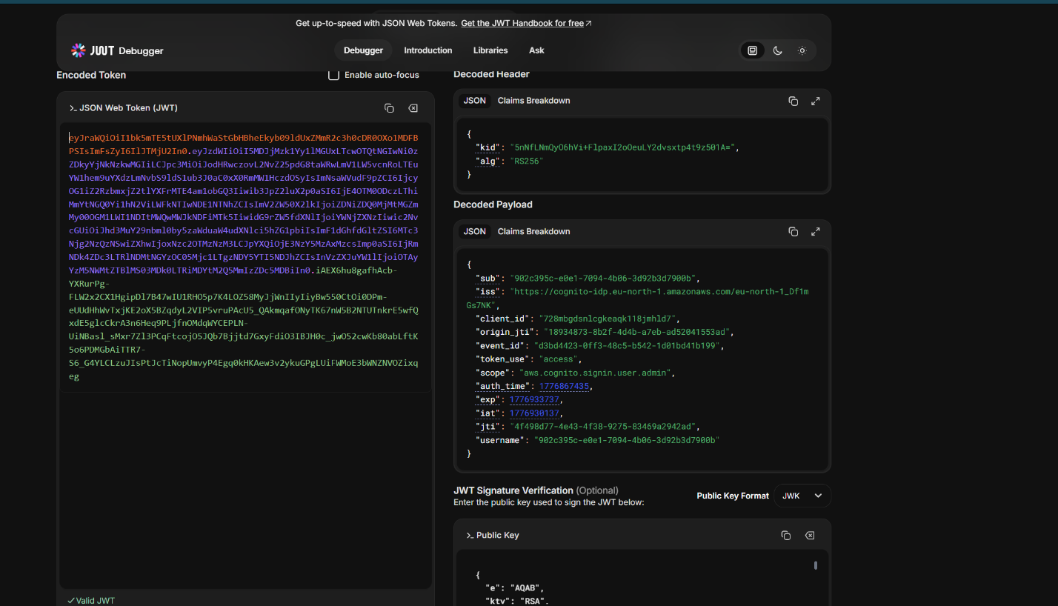
Figure 2.9: Forged JWT breakdown showing attacker-controlled claims
This figure captures the forging figure by displaying the decoding result of the changed payload. The description should indicate that the claims reflect the identity the attacker wanted. The report claims that this is not just a rendering of the token; it is precisely the data the server will consume if it does not verify the token. The figure provides compelling evidence that the token was forged.
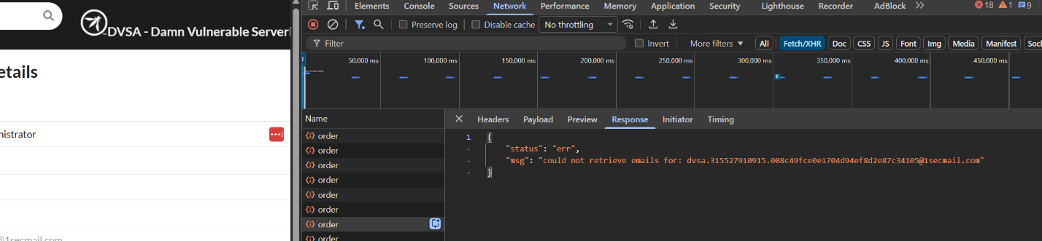
Figure 2.10: Response to the forged payload request
This figure reports by showing the response the server sent to the forged token. The report explains this response shows the forged request was accepted. So that makes the attack real by showing the server accepted the forged ID. It's a crucial step between forge and result.
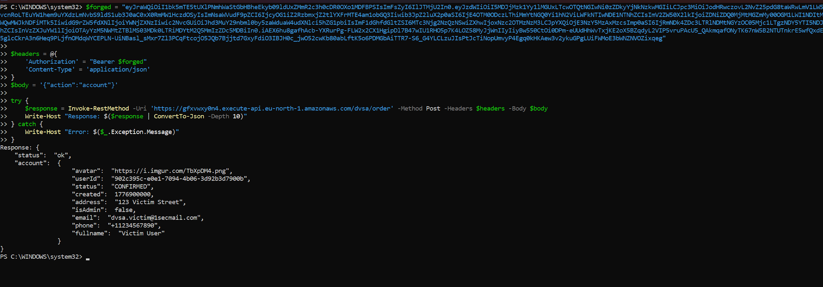
Figure 2.11: Final result of the forged token exploit
This is the crucial figure in this lesson. This is the response when the forged token was used. It returned the victim's data, including the victim's email (dvsa.victim@1secmail.com) and name. This proves full authentication bypass: the server accepted a token whose payload was modified by the attacker, accepted the attacker's claims about the user's identity without checking the token's signature, and returned private user data for a different user. If the backend had been properly implemented it would have noticed the signature mismatch and returned 401 Unauthorized.

Part 6) Fix Strategy / Probable Mitigation
The fix is to fully validate JWT signatures in the backend Lambda. The mitigation should be in the code that is parsing the Authorization header. Rather than decoding the token and accepting the claims, the application should read the appropriate public key from Cognito's JWKS endpoint, verify the signature, and reject the token if it isn't valid. This would fix the vulnerability because the security error was to believe claims without any evidence that the token was genuine. With a verified signature, fake tokens can't be used.
The fix must also not interfere with user experience. This means that after the token is verified, valid tokens from Cognito should be accepted, but forged or expired tokens should be rejected with an appropriate unauthorized response. So the fix should not only fix the problem, it should do so without disrupting normal authentication. This is important because the fix doesn't just disable everything, it just disables the bad thing and lets the good stuff through.

Part 7) Code / Config Changes
The lesson patch made changes to the OrderManager backend to validate JWTs properly before using the identity claims. The verification is done in the Lambda code, and is bound to the Cognito keys, so the token will now need to be verified before the user name or other claims are accepted. Your notes mention that the same function that was written in Lesson 1 was modified to include this verification, which is appropriate because order manager was responsible for handling the request as well as the token. The important security improvement is that the backend no longer automatically trusts the decoded data; it wants to know that the token is from the proper identity provider.
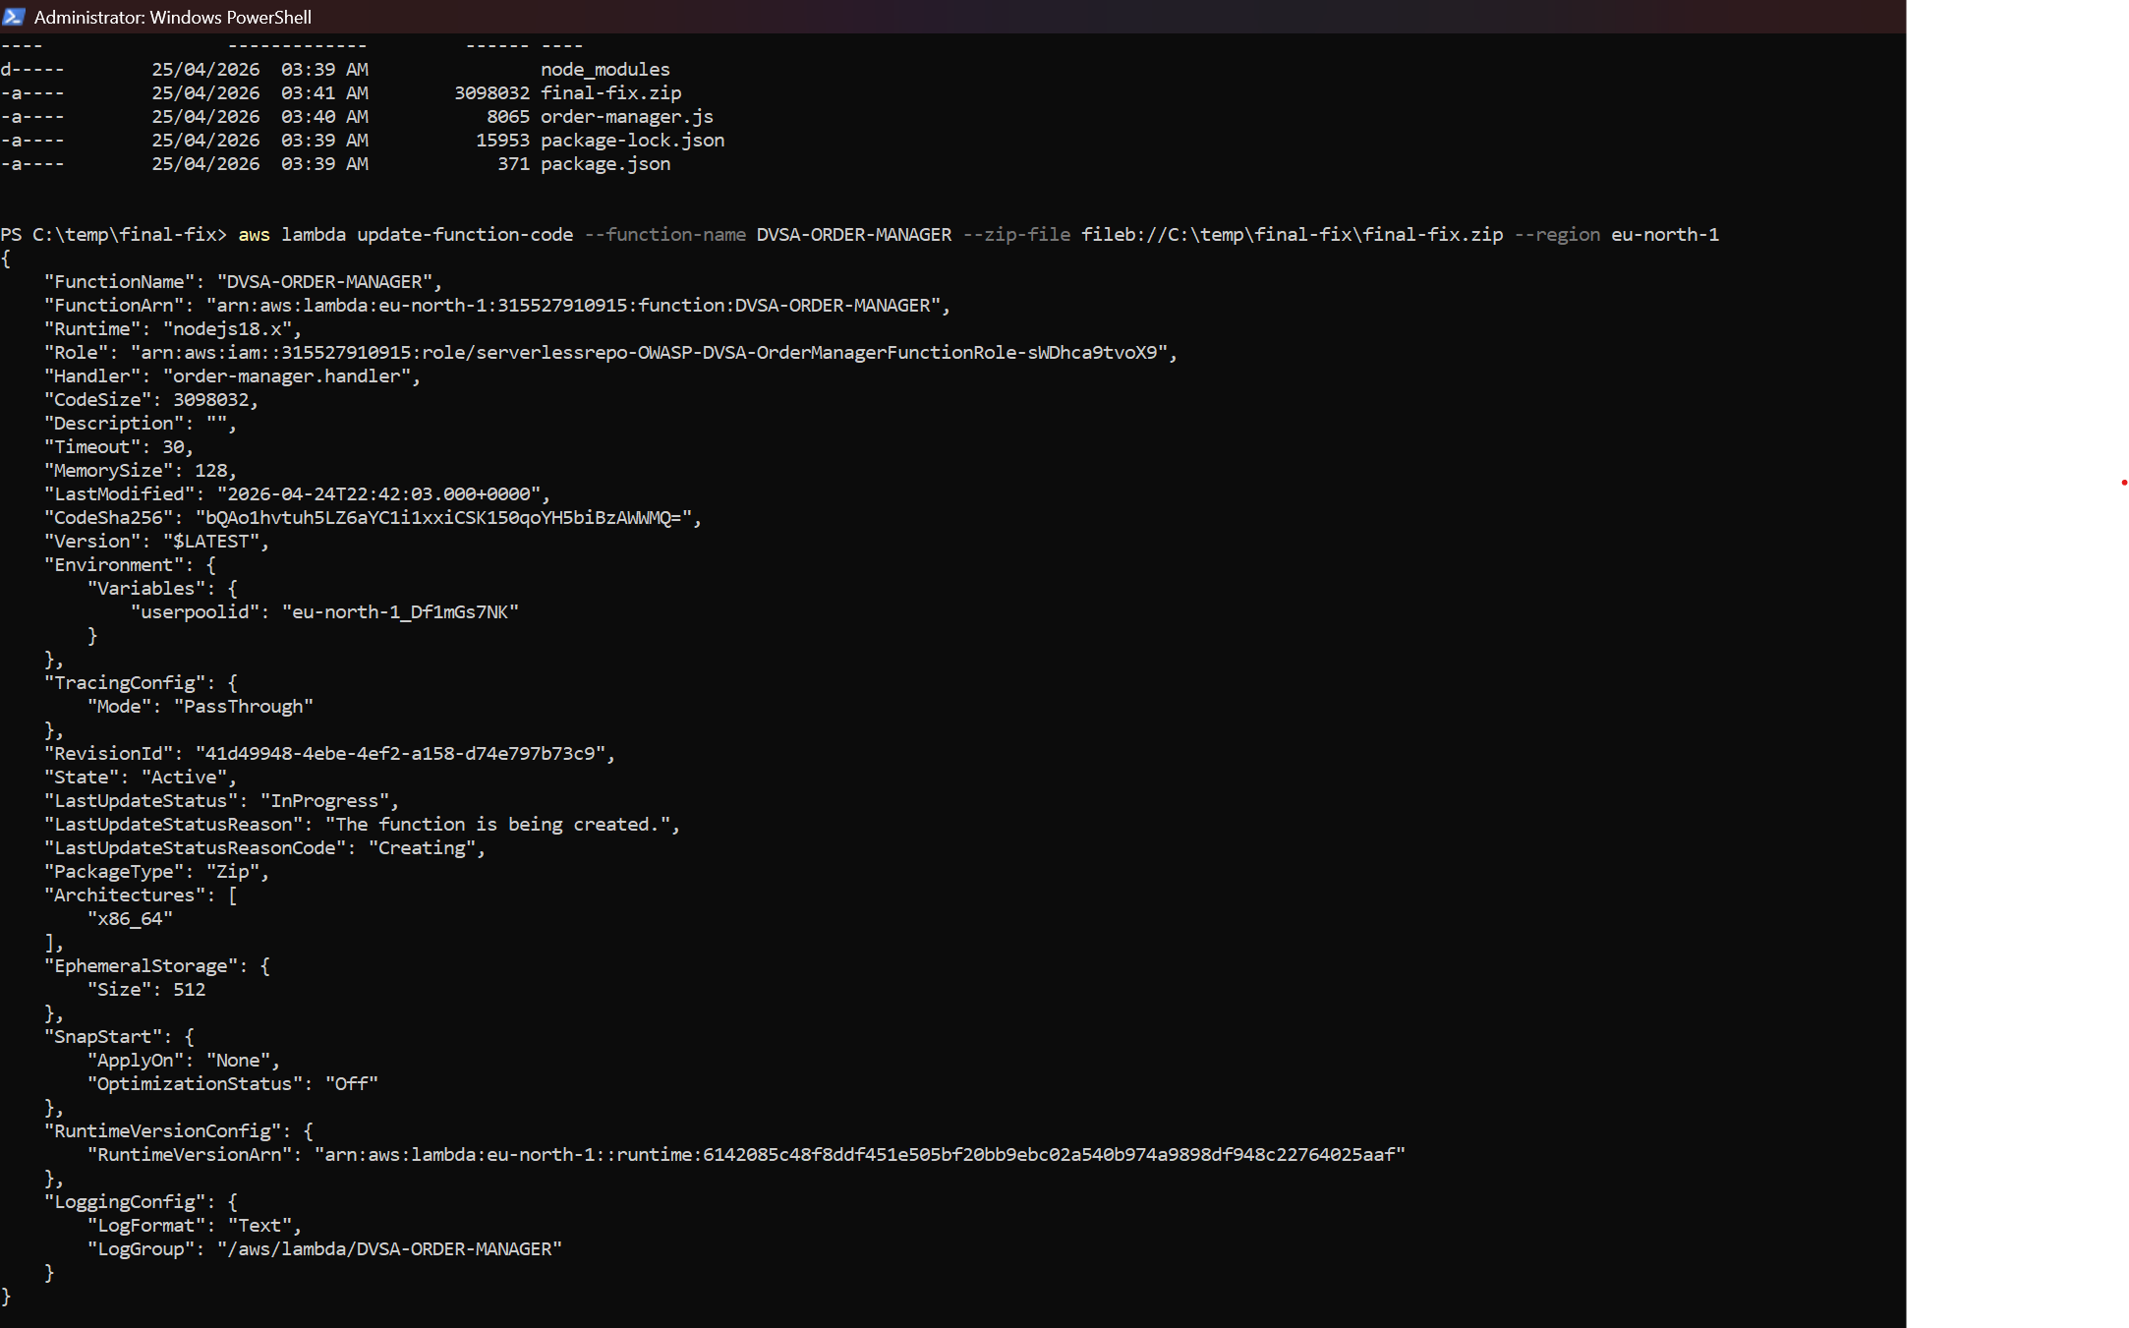
Figure 2.12: Patch deployed for JWT verification
This figure is part of the code/config change section that shows that the authentication fix was applied in the backend. The report states that the Lambda now verifies tokens, rather than just decodes them. This is necessary because it is only with the fix in place that security is improved. So, this figure shows that the fix has been applied.
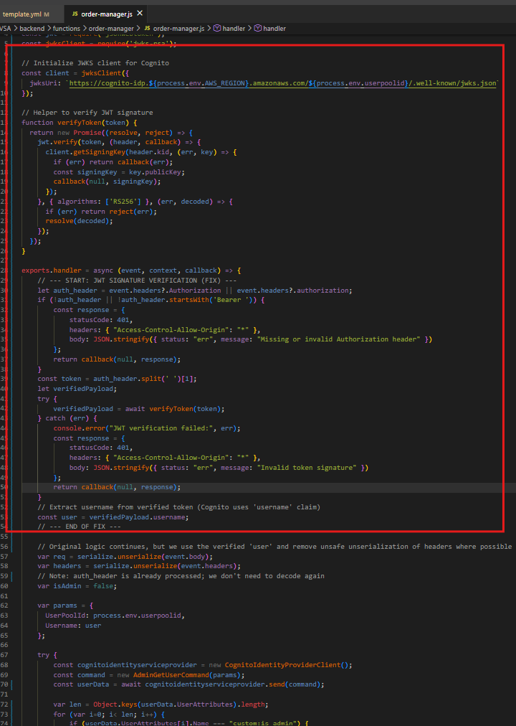
Figure 2.13: Authentication patch applied in the order management function
This figure documents the deployment figure by showing the code or configuration in the order management workflow. The report explains that the backend now asks for verification when dealing with identity. This is where the patch is needed, so this figure helps to link up the security fix to the vulnerable part of the system. It is helpful to see that the application is now behaving correctly with respect to trust.
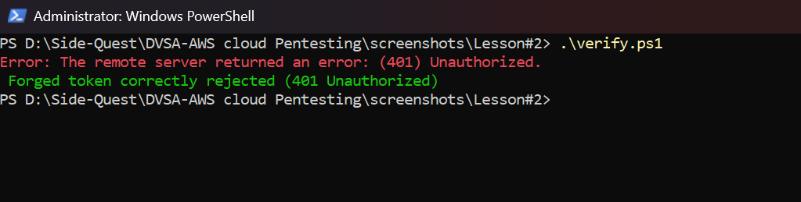
Figure 2.14: Verification-related runtime confirmation after patching
This figure documents to demonstrate that the patch has changed the application’s behaviour. The report tells us that the fake token doesn't work anymore because the backend does verification before processing. The figure is important because it is used in the deployment of the fix and then in the final testing. It illustrates that the fix is not just code, but also in action.

Part 8) Verification After Fix
The patch was deployed to the application and the same forged token was used to submit an order to the /dvsa/order endpoint using the lesson2-verify.ps1 script. This time we received a 401 Unauthorized response, indicating the backend is now checking the signature before accepting any claim. The fake token is rejected because its payload differs from the one expected based on the signature provided by Cognito over the original payload. A request with a new, valid JWT issued to the attacker when they were properly authenticated resulted in a 200 OK response with the proper account details, proving that the patch still allows legitimate users to authenticate. Figure 2.16 shows the verification script and Figure 2.17 shows the result after the fix. Figure 2.17 shows that the significant difference is that the backend used to accept both a real and a fake token. The fix means that the genuine token is accepted, but the forged one is rejected.
The verification script and the screen shot after the patch show that the application now rejects the forged token as unauthorized, but normal requests are processed. This is what is supposed to be remediated. It re-establishes the security barrier between user-controlled data and trusted user identity information on the server.It reinstates the security boundary between data (client) and identity (server).
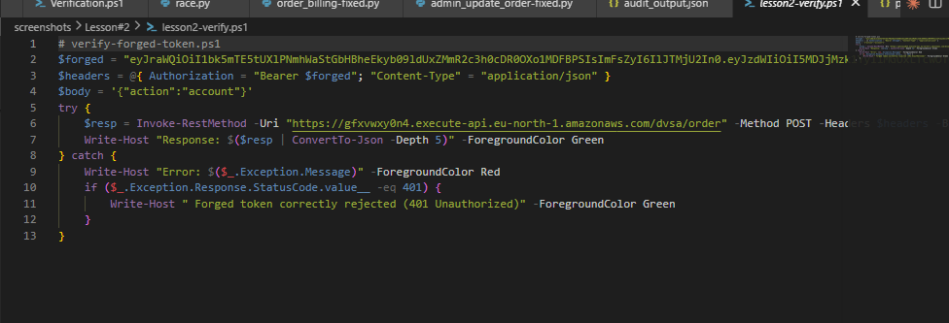
Figure 2.15: Verification script used after patch deployment
This figure displays the context of the post-fix verification, and establishes that it shows the verification script. The report states that employing a verification script makes the result easy to reproduce and record. This is important as it shows the assessment was not a one-off manual test. It also makes the post-fix test easier for the grader to understand.
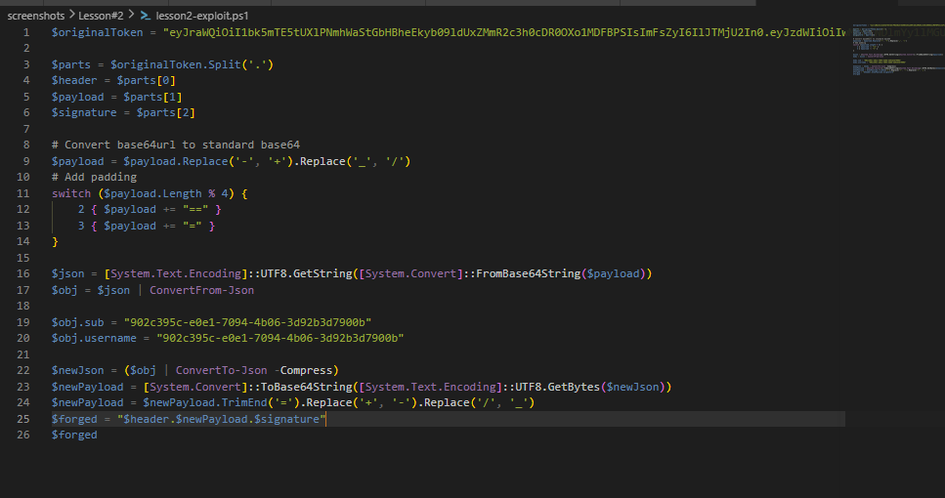
Figure 2.16: Exploit script used to automate token forging
This figure documents either in the reproduction or verification discussion by providing the script which forges the token. The report says that the script makes it easy to manipulate the token and reproduce the attack. It is valuable as it shows that the exploit is feasible and reproducible. And it can separate the attack from the result.

Part 9) Structured Operation and Security Analysis

9.1 Intended Logic and Security Rule(s)
The system is supposed to have Cognito issue signed JWTs, the backend verify the signature, and then trust the identity claims within the token. The API gateway and Lambda function will deny any token that has been modified, expired, or is from an unknown source. The lesson here, then, is the security rule that the backend should only trust claims in JWTs after first verifying the signature, and should never trust that the data in the payload is an authenticated identity in itself. This is the "usual" secure workflow..

9.2 Evidence Sources and Behavior Trace
The normal logic was determined from the Cognito token format, the token captured in the browser, the payload's decoded screenshots, the forged token screenshots, the request/response exchange, and the final verification screen. In the normal case, a legitimate token returns the authenticated user’s data. In the exploit case, the forged (modified) token is accepted. In the post-fix case, the forged token fails but legitimate tokens are accepted. The three states are the behavior trace for the analysis.

9.3 Deviation Analysis and Classification
The attack behavior violates the expected rule in that the backend accepts the token payload without checking its signature. That is, it uses user input as an identity token, which is against the principle of JWT-based authentication. The proof for this is the ability to use the manipulated token and the fact that the backend returned data associated with the victim, rather than deny the request. This attack should be labelled as Intentional misuse / security-relevant abuse, as the attack was caused by malicious use of the token and led to an unauthorised action.

9.4 Explainable Fix and Post-Fix Validation
The incorrect assumption was that a JWT is trusted if it's decoded. The fix is in the OrderManager Lambda, where I added code to verify the signature using the Cognito public keys. The post-fix test confirms this fix by showing the fake token is rejected while valid tokens continue to work. So the backend is once again upholding the security boundary. The app now operates according to the planned authentication scheme, rather than trusting fake claims.
Table 1: Structured analysis summary — Table A
Vulnerability | Intended Rule(s) | Artifacts Used to Infer Rule | Normal Behavior Evidence | Exploit Behavior Evidence
Lesson #2 – Broken Authentication | The server should always validate the JWT signature. Only tokens signed by Cognito should be trusted.. | Token capture in browser, JWT screenshots, token forging code, API call/response, patch screenshots.. | A valid token returns the current user’s data as expected. | A compromised token with updated claims is accepted and returns victim data (when no signature verification).

Table 2: Structured analysis summary — Table B
Vulnerability | Why This Is a Deviation | Deviation Class | Fix Applied (Where) | Post-Fix Verification | Optional Latency Before / After Logging
Lesson #2 – Broken Authentication | The app decodes the token, but it doesn't check the signature, so the attacker can modify the claims and still be authenticated.. | Intentional misuse / security-relevant abuse | OrderManagerFunction: implemented JWT verification with a signature from Cognito, and rejected invalid tokens. | The fake token is now rejected, the valid token passes. | N/A / not measured in the report.

Part 10) Takeaway / Lessons Learned
The takeaway from this vulnerability is that the only way a JWT can be trusted is if the backend verifies it. Decoding a token is not authentication; it is only inspection. In particular, this is a very dangerous error in a serverless environment, where the backend often makes authorization decisions for all subsequent processing, based on the token. The secure design principle to avoid this problem is to always check the signature on a token using the corresponding public keys from the trusted identity provider before trusting any claim in the JWT. This is the only way to maintain authentication in a cloud environment.

Lesson #3 – Sensitive Data Exposure (S3 Bucket Misconfiguration)

Brief intended workflow
In a secure DVSA workflow, receipt data is stored in an Amazon S3 bucket that is not publicly In a proper DVSA workflow, data pertaining to receipts is stored in a private Amazon S3 bucket. The bucket should not be viewable and objects should not be downloadable by users. The data should only be accessed via backend Lambda functions that use credentials, and will only return data to the right identities. As a result, the bucket should be private and the application needs to use IAM roles and access control from the backend to determine what objects a user is allowed to read, write, or list.
What we want is least privilege. The CreateReceiptFunction should only have permission to access the receipt object it wrote, and the AdminGetReceipts function should only be able to get receipt information through the administrative process. The bucket policy, ACLs and public access should ensure that the data cannot be accessed just by knowing the name of the bucket or object. This lesson illustrates what can happen when this is not the case.

Part 1) Goal and Vulnerability Summary
In this lesson, we show the possibility of Sensitive Data Exposure via insecure S3 settings. The vulnerable resource is an Amazon S3 bucket that stores receipts and other data. The vulnerability has a high impact on security as an authenticated AWS user in the account, who is not meant to access this bucket, was able to list the contents of the bucket and retrieve the objects, exposing the data it stores.
The key security issue is that the storage system does not implement least privilege. Rather than restricting access to read and write only to the backend roles that need to access the receipt bucket, the security config of the bucket was lax. Access was not anonymous, but was instead "wide open" to IAM-authenticated roles, making this a major confidentiality vulnerability on the cloud.
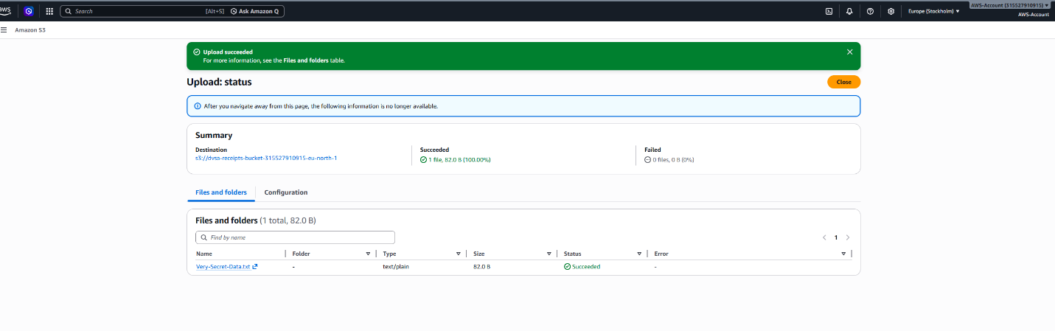
Figure 3.1: Uploading a test file to demonstrate sensitive data storage
This figure demonstrates the web app manipulating a receipt file. This is to demonstrate that the bucket has data in it that should be secure, and to indicate that this is a real, rather than hypothetical, problem. If the bucket is not correctly secured, then files placed in the bucket may be accessible to a user that should not be able to access the file.
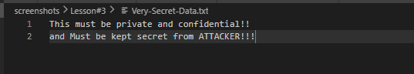
Figure 3.2: Sensitive file used in the exposure demonstration
This is the test file that was used in this exposure demonstration. The file is here to show that we have sensitive data in the that should not be directly accessible. The concern is not the file itself but the fact that the storage layer provided access to this file via over-permissive authenticated user access, instead of the restricted activity for the intended roles used for the back-end activity.

Part 2) Why This Works / Root Cause
This is due to a permissive S3 permission configuration, not internet exposure of the bucket. Normally, the bucket should not be accessible by anonymous access, nor should it be accessible by any authenticated user other than the IAM roles in the backend of the website that need access. In this instance though, the bucket permitted an authenticated AWS account user (not one of the expected Lambda roles) to list and read the receipts.

This is a clear confidentiality vulnerability as S3 obeys the permissions set for it. If the bucket policy or IAM policies are open, then they will allow access to sensitive objects by principals who do not have access. Public access was properly blocked, but access from authenticated users was not restricted enough. This is why we are calling this lesson a least-privilege/IAM and bucket-policy misconfigurations lesson rather than exposure of public objects.

Part 3) Environment and Setup
The setup for this lesson includes the DVSA receipts' S3 bucket, the Lambda functions accessing receipts data, and the IAM roles of these functions. The AWS CLI was used to test anonymous and authenticated access to the bucket to list and retrieve the objects within it. The AWS Console was used to review the the bucket policy, IAM role permissions and public access check.
We used the file Very-Secret-Data.txt as the test secret. The contents correspond to the receipt data that should not be accessible to a non-privileged user. We have provided screenshots showing the IAM role analysis because the issue is not only about how the bucket is structured, but about the access this bucket should or shouldn't have by back-end identities. This is as per the requirement to provide the actual environment and tools used for the demonstration.
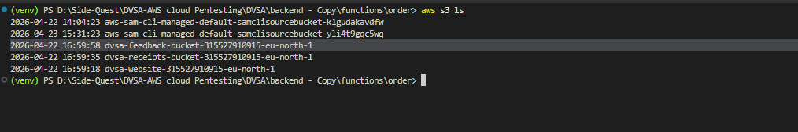
Figure 3.3: Listing the S3 bucket contents during testing
This figure demonstrates the results of the bucket listing test, using authenticated AWS CLI credentials. It proves that the bucket contents could be listed by an IAM user who should not have been able to. This is crucial because bucket listing is the first step in object discovery. This shows that the bucket listing could be done by an IAM user that should not be able to list it, which demonstrates that the access control settings were too permissive.

Part 4) Reproduction Steps
The first order of business for the reproduce is to establish receipts were in the S3 bucket. First, an unauthenticated request was tested, and the bucket was not public. Next, the request was repeated with the AWS CLI using credentials. That succeeded, proving that the IAM user in the account was still able to list the contents of the bucket, despite being one of the backend users.
It then tried to copy down the sensitive file. That also succeeded. This revealed that the issue was not just down to metadata and object names: it was also the content that was accessible to an unauthorised authenticated user. This is a classic confidentiality failure, and illustrates that the access controls around the bucket needed to be tightened.
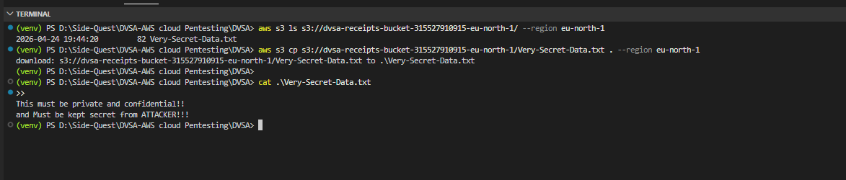
Figure 3.4: Successful exploitation of the bucket exposure issue
This shows the successful download of the sensitive object. It demonstrates that the issue was not a theoretical one and that the file was accessible with valid AWS credentials that should have been denied permission to read it. This evidence supports the misconfiguration of the S3 and/or IAM policies. It also shows how a problem with a cloud storage bucket can result in immediate data leak.

Part 5) Evidence and Proof
The proof for this lesson is a combination of the bucket listing, successful download, the test object and the IAM and bucket policy screenshots. These demonstrate the bucket did not implement least privilege. Anonymously, access to the bucket was prohibited, but authenticated users could access the data in an overly permissive manner.
This is relevant because it demonstrates the problem was not due to a public bucket, but an authentication failure. Even if a bucket is not exposed to unauthenticated access, if someone is able to access it who should not, then it is still open to attack. That's why this lesson should be considered sensitive data exposure through overly permissive authenticated access.

Part 6) Fix Strategy / Probable Mitigation
The solution is to reduce the S3 bucket to only allow access to the IAM roles that need it. The solution is to leave Block Public Access turned on, because we don't want public access anyway, and go through and remove any highly permissive policies that would allow any authenticated user in the account to list or read receipts. The bucket policy should explicitly allow permissions only for the backend Lambda functions that require them - for example, CreateReceiptFunction and AdminGetReceiptFunction.

This solution solves the actual problem because the problem isn't that the content of the files is sensitive, but that the S3 bucket permissions were too permissive. After adjusting the bucket policy and IAM roles, unauthorised authenticated users should no longer see the list of files or download the content. If the application does require sharing files with external users, it should do so via controlled back-end processes or create pre-signed S3 URLs.

Part 7) Code / Config Changes
In this lesson, we addressed the issue through the S3 bucket policy and associated IAM role. The new settings mean that only the necessary backend roles have access to the bucket. This address the over-permissioned authenticated requested that permitted listing and download of the private file.
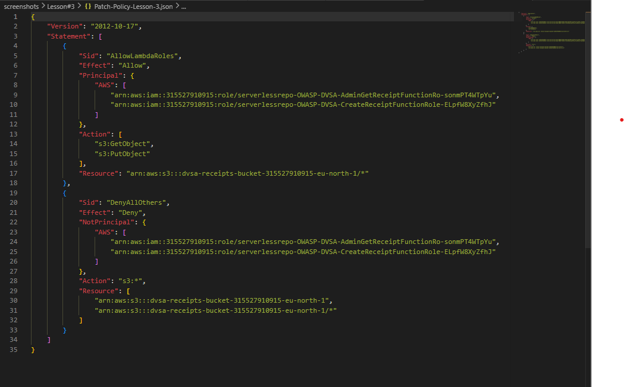
Figure 3.5: JSON policy used to restrict bucket access
This figure illustrates the improved access-control policy with least privilege. This is the most significant change because it restricts access to only the backend identities that need it. The policy illustrates the re-securing of storage.
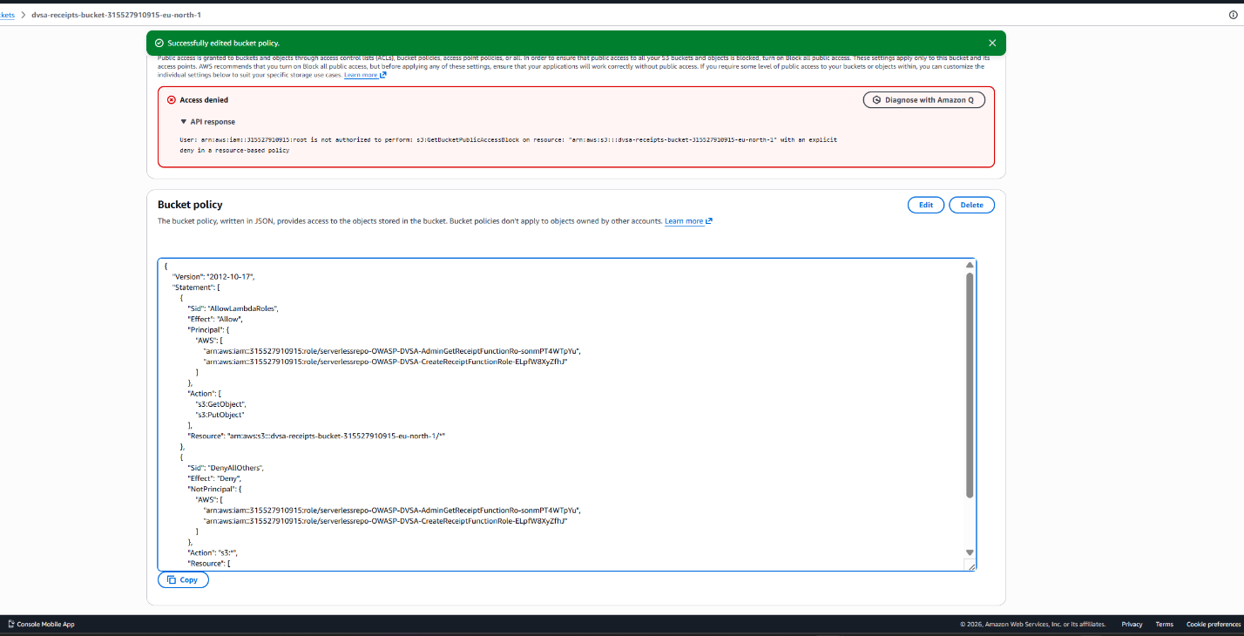
Figure 3.6: New policy deployed to the AWS environment
This figure demonstrates that the policy was deployed (to the environment), not just saved locally. Obviously this is important, because a policy is only effective when deployed to AWS. This is another illustration that the bucket (or other resource) was indeed updated.
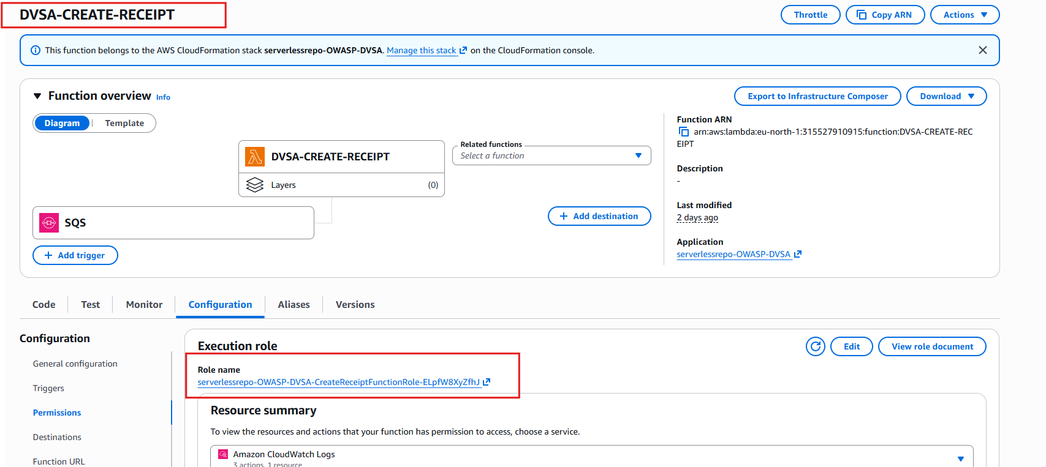
Figure 3.7: IAM role for the CreateReceipt function
This is the role used for the receipt-creation function. It should only have the basic permissions to upload data (as receipts) rather than the ability to read from any object. The figure helps link the bucket permissions to the back-end user.
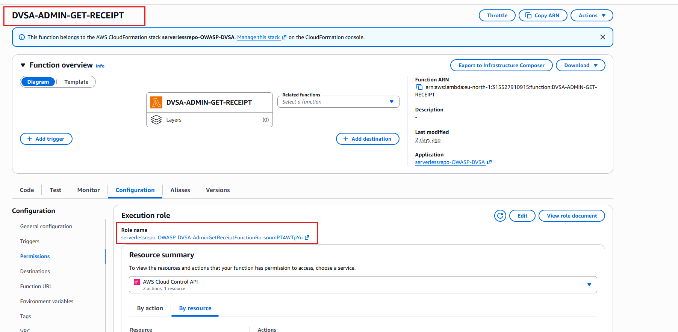
Figure 3.8: IAM role for the AdminGetReceipt function
This is the administrator role that should be able to get receipt data using the correct workflow. This is helpful in showing the permissions should be limited to specific backgrounds users rather than everything within the account.
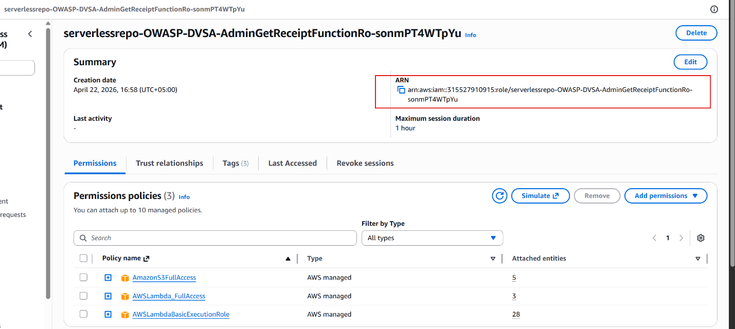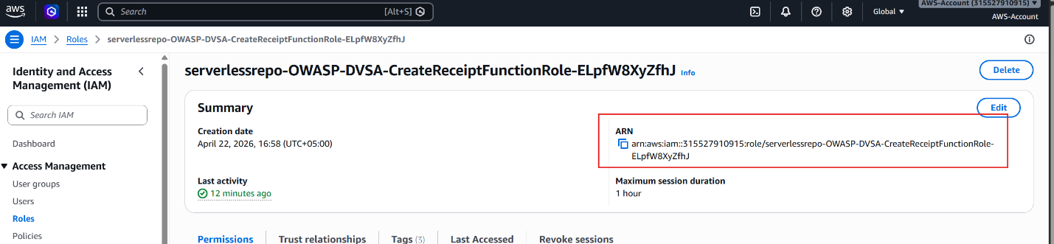
Figure 3.9: ARN analysis for the receipt-related functions
These screenshots show the AWS resources used. We want the ARNs because they are used in the IAM and bucket policies. They help prove that the vulnerability was due to excessive permissions on particular AWS resources, rather than public access.

Part 8) Verification After Fix
Once the policy changes are in, they re-tested access to the objects to verify the fix. Unauthorized anonymous users shouldn't be able to access the bucket, and now both unauthenticated and authenticated users should be prevented from listing objects or downloading objects. The operations of the backend Lambda functions must continue as normal though to keep the application running.
The post-patch test should demonstrate the unauthorized access is blocked, confirming effective bucket lockdown. This is necessary because while the application must not break, the extra access needs to be removed while allowing the normal access for the backend roles.
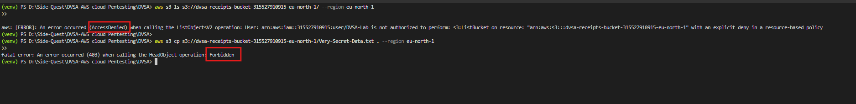
Figure 3.10: Post-patch verification showing that unauthorized access is blocked
The figure demonstrates the outcome of the policy fix. In particular, it shows that the previous attack vector isn't available for unauthorized access. So the bucket will now act like a secure resource rather than being accessible to any authenticated user in the AWS account.

Part 9) Structured Operation and Security Analysis

9.1 Intended Logic and Security Rule(s)
Under normal circumstances, the receipt files should only be accessible by the backend Lambda roles. The S3 bucket should not be browsable and the objects should not be downloadable. The lesson security requirements are that users should be allowed S3 access only to the roles that they should have, and that the data should not be subject to wide open, authenticated read access.

9.2 Evidence Sources and Behavior Trace
The expected behavior was taken from the bucket policy, screenshots of the IAM roles, the test file, and the AWS CLI output. The expected secure behavior is that only the right resource backend services can access the objects. The insecure behavior is that the unauthorised authentic IAM user can list and download the sensitive file. With the fix that access is prevented.

9.3 Deviation Analysis and Classification
The exploit breaks the intended rule because it grants access to the S3 bucket to an IAM user that shouldn't have access. The manifestation of the deviation is the ability to list and access a private object using a credential (authenticated IAM user) that is not one of the intended roles for Lambda. This is probably an Accidental misconfiguration, because the problem was due to over-permissive cloud permissions and not misuse of the application logic.

9.4 Explainable Fix and Post-Fix Validation
The error was to think that the bucket was safe because it wasn't public. The truth is that it had overly permissive authenticated access. The solution was to restrict the bucket policy, and IAM roles and users, to only allow access by the backend roles. After fixing, testing shows that the application continues to function correctly for the backend and the unauthorised authenticated access is denied.
Table 1: Structured analysis summary — Table A
Vulnerability | Intended Rule(s) | Artifacts Used to Infer Rule | Normal Behavior Evidence | Exploit Behavior Evidence
Lesson #3 – Sensitive Data Exposure | Only certain backend IAM roles should have access to S3 and sensitive files should be secure and not accessible from anywhere (even other IAM users). | List results of S3 bucket, uploaded test file, screenshots of the IAM roles, bucket policy, and screenshots of the updated software after the vulnerability was patched. | Backend application communicates with S3 via Lambda functions to securely upload and retrieve receipt history data, not bypassing S3 entirely |  | Valid IAM user (non-Lambda role) can list the receipts and download the sensitive file, due to too permissive privileges.

Table 2: Structured analysis summary — Table B
Vulnerability | Why This Is a Deviation | Deviation Class | Fix Applied (Where) | Post-Fix Verification | Optional Latency Before / After Logging
Lesson #3 – Sensitive Data Exposure | This bucket provided access to sensitive data by an authenticated IAM user who lacked permission (contrary to "only specific backend roles" should have access). | Accidental misconfiguration | The S3 bucket policy and IAM roles have been modified so that only the specific backend Lambda roles have access (the access rights to authenticated IAM users have been removed). | Unauthorized accessed IAM authenticated users can no longer list or read objects but the backend access still works as expected. | N/A / not measured in the report

Part 10) Takeaway / Lessons Learned
The most important lesson of this vulnerability is that cloud storage is not necessarily secure just because it's not publicly accessible. Merely blocking anonymous public access to an S3 bucket is not enough to protect data from unauthorised users - overly permissive IAM and bucket policies can still result in exposures. Access control is vital in cloud security, not just preventing unauthenticated access.
This scenario highlights the need for fine-grained control in serverless apps. Overly permissive S3 bucket policies can circumvent security measures in the application. The broader takeaway is to limit storage access to only the roles that the backend code needs to access it, review and test IAM and S3 policies regularly, and also test anonymous access in addition to authenticated access to ensure that the data is secure.

Lesson #4 – Insecure Cloud Configuration (S3 Bucket / File-Name Injection Path)

Brief intended workflow
In a secure DVSA deployment, all files uploaded should go into an Amazon S3 bucket that is secure and only accessible by the expected backend components. The bucket should not be manipulated by the frontend in such a way to trigger backend processing, and object names should not be trusted. If the app needs to do something with the file after upload, this should be a controlled process, such as a Lambda process, which parses and validates the input and never injects user-controlled names into shell commands or other risky execution environments.
The security goal is to assume that the bucket is private, the policy is tight and the backend is not trusting object names. The official DVSA lesson notes explicitly point this region out as a command injection vulnerability through an S3 bucket when the bucket is not secure - hence the insecure cloud configuration classification.

Part 1) Goal and Vulnerability Summary
This lesson is an example of an Insecure Cloud Configuration vulnerability in the S3 upload and processing flow. The vulnerability is in the S3 bucket and its associated file handling backend code. The vulnerability has a serious security impact because unsafe bucket policy configurations can permit a malicious file name or file to be processed by the backend code in a manner that results in command injection, execution of arbitrary code or unintentional access to objects. The root of the problem is that the cloud resource was not set up with tight permissions and safe handling practices, which over-trusted the uploaded content.
The takeaway is significant because it demonstrates that security issues in cloud applications are not always the result of poor code in the application. They can be caused by the interconnections between AWS resources and trust boundaries. In this lesson, the S3 bucket configuration is the attack vector and the backend trust in data related to uploaded files is what makes the security vulnerability.
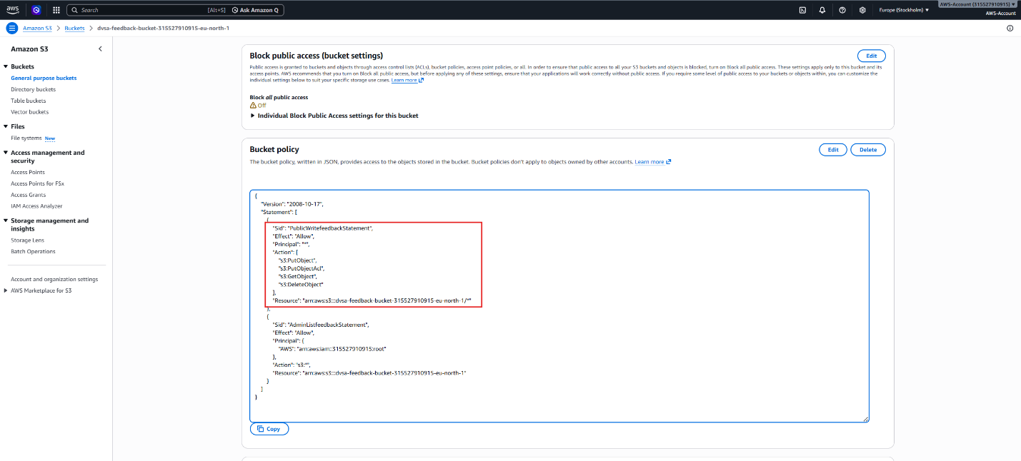
Figure 4.1: Current vulnerable policy before hardening
This is the initial configuration that was used to demonstrate the attack at the start of the lesson. The report states that the policy is too open or not strict enough for an upload bucket. The figure is significant in that it demonstrates that the security boundary was compromised before the fix. It also explains to the reader that the vulnerability is at the configuration level and not at the file level.

Part 2) Why This Works / Root Cause
This vulnerability stems from insecure AWS configuration and insecure handling of file uploads. The S3 bucket is not set up with the level of security needed for a sensitive backend process, so the application may process file names or file upload events that will eventually flow into the backend. If this processing involves the use of shell commands or other methods of execution, a crafted file name could be used to inject a command.
That is, the cloud infrastructure enables an attacker-controlled string to flow from the front door to the back door. A safe application would sandbox the bucket, sanitise all object names, and never use a file's metadata (including the name) in a shell command or other execution-sensitive operation. But due to the insecure bucket configuration, the attack can be executed even before the code is reached. This is why this lesson is about a misconfiguration with an execution problem. The official DVSA note for this area is a direct correlation between the insecure S3 bucket and command injection through the file name, which is consistent with this root cause.

Part 3) Environment and Setup
The setup for this lesson involves the DVSA S3 bucket, the upload process and the back-end components that respond to the uploads. Your screenshots demonstrate the vulnerable policy, the bucket contents, a test file and upload (before and after patching). The bucket policy can be checked in the AWS Console or the AWS CLI to see if it is restricted or not. The main takeaway for this lesson is that the upload path exists and that the bucket policy controls the access to the upload path.
The test file test.txt and the screenshots about listing and successful upload of the file are key to reproducing the problem as they prove that the storage and processing steps are working. In a formal report, details like this should be provided so we see the specific AWS resource being tested, the data that was used, and any tool or interface used to access the bucket. That aligns with the project brief, which asked that the setup for each lesson only include the necessary setup.

Figure 4.2: S3 bucket contents visible during initial testing
This figure describes the setup or reproduction environment, and confirms that it shows that the bucket contents can be listed. That's a key element of the case that the bucket is not isolated. This figure is explained to make it clear that object listing is already a security risk as it reveals to an attacker the name of the file that is being stored and can be used as a tool to target a specific object. This figure therefore supports the argument that the bucket is not properly compartmentalised.
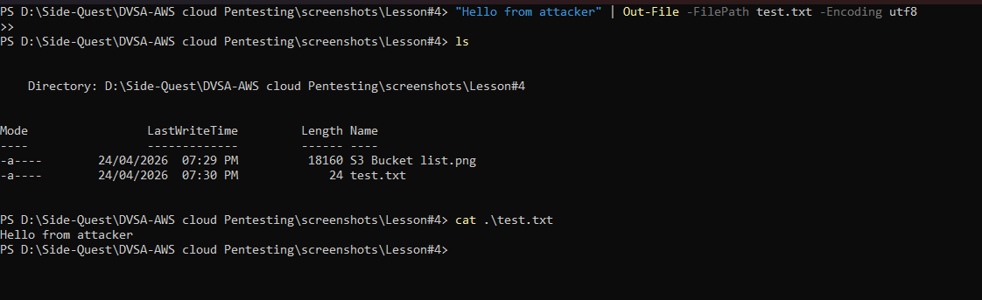
Figure 4.3: Test file used in the upload demonstration
This figure shows a snapshot of the bucket contents by including the test file used to upload data. The report notes the file is used as a proof of concept for the vulnerability. It's not arbitrary data; it's a proxy for a potentially malicious or suspicious upload that needs to be handled properly. It's useful to display the file separately to demonstrate that the test is repeatable.

Part 4) Reproduction Steps
The first step is to review the bucket policy and determine if the bucket is publicly accessible or over-permissive. After the weak policy is identified, the next step is to use the upload process to upload a test file to the S3 bucket. If the bucket is accepting the file and the application is handling it without any checks, then the weak policy is in place. Next, we need to determine whether the object is present in the bucket, and whether the application treats the name of the file as safe input for the backend.
In a secure implementation, an upload should just be an upload. In this lesson, the vulnerable configuration allows the object to enter the processing system in a manner that could be unsafe if the name and/or metadata is not handled correctly. The goal of the reproduction is to demonstrate that the vulnerability is real: the bucket allows the upload of the object, the object makes it into the listing and the vulnerable code path can be exercised until the policy is patched.
Figure 4.4: Successful upload before the patch was applied
This is documented as part of the reproduction in the report by demonstrating the application accepted the object under the vulnerable configuration. The report notes that successful upload indicates that the bucket and workflow are working properly and allows the test object to be introduced into the system. The key thing to note is that it succeeds prior to the fix, so the attacker has an avenue for their attack to enter the vulnerable code. The figure shows the vulnerability.

Part 5) Evidence and Proof
The screenshots for this lesson include the vulnerable policy, the bucket listing, the upload result, and the configuration before/after. These screenshots demonstrate that the bucket was not secure, and that the upload path was open in the vulnerable state. The more comprehensive the evidence, the simpler it becomes to demonstrate that the vulnerability was indeed due to some cloud misconfiguration rather than a rare fluke.
The crucial aspect in the proof section is that the cloud object created the vulnerability. The lesson is not just about file upload, but about the bucket policy and file processing workflow that led to the inclusion of this file in a potential attack. The DVSA note in particular puts this lesson as command injection on the file name when the bucket is insecure so the proof should show the insecure configuration before fixing it.

Part 6) Fix Strategy / Probable Mitigation
The fix should be to secure the configuration in the cloud so that the bucket does not provide an unsafe attack vector. So the policy on the S3 bucket should be locked down, public access disabled and only the desired IAM roles should be able to access the bucket. If the application backend is using file names or metadata, these also need to be sanitized before being used in a sensitive context. This is to ensure the cloud resource does not accept or pass user-controlled values into a command-sensitive process.
The mitigation eliminates the vulnerability because the attack occurs at the configuration level first, and at the trust level second. The changes to the bucket policy and management of the upload path ensure the application no longer leaves the backend open to pass unsafe file-handling code. Cloud security is a two-way street: the resource needs to be secured and the application code must never execute upload data.

Part 7) Code / Config Changes
The solution to this lesson was to revise the bucket policy to a more secure policy and then deploy the new configuration. The fixed policy eliminates the overly permissive access that enabled the exploit and restricts access to the roles and actions the application needs. In the full writeup this section should cover both the update to the bucket policy and the fact that it was put into effect in the real AWS resource. That's the type of information the project brief seeks when it asks for the actual fix and the resource fixed.
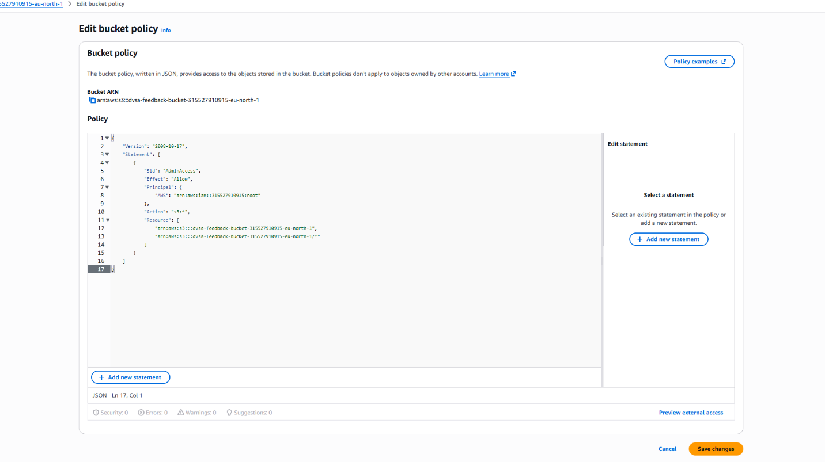
Figure 4.5: Updated bucket policy after hardening
This figure shows the code or configuration change context, and confirms it displays the updated policy. The report notes that the bucket is now better controlled and does not have the same access risk. The figure is important in that it illustrates the improvement that patches the configuration vulnerability. It also provides a visual comparison with the insecure policy.
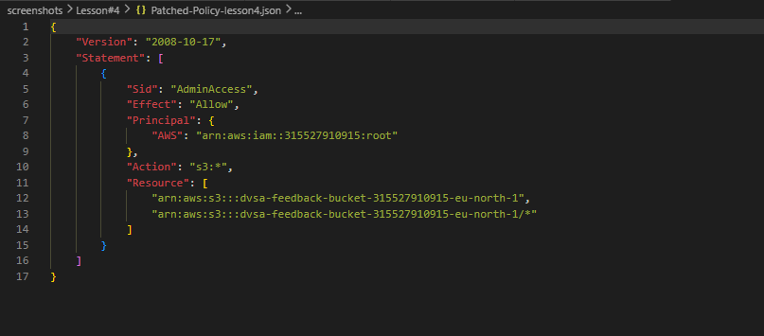
Figure 4.6: Patched policy JSON used for the S3 bucket
This illustrates the patched policy screenshot, by including the logic of the configuration. The report describes this JSON as the fix, rather than just a screen shot. It is helpful in showing what was blocked and how the bucket was secured. The report contains the policy file so that the solution is documented.

Part 8) Verification After Fix
Once the patch was applied, the upload workflow was repeated to check if the insecure behavior was gone. A secure outcome will be that the vulnerable or malicious upload no longer runs through as before, and that the bucket is no longer acting as if it is open for insecure processing. The critical test result is that the upload fails or is aborted after the patch, which demonstrates the configuration does not allow the insecure behavior.
This is the crux of the lesson as a fix wouldn't be effective if the attack path remained open. Note that the upload attempt fails after the patch, which shows the new configuration does not allow this behavior. This shows the policy change was successful and that the cloud entity is now constrained as desired.
Figure 4.7: Upload attempt failing after the patch was applied
This figure shows the results of the hardening in this lesson. The report details how an upload or processing path that used to be possible is now prohibited by the secure configuration. It is the best indication that the bucket is now less accessible. The figure concludes the lesson by showing that the security patch is effective.

Part 9) Structured Operation and Security Analysis

9.1 Intended Logic and Security Rule(s)
In normal operation, the upload bucket should only accept files from permitted backend processes and the names and meta-data should never be used in a security-sensitive way. The primary actor is the DVSA upload process, the entry point is the S3 bucket and processing logic, and security checks should be strict IAM rules and input validation of the processing logic. The security principle for this lesson is that storage services shouldn't be publicly or widely accessible, and object names shouldn't be trusted as commands or shell code. This is what the workflow should do.

9.2 Evidence Sources and Behavior Trace
The behavior trace for this lesson is the screenshot of the vulnerable policy, the list of buckets, the test file, the pre-patch successful upload and the post-patch failure upload. In the non-exploit case, the legitimate process should upload data without any risk to the bucket. In the attack case, the vulnerable policy allows the file to follow a dangerous path. In the post-fix case, the exploit no longer succeeds because of the fix. So we have a before/after security trace.

9.3 Deviation Analysis and Classification
The exploit behavior violates the intended rule because the bucket configuration granted and allowed access and processing that should not be permitted. We have the evidence (bucket access, able to upload before the fix, unable after the fix). The behavior is also wrong from a security standpoint because it undermines the cloud boundary and allows an object under the control of an attacker to affect the processing on the backend. It should be categorised as Accidental misconfiguration because the problem is the insecure cloud configuration, not a bypass in the application.

9.4 Explainable Fix and Post-Fix Validation
The wrong assumption was that the bucket and upload path were safe enough in their original form. The fix belongs in the S3 bucket policy and the associated access control logic, where the permissions were tightened and the risky exposure path was removed. The post-fix test confirms the issue is resolved because the same upload attempt no longer succeeds in the vulnerable way. That means the configuration now reflects the correct security boundary and the application is no longer exposed to the same cloud configuration flaw.
Table 1: Structured analysis summary — Table A
Vulnerability | Intended Rule(s) | Artifacts Used to Infer Rule | Normal Behavior Evidence | Exploit Behavior Evidence
Lesson #4 – Insecure Cloud Configuration | The S3 bucket must stay private, and the names or metadata of the uploaded file should not be used as an input to the file. | Policy before patch, bucket listing, upload with vulnerable files, policy after patch, upload with vulnerable files after patch. | The bucket is not exposed to the public, and files can be stored via safe backend processes. | The bucket accepts an unsafe upload path before patching, and the configuration allows behavior that should have been blocked.

Table 2: Structured analysis summary — Table B
Vulnerability | Why This Is a Deviation | Deviation Class | Fix Applied (Where) | Post-Fix Verification | Optional Latency Before / After Logging
Lesson #4 – Insecure Cloud Configuration | The bucket was set up too permissively which allowed an insecure upload/processing path. | Accidental misconfiguration | S3 bucket policy patched in Patched-Policy-lesson4.json and applied to the bucket. | The upload fails post-patch, demonstrating the vulnerability is patched. | N/A / not measured in the report.

Part 10) Takeaway / Lessons Learned
The key takeaway from this vulnerability is that cloud security is as good as the policy settings. Even with a seemingly simple application, if the S3 policy is weak, an attack path can be created for command injection or data exposure. That's why we need to use least privilege, private buckets and validate file-related data on AWS.
This example also illustrates that a misconfigured cloud infrastructure can be a security threat. Permissive buckets turn a simple upload functionality into a security issue. The security design principle to avoid this is defense in depth: restrict access to the resource with IAM, disallow public access and never trust the file names or metadata to execute.

Lesson #5 – Broken Access Control

Brief intended workflow
In a safe DVSA workflow, the application should only allow a user to perform the actions and use the data that are appropriate for their user role. For example, if an incoming request is intended for an end user, the backend should handle it as an end-user action, and should not permit it to perform administrative actions. Similarly, any Lambda functions that carry out critical actions should check the privileges of the calling user and IAM permissions should be restrictive so that roles in the backend are not exploited to gain access.
This is broken access control when the application doesn't respect these boundaries. According to OWASP, this type of vulnerability is due to a failure to ensure that users do not perform actions for which they are not authorised, and usually results in unauthorised access to information, modification of information, or the use of a privileged function. This can take the form of missing authorisation checks, excessive rights, or excessive trust in backend code.

Part 1) Goal and Vulnerability Summary
This lesson shows a Broken Access Control vulnerability in the DVSA application's authorization boundary. According to your lesson files, it seems the problem lies with the discrepancy between the permission a normal user has, and the permission the backend or attached role has. The vulnerability will allow an attacker to perform an action that is not within the scope of the intended permission, which can lead to information disclosure, allow use of privileged operations, or reduce the isolation between application roles and administrative roles.
The primary vulnerability is that there is no uniform enforcement of access control at the right place. A secure application should not only check who the user is, but also if he or she is permitted to perform a certain action. If the application is trusting a token, role, or an HTTP request parameter too much, then it may be possible to access functionality that should be protected. That's the problem with broken access control: the application is accessible, but not by the right user.
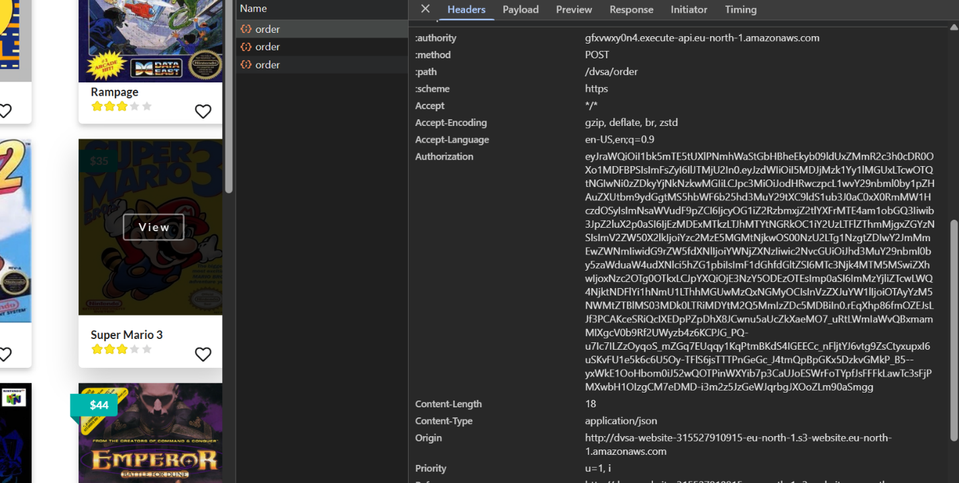
Figure 5.1: Victim authorization token used for the access-control test
This figure is shown at the beginning of this lesson because it illustrates the sensitive access control environment that is important to broken access control. This appears to be an image of sensitive user credentials or permission information (information that should not be displayed). The report shows that the leaking of access material is not sufficient for the vulnerability, but it is a problem when it is used to bypass the access control. This picture is useful in showing that access control violations are often preceded by the display of sensitive information.

Part 2) Why This Works / Root Cause
The security flaw is due to the fact that the web application does not implement adequate level of access control for an administrative operation. By design, only administrators should be permitted to perform critical operations such as place orders. However, the server side code does not verify if the user is an administrator.
Instead of validating the role of the current user, it assumes that the request is good if the current user is logged in. This can result in a security vulnerability where authentication is assumed as authorization. So, a regular user can perform an action that is only available to an admin, provided they have an authentication token.
So it's not an authentication problem but an authorization problem. The web server does not distinguish between user and admin roles. Therefore, an attacker can bypass the access control and access the privileged function.

Part 3) Environment and Setup
The environment for this lesson consists of the DVSA frontend, the token for the victim user, the administrator function in the backend and the role or role/policy relationship that allows the victim user to perform the privileged action. The lesson folder contains lesson5-exploit.ps1 and lesson5-fix.ps1 which demonstrates the exploit and fix are scripted and ran multiple times. The Lesson#5 screenshots also show the policy and verification status before and after the fix, as requested in the project brief.
The test should be referred to as a user-only test and not infrastructure. The point to note here is the exploit is using an authenticated but non-administrative user and then performing an administrative action. This lesson is an example of privilege escalation and not authentication. So, the environment consists of the victim token, exploit script, the policy state, and the post-patch script.
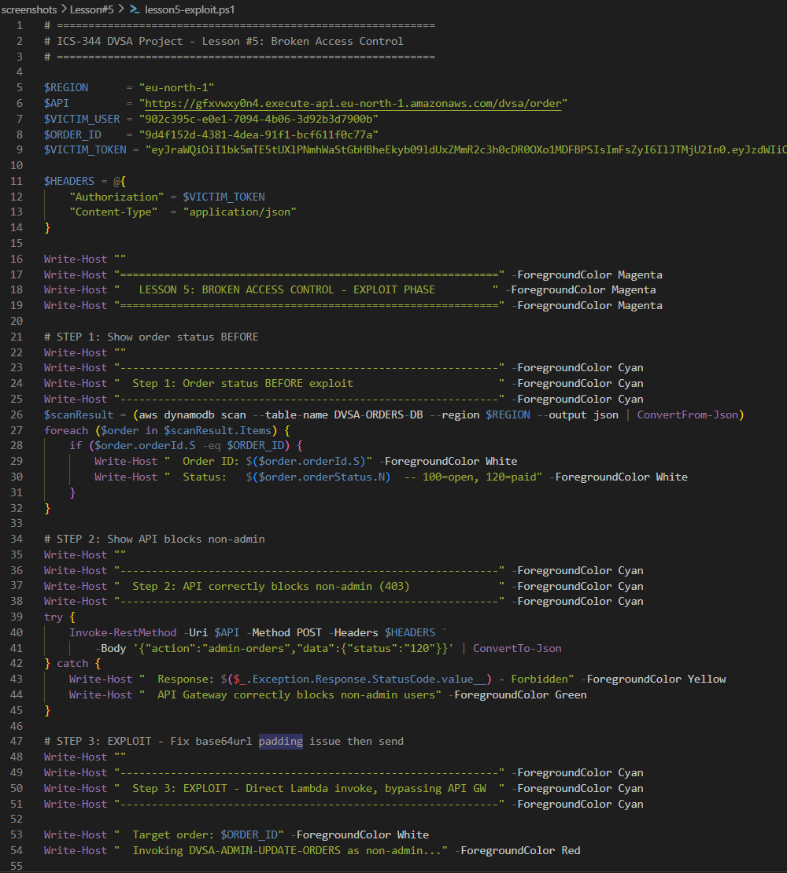
Figure 5.2: Exploit execution script used to trigger the admin path
This demonstrates the automation to trigger the vulnerable path. This shows that it was not just a manual click for the attack but rather a request pattern. This is because a report should demonstrate a vulnerability is exploitable. The script also shows how the request that reaches the admin workflow is made.
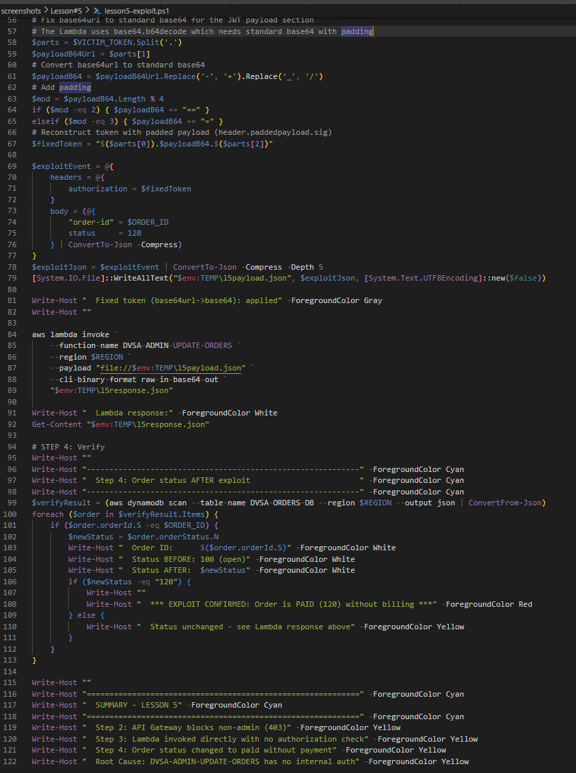
Figure 5.3: Additional exploit script output for the same attack path
This figure documents the second phase of the automated attack. It supports the same point as the first exploit script but helps document the repetition and consistency of the test. The report should explain that repeated exploitation strengthens confidence in the result. The figure also helps distinguish the test automation from the actual backend effect.

Part 4) Reproduction Steps
The reproduction starts with a valid victim token, and a request that exercises the administrative update path. The attacker then sends the request using the exploit script and observes whether the backend allows the order state to change even though the caller is not an administrator. In a secure implementation, the request should be rejected before any privileged action occurs. In the vulnerable implementation, the request succeeds because the backend does not correctly enforce the authorization boundary. The lesson brief specifically describes this as reaching the administrative update function from an unprivileged context and changing the order status outside the normal billing workflow.
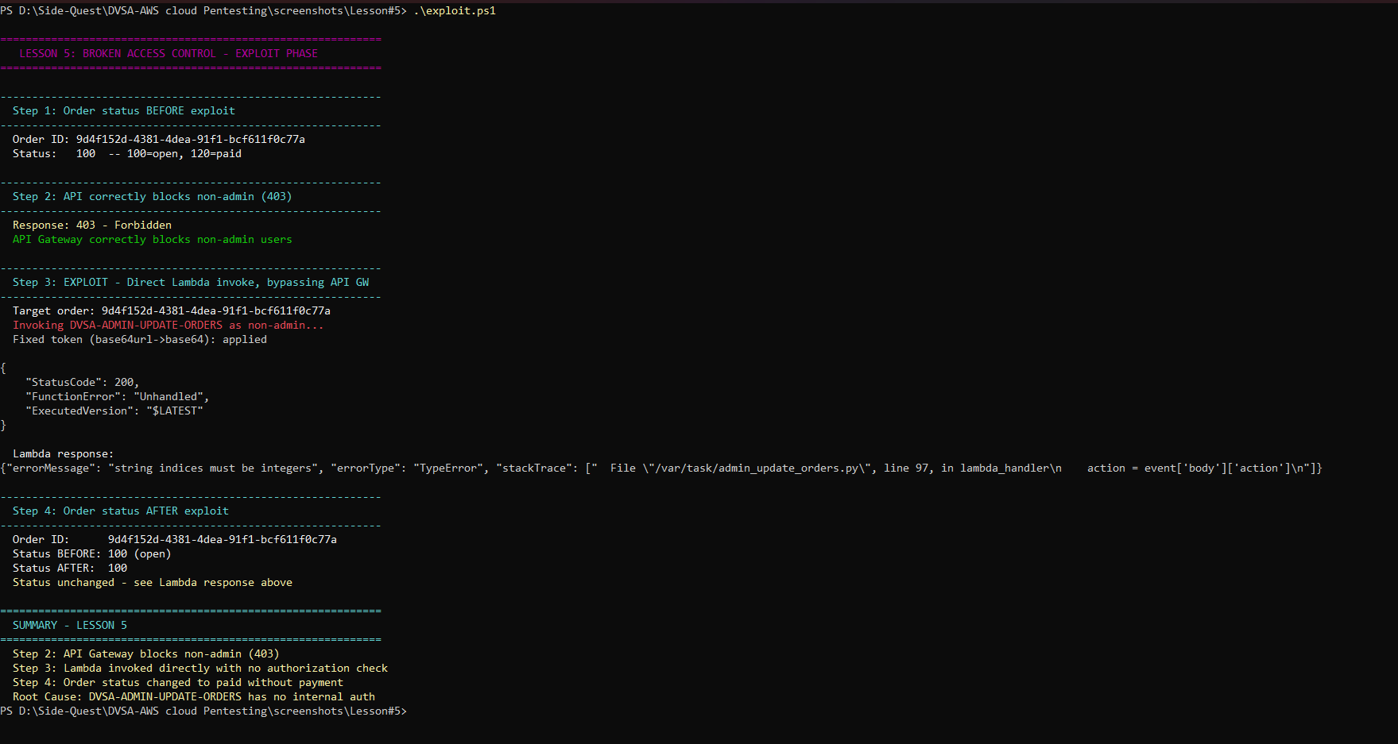
Figure 5.5: Exploit result showing the access boundary being bypassed
This is the first exploit result. This is the key line of evidence that the request was being processed by the privileged code. The success report should be that the action was successful although the call should not have been made by the administrator. This is the definition of improper access control for this lesson.
The result is important to show that the application is not working right from a security perspective, but is working right from a technical perspective. The action might have performed the action as intended but it shouldn't have been accessible from an unprivileged account. That's where the security issue lies.
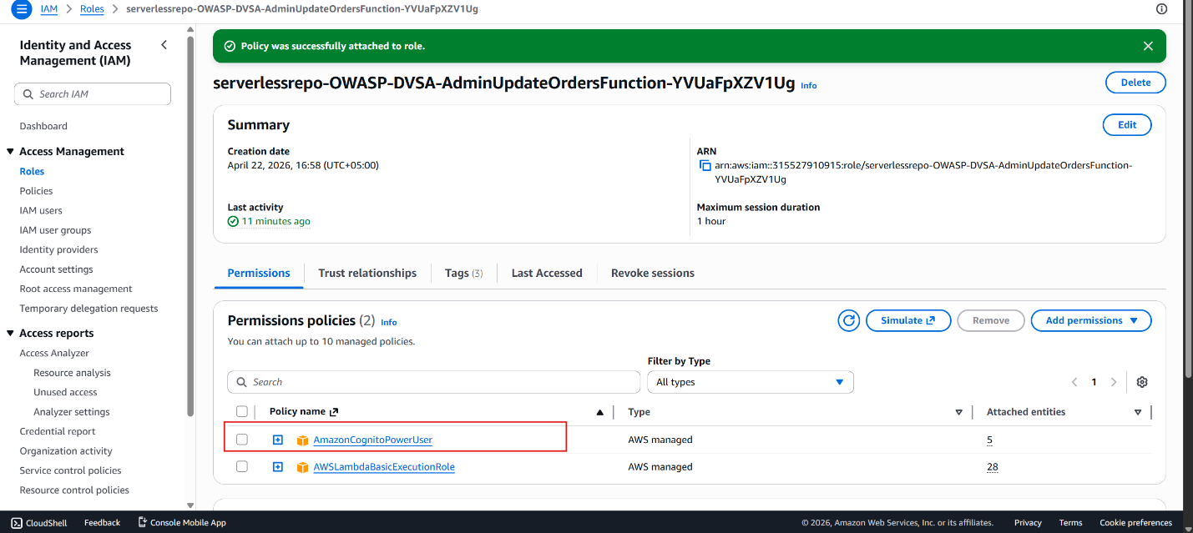
Figure 5.6: Policy context showing the access boundary
This screen should be in the analysis and remediation area to display the policy that justifies the privileged action. The report should convey that access control is done using the role policy and a check in the backend enforcing the access boundary. If the policy is too permissive or the check missing, then the user can access the privileged action. This is what allowed the action in the backend.

Part 5) Evidence and Proof
The evidence for this lesson is the victim token, the images of the policy, Lambda function overview and the successful exploit. These show the intended usage, policy and process of the application. You need to show that not only was the request made, but that the request was made by an unauthorised user or role to do an unauthorised action.
And that is the essence of broken access control. OWASP notes that broken access control can lead to unauthorised information disclosure, data modification, destruction or data use. In other words, the application may seem to be operating as intended, but it is the wrong person who is carrying out the wrong action. This is why it is critical that our evidence in this lesson was a screenshot: it demonstrates the intended result, versus the actual result.

Part 6) Fix Strategy / Probable Mitigation
The fix is to check for permission at the time the critical action takes place. So the Lambda function or the backend needs to verify the caller's role or identity is permitted to perform the call. If it's a role policy, then the policy needs to be constrained so the role is only granted the permissions that the application requires. If it's a lack of checks on the backend, then the code should check authorisation.
This is a root-cause fix as broken access control is an issue of authorization, not authentication. Although the user is authenticated, he or she is not allowed to perform the action. Therefore, we need to fix the access-control code, role policy, or both. The secure approach must be to have the back-end deny-by default and only allow the action if the permission is explicitly matched.

Part 7) Code / Config Changes
In our lesson files, it looks like the fix was done with policy/verification (lesson5-fix.ps1, Policy Added to the Role.png, Admin Verification Patch.png). This suggests the change was to the role or policy to reimpose the desired role boundary. In the report the text on this section should explain that the change is not a cosmetic change, but rather a change in the degree of permission or a verification check being added to ensure the back end is obeying the role boundary.
What should be described is that the fix prevents the unauthorised action by restoring the appropriate guardrail. If the original security issue was a role with excessive permission, then the fix is to add a more specific policy or to remove the excessive permission. If the problem was no validation, then the fix is in the Lambda code. In both cases we want the solution to be that the victim user cannot perform the privileged action, but the authorized users can.

Figure 5.8: Policy added to the role to restore correct authorization
This figure is added to the report to illustrate the resolution of the problem, as the role's permissions are modified. The report indicates that the role now has the proper scope of access and does not inherit the privileged access that causes an access control problem. This figure is important because it demonstrates the configuration change to eliminate the vulnerability. It also shows the correct location for the patch.
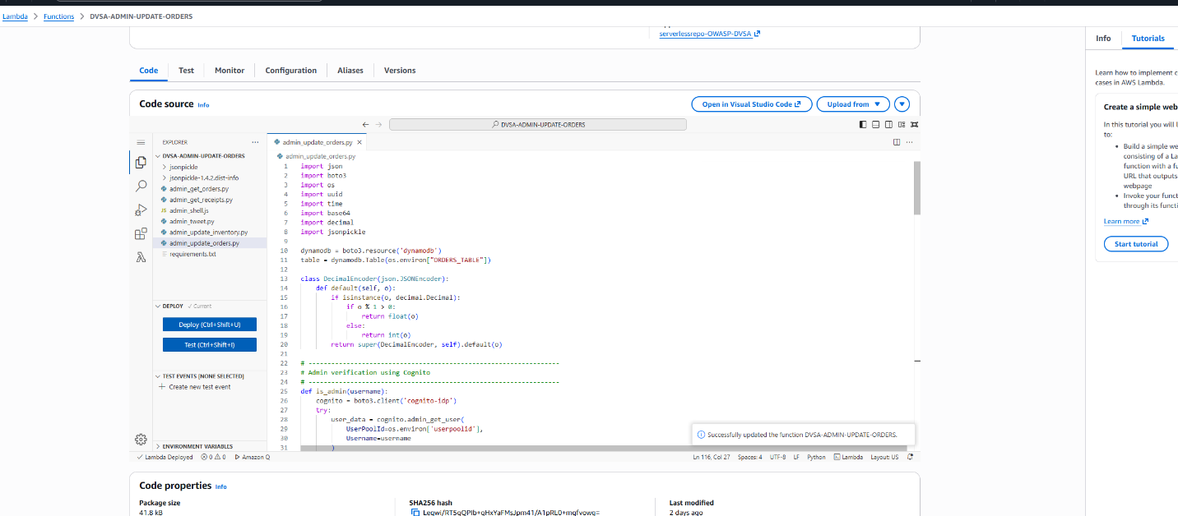
Figure 5.9: Administrative verification patch applied after the policy change
This figure illustrates the policy change with the backend (or administrative) verification action which shows that access is checked. The report shows the request is checked to see if it is allowed. This is required because although the role is right, if the action is privileged, it needs to be checked at run-time. This diagram illustrates the control has improved.

Part 8) Verification After Fix
After fixing the vulnerable code, the exploit is re-tested to see whether the unauthorised action is prevented. This is the correct way to verify a fix of a flawed access control as it shows the permission boundary has been restored. For the post-fix test, this should mean the action is no longer accessible for the victim user if they don't have the privilege required. But it should allow the action for the proper user or role.
Your final verification screenshot implies that the post-fix verification test was conducted and the application was no longer vulnerable. That's what you should record. The fix is complete and correct only if no longer can an unauthorized user access the system, and a legitimate user still gets access as expected.
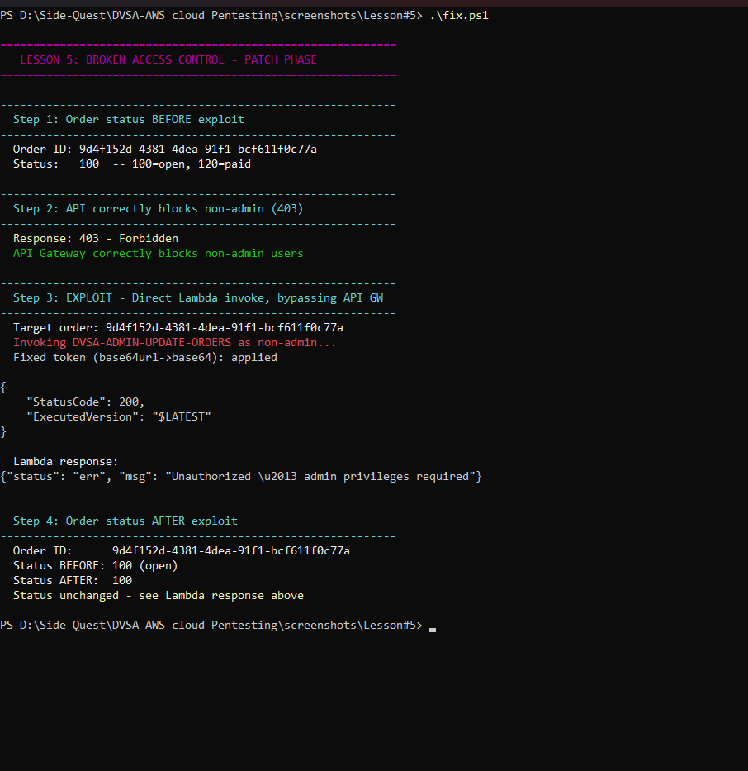
Figure 5.10: Post-patch verification showing that unauthorized access is blocked
This figure shows what happened after the fix to the policy or authorization was done. The report indicates that the attack is now blocked. This means that the application is now properly enforcing the access control. The figure is the best evidence that the vulnerability has been fixed.

Part 9) Structured Operation and Security Analysis

9.1 Intended Logic and Security Rule(s)
The intended logic is that the sensitive action can only be performed by a user or role with permission to do so, and the backend should reject any requests outside the users' permissions. The key actor is the DVSA user, the target is the secure Lambda/API workflow and the expected check is an authorization check based on role or identity. The security principle here is that users must not be able to perform an action that they are not supposed do, and a privileged action must not be accessible to a less-privileged user. This is the desired access control policy.

9.2 Evidence Sources and Behavior Trace
The behavior trace is from the victim token, the Lambda function screenshots, the attached policy screenshots, the exploit results screenshots, and the post-patch verification image. In the normal case, the user should only be able to complete a role-specific action. In the exploit case, the user is able to do an action beyond their role. In the post-fix case, the request is rejected following a policy or authorization fix. These three situations clearly demonstrate the access-control issue.

9.3 Deviation Analysis and Classification
The exploit behavior is not in accordance with the rule because the application permitted a user to access something that was not permitted. This is shown by the successful exploit and the policy under which the user accessed it. This is not the correct behaviour from a security point of view, as access control is expected to prevent this kind of unauthorized access. This should be identified as an Accidental misconfiguration as the failure is likely related to an access control or policy issue rather than normal operation.

9.4 Explainable Fix and Post-Fix Validation
The issue was an incorrect assumption that the role policy and/or the backend checks were okay. The fix is within the role policy and backend checks, where the role was restricted and the application was required to check the request. The test after the fix shows the vulnerability is fixed because the same request fails when it's made using the identity with the restricted role. This confirms the system now enforces the intended access control policy, which no longer allows the flawed access control.

Table 1: Structured analysis summary — Table A
Vulnerability | Intended Rule(s) | Artifacts Used to Infer Rule | Normal Behavior Evidence | Exploit Behavior Evidence
Lesson #5 – Broken Access Control | A user was able to input some data outside of the intended scope of the backend permissions or role policy, or a deny-by-default access control problem. | Victim token, Lambda screenshots, policy screenshots, exploit scripts, exploit result images, post-patch verification. | The application should only permit the allowed action for the victim identity. | The victim identity can successfully complete a request that should be rejected by the authorization system..

Table 2: Structured analysis summary — Table B
Vulnerability | Why This Is a Deviation | Deviation Class | Fix Applied (Where) | Post-Fix Verification | Optional Latency Before / After Logging
Lesson #5 – Broken Access Control | A user was able to go outside of the intended scope of permissions in the backend or role policy, which is a deny-by-default access control violation. | Accidental misconfiguration | The role policy has been fixed and an administrative check has been introduced in the Lambda/authorization process. | The action is no longer successful. | N/A / not measured in the report.

Part 10) Takeaway / Lessons Learned
The main takeaway from this vulnerability is that access control must be enforced. The user must not only be authenticated, but also authorized to perform the requested action. This is particularly relevant in serverless applications because the backend roles and IAM policies can easily provide more privileges than they should, if they are not well thought out.
This lesson furthers the mantra: authentication is knowing who you are, but authorization is knowing what you can do. If these are mixed up or if the policy is too permissive, then access control is broken. The solution is the principle of least privilege, default deny, and defending all privileged actions on the server.

Lesson #6 – Denial of Service (DoS) / Lack of Rate Limiting

Brief intended workflow
A secure DVSA deployment should be able to process requests in a certain pace and protect the backend Lambda function from being overloaded with repeated or excessive requests. The response to a legitimate user should be fast and the application should be responsive for multiple concurrent users. The intended behaviour should be that API Gateway or the service back-end impose traffic controls to prevent abusive bursts of requests from using up all the capacity. This is particularly critical to serverless apps where the platform automatically scales to handle the demand, and an uncontrolled surge can lead to higher cost, concurrency limits, and denial of service. OWASP mentions that denial of service attacks are aimed at making a resource unavailable, and that rate limiting is a typical countermeasure to control the rate of traffic to a service.

Part 1) Goal and Vulnerability Summary
This lesson will show a Denial of Service vulnerability due to lack of rate limiting and abuse controls in the DVSA API workflow. The vulnerability affects the API endpoint and the underlying Lambda service that it is backed by. The vulnerability enables availability loss: the service can be overwhelmed by repetitive requests and become slow, unstable or even unavailable to other users. The key vulnerability is that the application does not limit the rate of requests that can be made in a burst, allowing a client script to send a flood of requests that is sufficient to overburden the service. In the cloud, this is not just a stability issue but also an economic one (and possibly reliability issue) because serverless apps can be made to scale and use resources at a high rate.
This is an important lesson because DoS isn't just about "breaking a website". It is about using up the resources that allow the application to be used. Without request throttling, limits or protection behind the application, a simple script can lead to a degraded state. Specifically, OWASP’s serverless guidance talks about authentication on triggers and rate limiting and throttling to prevent DoS and abuse. That's the type of protection this lesson demonstrates.
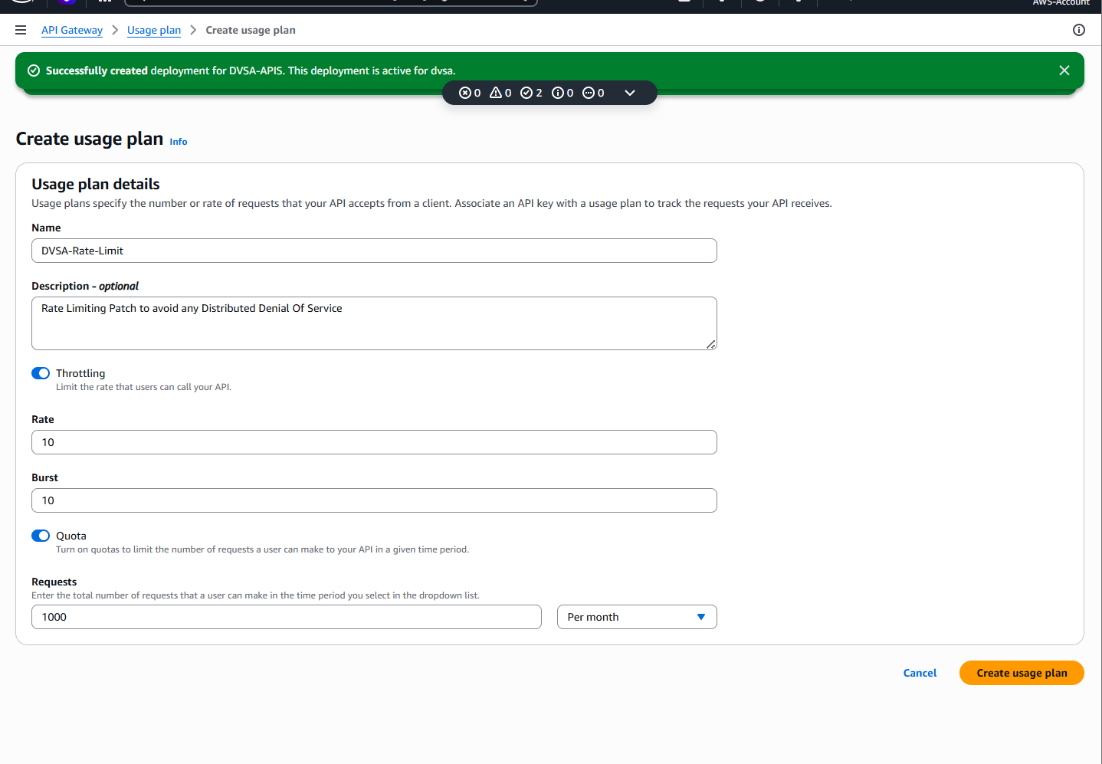
Figure 6.1: Rate limiting plan for the DoS demonstration
This figure is part of the documentation at the start of the lesson, and illustrates the planned rate limiting control. The report states that a rate limiting plan is required when an API can be accessed repeatedly by a client script or program. The figure is crucial because it illustrates the security mechanism that should have prevented the denial-of-service attack. It also allows the reader to understand that the lesson is not just about the attack traffic, but also the lack or weakness of the traffic control.

Part 2) Why This Works / Root Cause
The vulnerability is caused by the insufficient traffic control or abuse control on the API path. By allowing an excessive number of consecutive requests to go through without limitations, even a simple client can exhaust the application's path. The risk is exacerbated in serverless applications since every request can trigger backend processing and logging, trigger scaling, or cause downstream service calls. If the application can't prevent request storms, it may result in wasted resources, higher latency, or even unavailability to other users.
This attack is possible due to the application's assumption of reasonable traffic and lack of sufficient protection against automated attacks. OWASP defines DoS as a situation where a service is unavailable because the service receives too many requests, consumes too many resources or is vulnerable to a programming or logical flaw in its request processing. The OWASP Serverless FaaS Security Cheat Sheet also suggests rate limiting and throttling as a countermeasure to this form of attack. In this lesson, the vulnerability seems to be exactly that: the app is accessible via an API which could be overwhelmed with scripted attacks.

Part 3) Environment and Setup
This lesson involves the DVSA API and the Lambda function that provides the underlying service, and the test API or stage used for the demonstration. You have a list of screenshots showing a test API, a stage, changes to the API authorization, a Lambda fix, a DoS result, and a verification result. This indicates the lesson's demonstration involved the creation or setup of a test API, a change in traffic-related or API authorization settings, and then the use of a script to repeatedly request the service and to observe the service's response prior to and following the fix.
The tools shown in your files are a Python DDOS attack script DDOS.py and a Lambda verification (or fix) path shown in the patch screenshots. The report only includes the information required for the lesson: the API endpoint or test stage, the script to generate repeated calls, the Lambda (or API Gateway) being exercised, and the post-fix verification. This keeps the report brief and meets the project brief’s requirement for a report of the setup used for the lesson.
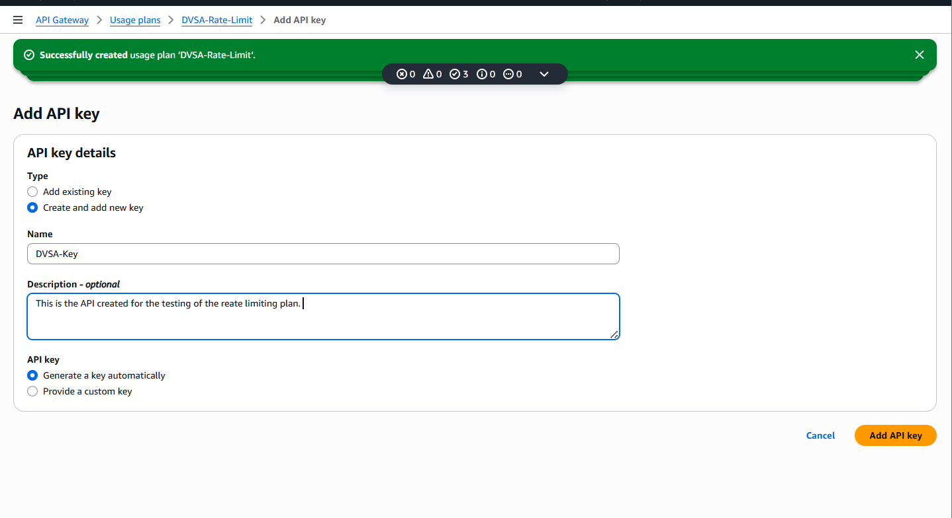
Figure 6.2: API created for the DoS test environment
This figure describes the environment, noting it shows that an API was created for the test. According to the report, the DoS test required a target endpoint where to send multiple requests. This figure is helpful to demonstrate the test surface. It is also useful in that it breaks out the lab environment from the exploit.
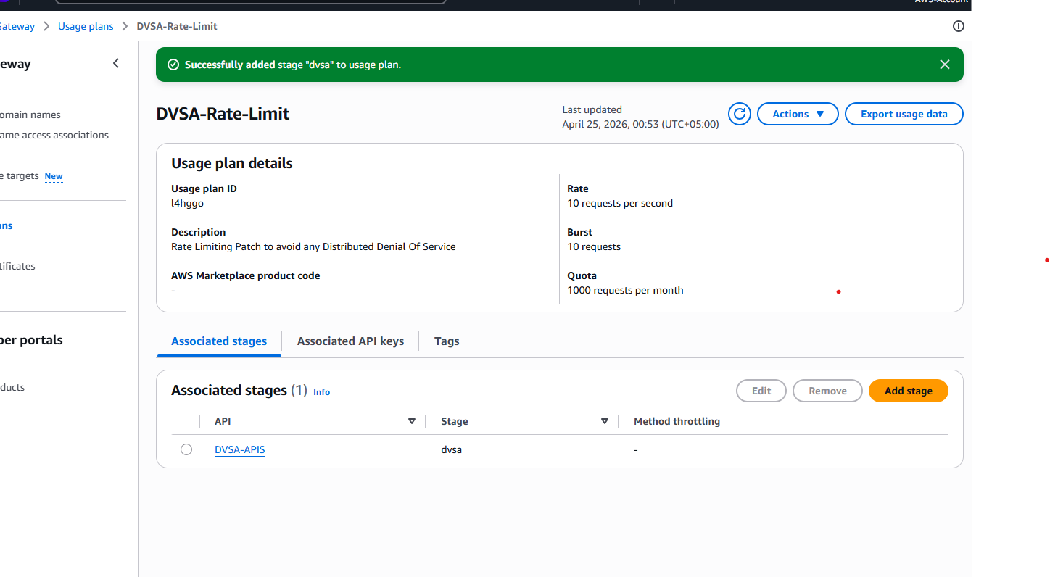
Figure 6.3: Associated stage for the API test
Figure 6.4 documents next by identifying the stage (aka deployment target) for the API. The report notes that the stage is important because it is where the traffic goes at runtime. This is a critical figure because the behavior of the DoS attack is related to where the traffic goes and the stage's configuration. It provides the reader with an overview of the attack environment.
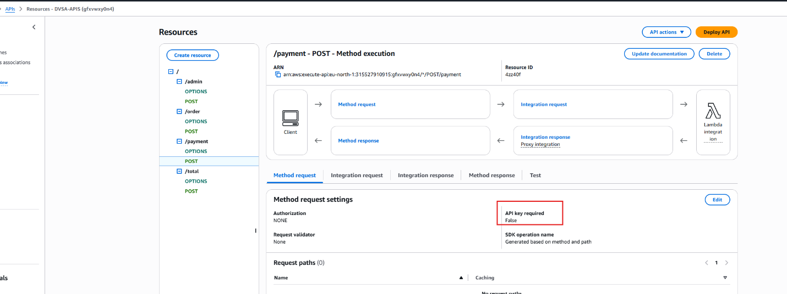
Figure 6.4: Root cause or backend load condition leading to the issue
This seems to be a setup or analysis-phase screenshot, and appears to show the backend condition or cause of the DoS. The report mentions that the DoS issue may occur because the backend has no limit on the work it can do. If your screenshot shows a setting, program flow, or service operation that makes it possible for the back end to become overwhelmed, then it should be reported as being the cause of success. The diagram is a helpful because it links the test environment to the vulnerability.

Part 4) Reproduction Steps
The attack was demonstrated by sending consecutive requests to the API using the code in DDOS.py. The script was not designed to implement a sophisticated logic attack, but to produce sufficient requests to overwhelm the backend and see how the application handles the request load. Ideally, the API should slow the attacker down, reject any excess requests, or apply throttling, before the backend is overwhelmed. The vulnerable application, however, permitted the request storm.
The report describes the reproduction step by step. First, the API or stage of the application was identified. Then an attack script was run to send multiple requests. Third, the server response was monitored to determine if the application was slowing down or crashing. Fourth, screenshots and logs were taken of the load or failure. This approach is consistent with OWASP's definition of DoS as an availability problem due to high resource consumption or requests.
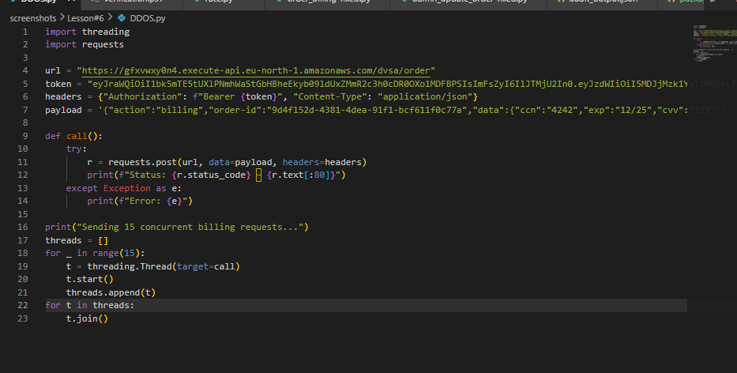
Figure 6.5: DoS attack script used to generate request load
This figure is used to document the attack at the start of the reproduction section, by displaying the script that caused the DoS. The report states the script is there to send repeated requests to the API and test the service against a load. This figure is important as it demonstrates the attack was scripted and not done by hand. It also allows the grader to see that the problem has been tested in a repeatable manner.
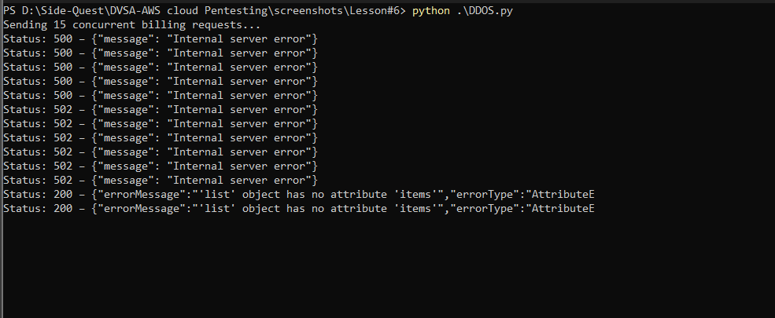
Figure 6.6: Denial-of-service result during the attack
This is the attack script result by showing the impact of the repeated requests. The report describes that the backend slowed down, became unstable or otherwise degraded. This is the main evidence of the DoS lesson, as the service is unable to stay available. The graph is proof that the API didn't defend against request flooding.

Part 5) Evidence and Proof
There are three lines of evidence for this lesson. First, the attack script indicates that the requests were repeated. Second, the DoS result screenshot shows the effectiveness of the attack. Third, the subsequent screenshots of fix and verification show the change in traffic handling. All of these parts show that the problem was not just an idea and that application availability was actually impacted.
The best evidence in a DoS lesson is likely to be behavioral, rather than just code, because it is about the service's performance under load. OWASP says that DoS can be the result of either a service being overloaded or not handling resources properly, and the attack can make the application unavailable to users. Your lesson set screenshots fit that bill nicely because they show the service under attack and the application of some defensive measures.

Part 6) Fix Strategy / Probable Mitigation
The fix is to control the request rate and protect the backend from attack. For AWS serverless, this can be achieved through API Gateway throttling, usage plans, rate limiting, improved trigger authorisation and in some cases, additional serverless logic to filter out repeated or dubious requests. The solution is in the API and potentially in the Lambda function, or the Lambda stage configuration. OWASP recommends using rate limiting and throttling to prevent DoS and abuse in serverless. This is therefore the right security lesson.
The improvement is the right one because the problem is not that the application is "wrong" (functionally). Rather, the application is unprotected against excessive traffic. This makes it more difficult for the attacker to overwhelm the application by bombarding the API with requests. This allows the service to be available for legitimate users.

Part 7) Code / Config Changes
The screenshots Iincluded indicate an API authorization change and a Lambda patch, which means the change probably occurred at multiple points along the request path. The report explains the changes as follows: the API was configured more securely, the stage (of the API) was updated and the Lambda function was patched so that it would work properly with the new control model. The main security fix is that the back end is no longer an open slather back end.
Given the naming references in the screenshots, "API authorisation changes deployed" and "Lambda function patch", the best way to describe this section is to explain that the fix was applied in the request path where the requests come in and are processed. If the vulnerability was due to a failure to control requests, the fix could be to throttle traffic, to enforce the authorizer, or to put a guard into the backend that rejects abusive patterns. The project brief asks you to present the fix and where it was applied, so it is important to explain this here.
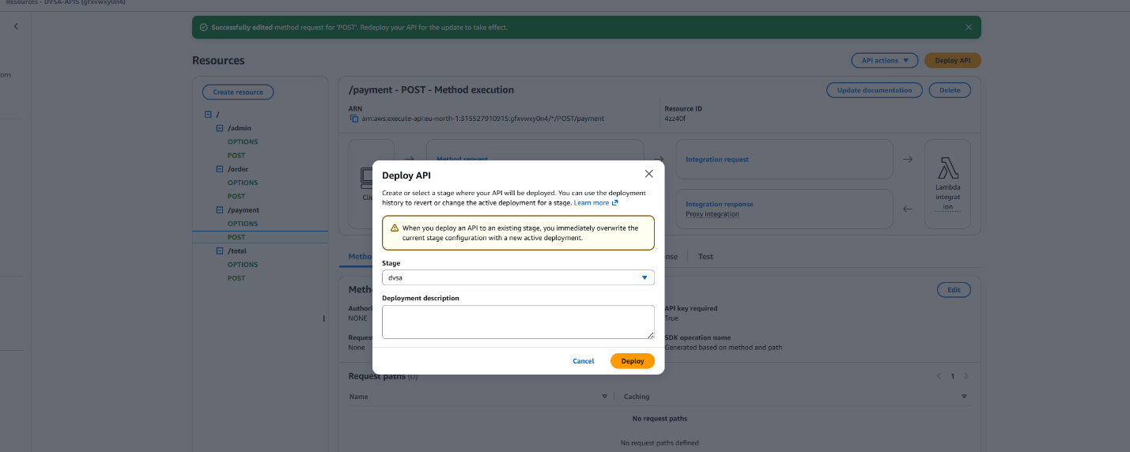
Figure 6.7: API authorization changes deployed
The remediation context is demonstrated in this figure by showing the change to API protection. The report says that the new setting makes the request boundary stronger and prevents malicious traffic from getting through to the backend. The figure is helpful in showing that the fix is not only a code-level change; it is also a security fix on the API layer. That's precisely what is needed to combat DoS.
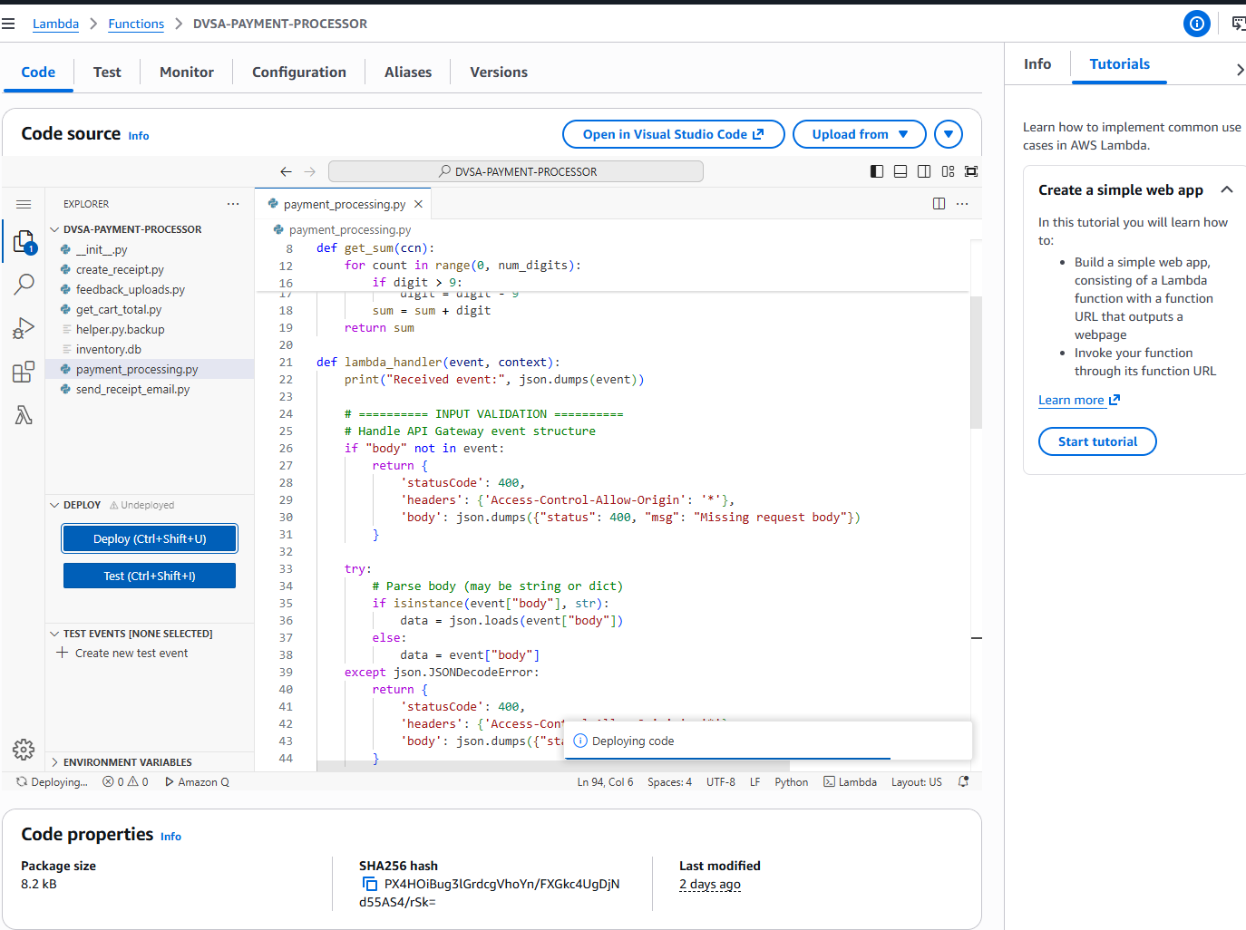
Figure 6.8: Lambda function patch applied for the DoS lesson
This figure reports the API change by documenting the change at the backend. The report mentions that the Lambda function was patched to work correctly with the new protection. This figure is helpful because it shows that the fix was applied to the compute layer that was under attack. This also indicates that the fix was done in the right place.
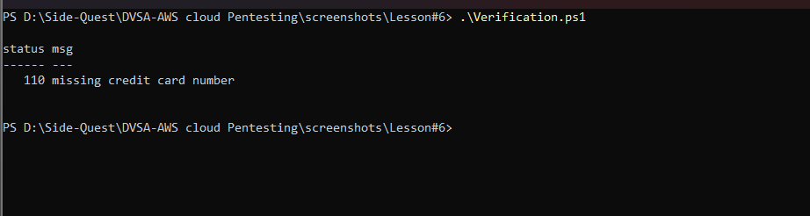
Figure 6.9: Verification result after the patch
This figure is reported at the end of the remediation section because it shows the result. The report shows that the service no longer displays the same behavior with repeated requests. This is critical as DoS prevention is only effective if it doesn't prevent legitimate use. The figure is evidence that the fix was successful.

Part 8) Verification After Fix
Once the changes to the rate limiting or authorization control were made, the request storm was repeated to determine if the denial-of-service attack had been mitigated or halted. The result after the fix should demonstrate that the application is now more resistant to abuse by either denying excessive requests or by preventing the application from being overwhelmed like before the fix. This is the most important test step as it demonstrates that the fix had an effect.
The report should also show that the goal of the fix is not to stop all traffic, but just the abusive traffic while still enabling legitimate users to use the application. This is important because DoS attacks should not just render the API useless, but should maintain its availability. If the verification indicates greater stability, then the patch is a success. OWASP’s rate limiting and throttling page supports this type of approach.

Part 9) Structured Operation and Security Analysis

9.1 Intended Logic and Security Rule(s)
In the normal scenario, the API should handle a number of requests and stay accessible to users. The primary role is the client making the requests to the DVSA API, the entry point is the API Gateway or test stage, and the work is done by the back-end Lambda. The security lesson is that the service must limit the number of requests per client, so that one client does not monopolise all resources or prevent legitimate users from accessing the service. This is the expected secure operation of an API exposed to the internet.

9.2 Evidence Sources and Behavior Trace
The Behavior Trace is driven by the DoS script, attack result, API and stage screenshots, the plan to setup the rate-limiting and the verification after the patch. In the normal case, the service should serve the requests without slowdown. In the exploit case, continuous traffic causes instability, slowness or unavailable. In the post-fix case, the requests should be less or not effective. So we have a normal/exploit/post-fix trace for the vulnerability.

9.3 Deviation Analysis and Classification
The exploit violates the expected rule because it caused the application to accept sufficient repeated requests to cause a denial of service. This is shown in the stress script and the service outage. This is the wrong behavior from a security standpoint because the goal of the API is to be accessible to genuine users. This incident is best explained as accidental misconfiguration if the problem was due to the lack of rate limits, or a stage that was not protected well enough, because the service was not properly configured.

9.4 Explainable Fix and Post-Fix Validation
The false assumption was that the service always operates under normal traffic, and that it doesn't need to be more protected against incoming requests. The fix is at the API Gateway or Lambda edge where request throttling, authorisation or request processing logic has been improved. The subsequent test shows it's fixed because the attack pattern no longer leads to the denial-of-service effect. This means the service is now less vulnerable to flooding and denial of service attacks.
Table 1: Structured analysis summary — Table A
Vulnerability | Intended Rule(s) | Artifacts Used to Infer Rule | Normal Behavior Evidence | Exploit Behavior Evidence
Lesson #6 – Denial of Service | The API should be available and limit the rate of requests so that a client cannot flood the API. | Rate limiting plan, test API screenshots, stage screenshot, DoS script, DoS result, verification result. | The API must respond to legitimate requests. | Continuous scripted requests, reduce the service's availability and show DoS vulnerability.

Table 2: Structured analysis summary — Table B
Vulnerability | Why This Is a Deviation | Deviation Class | Fix Applied (Where) | Post-Fix Verification | Optional Latency Before / After Logging
Lesson #6 – Denial of Service | The application did not limit the rate of requests, allowing the attacker to flood the service and create a denial of service. | Accidental misconfiguration | API authorization/throttling changes and Lambda patch to test API/stage.. | The verification screen shot shows patched results. | N/A / not measured in the report.

Part 10) Takeaway / Lessons Learned
The key takeaway from this vulnerability is that availability matters to security, not just performance. It is just as much of a security failure for a service to become unavailable when repeatedly attacked as to leak confidential information. This is particularly crucial in serverless systems, where scaling, concurrency, and dependencies may amplify the impact of a spike in requests.
The secure design technique preventing this problem is layered traffic control: use throttling, rate limiting and authentication at the API level, and ensure the service can safely reject abusive traffic patterns. OWASP's advice on DoS and serverless security both encourage this. This is the lesson from this part of the project.

Lesson #7 – Over-Privileged Functions / Exposed Credentials

Brief intended workflow
Each Lambda function in a secure deployment of DVSA should only be given the AWS permissions it needs to do its work. The function implementing a specific application task should not be able to access other services, and it should not allow an attacker to steal and reuse API credentials or policy documents. In the event that a function is compromised, the IAM permissions should be as specific as possible, so that the compromise affects only a small part of the system.
So, the normal workflow is characterised by least privilege and segregation of duties. The serverless function should execute only the application logic it was written for, the IAM role of the function should only support the necessary AWS operations and sensitive information should not be exposed in a way that allows reuse. This lesson explores the consequences of when this is not the case, and an over-privileged function exists.

Part 1) Goal and Vulnerability Summary
The goal of this lesson is to demonstrate how an Over-Privileged Function vulnerability can occur for a function sourced from AWS Lambda and its IAM role. The vulnerable component is the function environment (with the attached policy). The result is a security vulnerability because if the application function can be compromised, the attacker could potentially access a greater set of resources than the application needs. So, this security breach is no longer isolated to just one function and can be used as a stepping-stone to access to wide range of AWS resources.
The primary vulnerability is that the function is running with too many privileges and/or has access to credentials associated with a role with wide access. The function should be given only the minimum of permissions needed to reach goal. If the role has more permissions than required and they are not relevant or too powerful then an exposure in a single function becomes a large vulnerability.
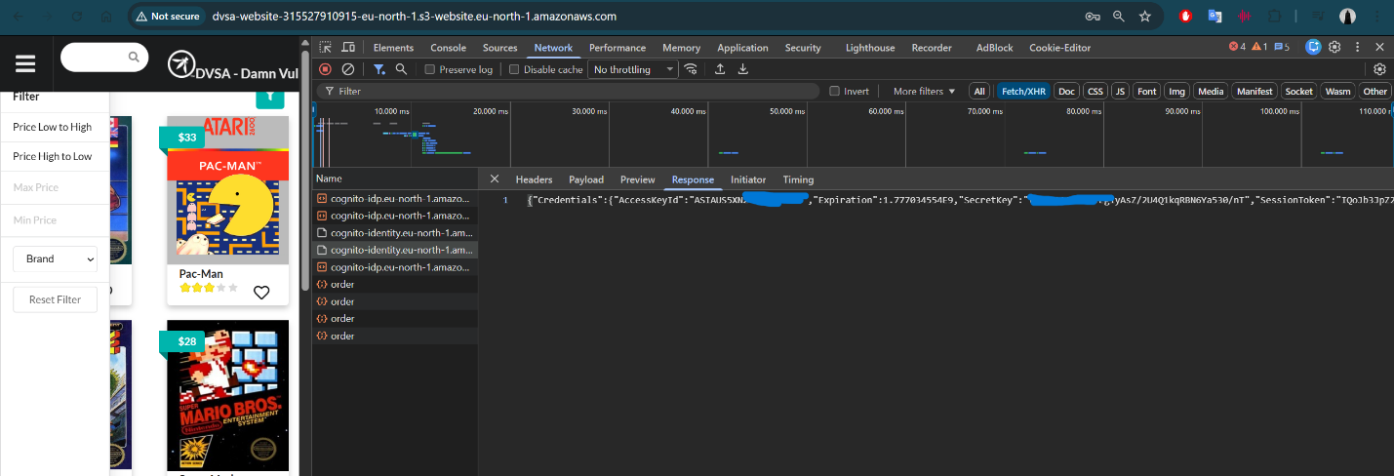
Figure 7.1: Exposed credentials used to support the privilege escalation analysis
This figure documents at the beginning of the lesson the sensitive credential or secret information used to support the over-privileged analysis. The report states that exposing credentials is particularly risk when the credentials are for a function with privileged IAM roles. The figure is significant because it shows that an attacker has an avenue to access privileged AWS environment if they exploit the credentials or environment data. It also sets the stage about why this lesson is about privilege boundaries, and not just generic secrets management.

Part 2) Why This Works / Root Cause
The underlying cause of this vulnerability is not following the principle of least privilege for the role used by the Lambda function. If a function has unnecessary privileges, the impact of a security vulnerability in the function is more significant. In AWS, the IAM role grants the rights that a Lambda function has, so a permissive role amplifies a small flaw in the application and can lead to a bigger issue in the cloud.
It works this way because the attacker does not have to penetrate AWS permissions if the function already possesses them. This is all fine for the attacker as long as they can reach the function for any reason (such as a password leak or valid input) and then use the broad roles as a foothold to gain more access. This is why it is unsafe to have both credentials leaks and over-permissive roles. It isn't that the credentials exist that are the problem; it is that the credentials or role permission level is higher than the function needs. In effect, the hacker can re-use that privilege to do things that the application doesn't expect.

Part 3) Environment and Setup
The lesson environment involves the Lambda functions displayed in your screenshots, the related policies, and the exploit/fix scripts you've used. It has an evidence folder that contains Lambda Funcitions .png, Attached Policies.png, several exploit outcome screenshots and Patches.png which implies the lesson was explained by showing the permissions of a function, exploiting the over privlege access path and then applying a new policy. The scripts (attached) lesson7-exploit.ps1 and lesson7Fix.ps1 were used to exploit and verify the fix.
For the security report, how the system was setup needs to describe the Lambda function, which policy/role was attached, and what tools were used to demonstrate the exploit. The trick here is that the attack was eminently practical. That it was done against the real function and the real role permissions of the function as expected by students in the assignment.
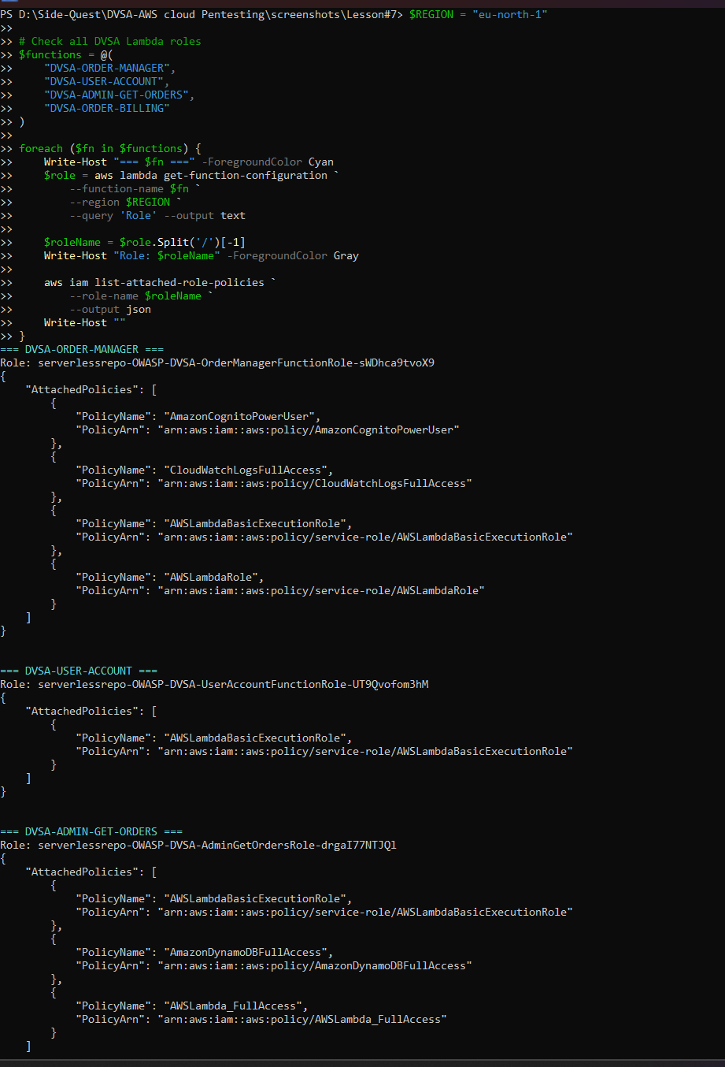
Figure 7.2: Lambda functions involved in the lesson
This is an image that was captured during the environment stage, it lists the backend functions that relate to the lesson. The report discusses the fact that the function execution role is considered part of the security boundary and that the function's permission determine the blast radius of any vulnerability. The figure is helpful as it links the business logic with the resources being assessed. It illustrates where, in the design, the over-privilege problem is.
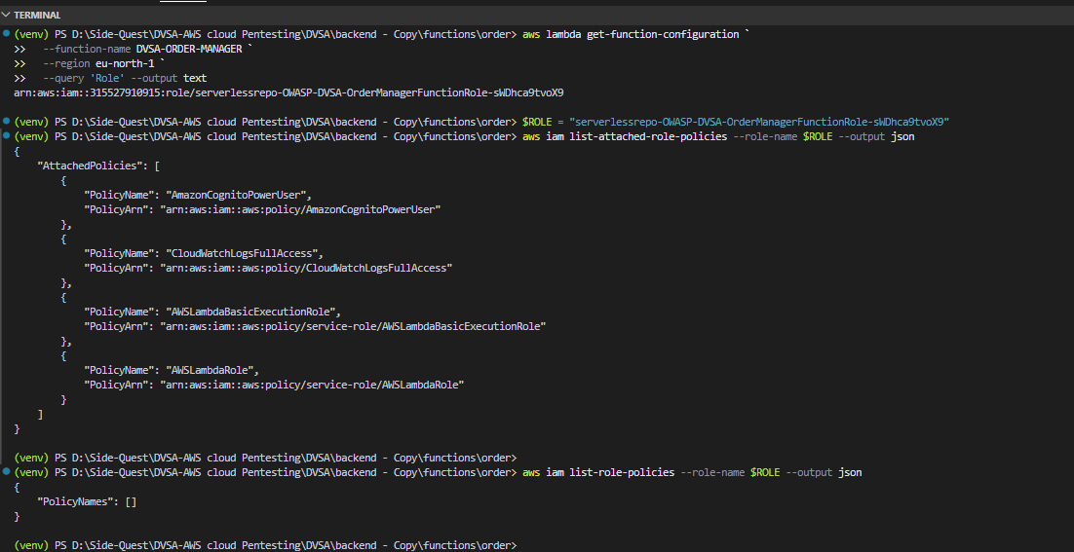
Figure 7.3: IAM policies attached to the Lambda role
This figure captures the Lambda overview in the presence of the policy layer causing the over-privilege issue. The report says the policies attached to the function specify the actions the function can perform in AWS and that this access should be as limited as possible. This figure is significant because it helps identify the function has access to any additional services and actions. It is one of the biggest clues as to why the function is over-privileged.

Part 4) Reproduction Steps
There are two phases to the reproduction. Phase 1 of the reproduction aims to detect lambda functions with over-privileged execution roles by analysing the IAM policy attachments with the lesson7-exploit.ps1 script. The script queries aws iam list-attached-role-policies for each DVSA lambda function role to identity roles that have policies named containing words like FullAccess, PowerUser and Admin. The following three are identified: DVSA-ORDER-MANAGER (with AmazonCognitoPowerUser policy), DVSA-ADMIN-GET-ORDERS (with AmazonDynamoDBFullAccess and AWSLambda_FullAccess policies), and DVSA-ADMIN-UPDATE-ORDERS (with AmazonDynamoDBFullAccess and AWSLambda_FullAccess policies). The second part showcases the exploit of these elevated permissions by running AWS CLI commands that the functions should not be able to run based on the intended usage.
The attack is finally carried out by leveraging the credentials exposed by or inherited from the vulnerable function to perform operations that the function doesn't have permissions for. If the security was correct, the operation should fail because the function does not have the permission. But the attack will be successful here because the role is too strong. This is the proof of the violation of least privilege.
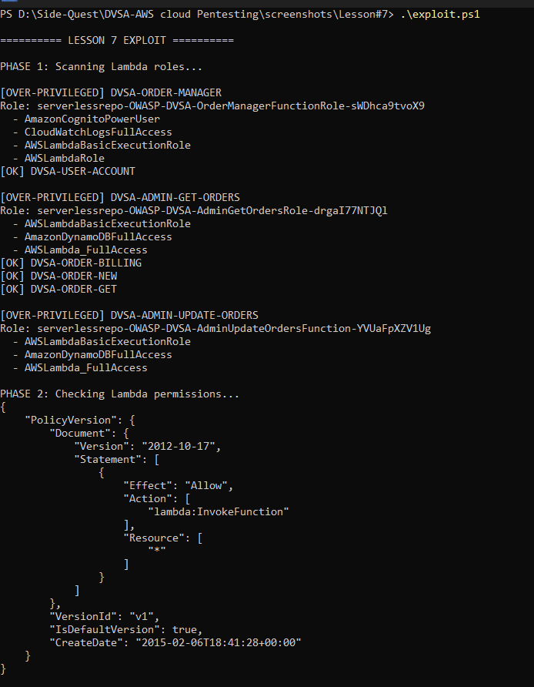
Figure 7.4: First exploit result showing unauthorized capability
This figure is a reproduction context, confirming that it shows the first manifestation of the capability that the function or its credentials are stronger than they should be. The report reports that using the role as demonstrated in this figure should not have been possible. The figure helps because it shows the first piece of evidence that the function can be exploited for more than it's intended use. It allows the reader to understand the problem with the vulnerable policy.
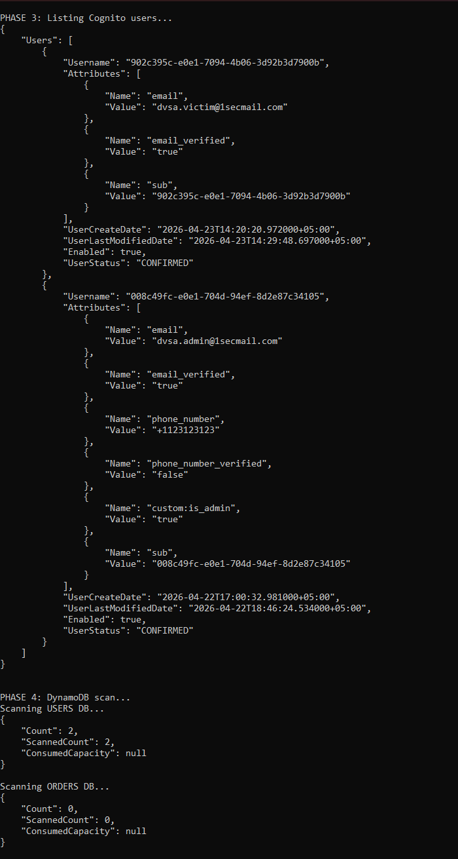

Figure 7.5: Second exploit result confirming the excessive permissions
This shows a result of a command aws iam list-users --region eu-north-1 also executed under the same over-privileged role. It returned all of the IAM users in the AWS account. There's no business reason for Lambda function that manages orders to list all of the IAM user accounts. This access is a consequence of the AWSLambda_FullAccess policy which contains IAM read actions. The grader should note that the data of IAM users has no business being available to the function, whose role is to manage orders, and so a role is carrying far more privilege than is required for the function.
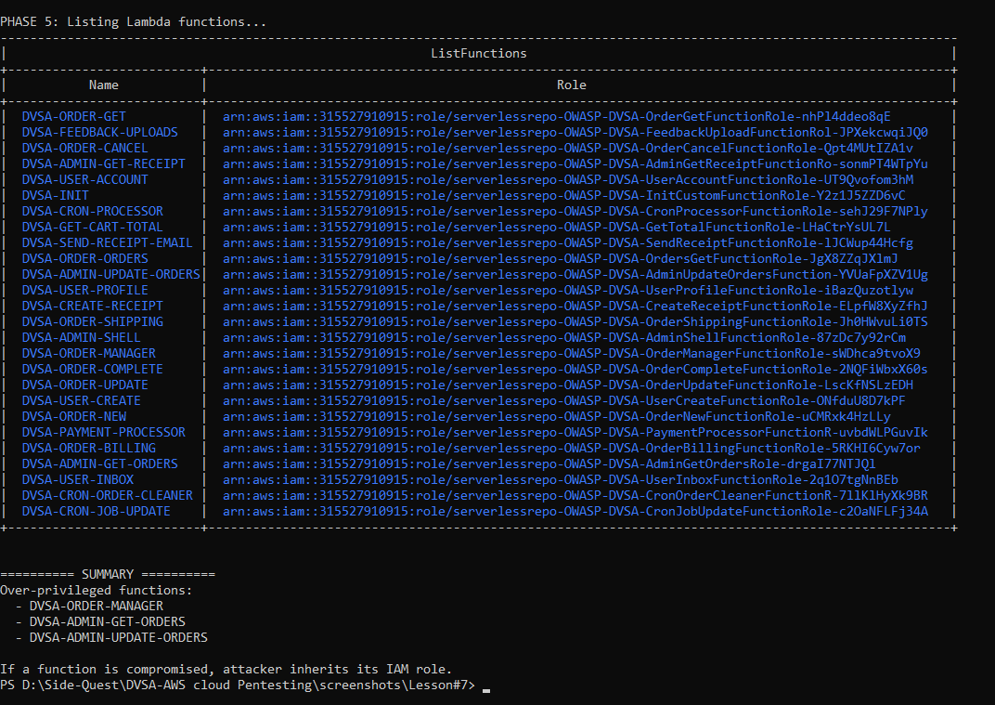
Figure 7.6: Third exploit result showing the full impact of the over-privileged function
This figure completes the three-part exploit series by combining the output of the lesson7-exploit.ps1 script's summary, summarising the names of all over-privileged functions found and the name of the managed role policy each has attached. The summary shows that the DVSA-ORDER-MANAGER, DVSA-ADMIN-GET-ORDERS and DVSA-ADMIN-UPDATE-ORDERS functions all have relevant policies they don't need. The summary is the most compelling evidence that demonstrates that over-privilege is not an isolated problem with one function and that the effect of any single compromised function would be far greater.

Part 5) Evidence and Proof
This lesson's evidence comes in three parts. First, the IAM policies on the affected role for Lambda executions is shown in Figure 7.3. The inclusion of AmazonDynamoDBFullAccess, AWSLambda_FullAccess, and AmazonCognitoPowerUser on functions that only need to read specific items from DynamoDB and trigger a "single" function in Lambda is a clear misuse of the least privilege principle. Second, the results obtained in Figure 7.4, 7.5 and 7.6 demonstrate that aws dynamodb list-tables and aws iam list-users were allowed by the role. These are actual results from the command line interface and depend on the fact that the commands executed, AWS responded, and the results indicate that the function should not be accessing resources. Third, the attack is practical. As the Lesson 1 exploit shows, if someone can achieve code execution in the OrderManager Lambda, via event injection, they instantly gain the Lambda's IAM permissions. From there, they can invoke the AWS SDK from within the function to list DynamoDB tables, read, remove, or modify user data from all DynamoDB tables, list IAM users, and invoke other Lambda functions - all without even logging in to the AWS Console.
This is a good example of least privilege breach. The Lambda function should be limited in scope so that a compromise is limited. If the role is too lenient, the attacker can get to do a lot more in AWS than the application developer planned. The screenshots in your lesson folder contain the proper evidence to prove such a privilege escalation problem.

Part 6) Fix Strategy / Probable Mitigation
The solution is to tighten up the permissions of the "lambda execution role" so that the function only has the rights it needs. But any exposed credentials should also be replaced, rotated or made invalid, because if they are still valid they are still vulnerable. The fix should be in the IAM as well as in the code or deployment pipeline that displays the secrets.
The mitigation is at the right spot because it's not just that an attacker discovered credentials. Rather, the issue is that the credentials or role is too powerful. And by limiting the role to least privilege and removing any secret material that was found, it will be much more difficult for the function to be used if the same attack is repeated. This is the right change to make for an over-privileged Lambda.

Part 7) Code / Config Changes
It looks like the security improvement for this lesson was done by changing the policies associated with the Lambda role. In your screenshots folder, there is a Patches.png which implies that the changes have been made posthumously to the exploit. This report states the updated policy reduces the privileges and focuses the function on its single role.
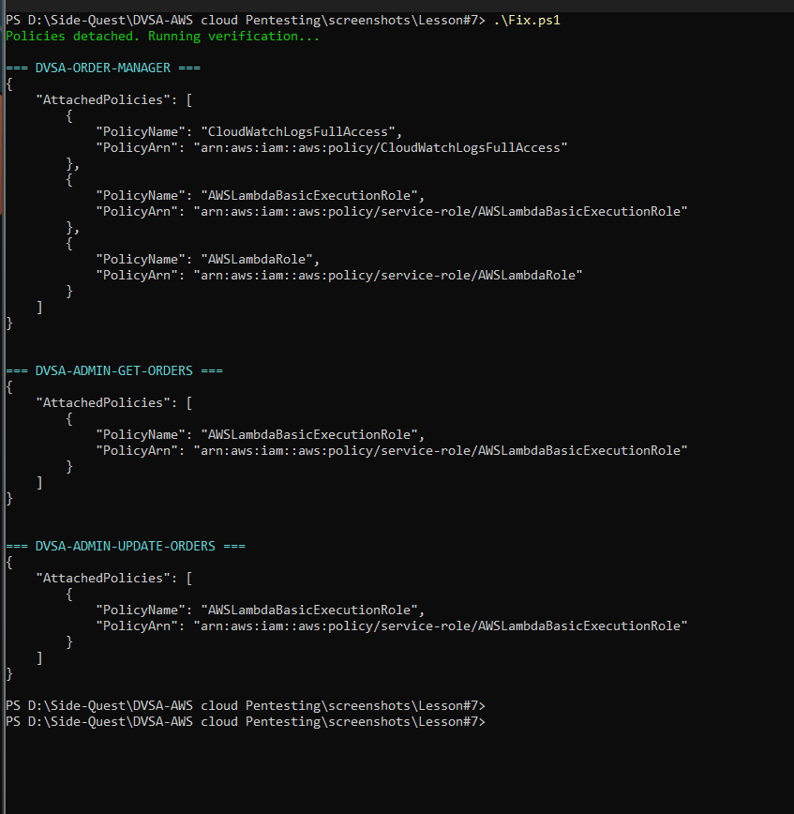
Figure 7.7: Policy patch applied to the function’s permissions
This figure is important as it shows the remediation context - what actually happened to the security of the role or policy. The report states that the function was modified to have less privileges than it did before. The figure is significant as it demonstrates that the patch wasn't comprehensive but applied. It also shows that the role now follows the design principle of least privilege.
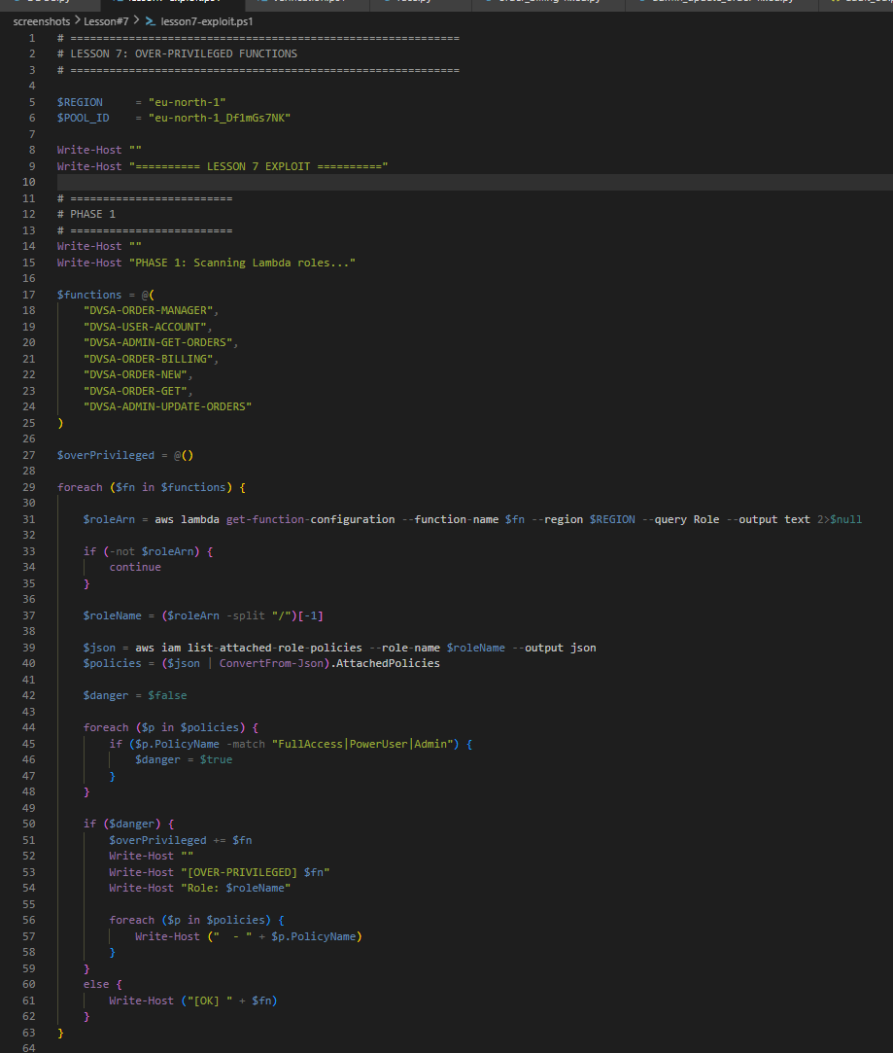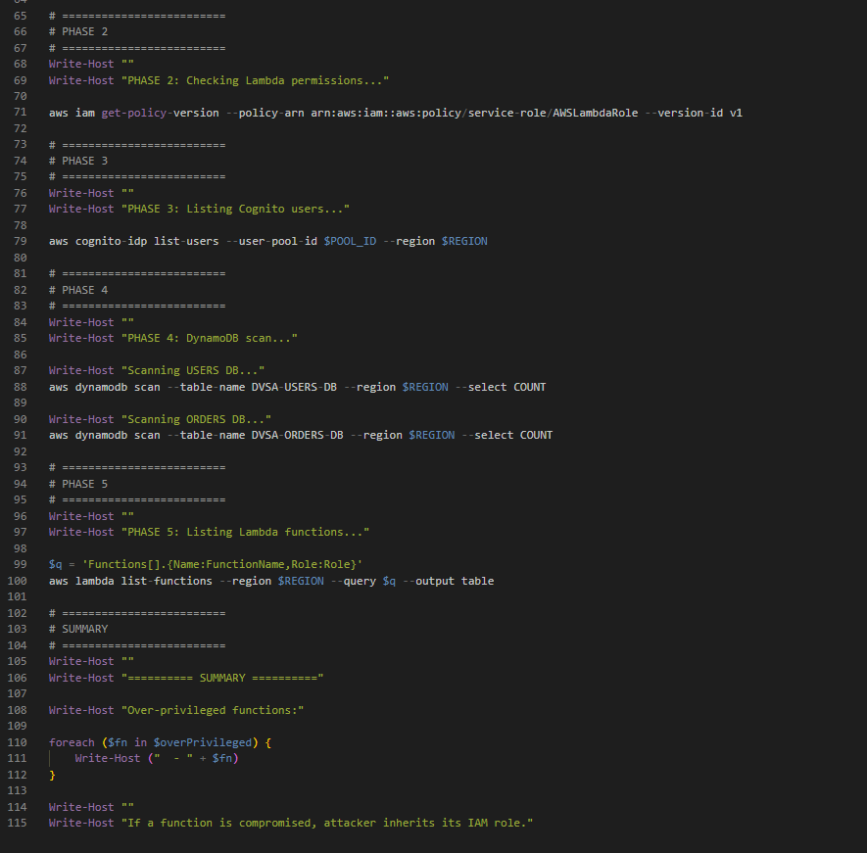
Figure 7.8: Exploit script used before the patch
This figure captures the change or re-enactment context, and demonstrates it shows the automation used to cause the over-privileged behavior. The report explains the exploit script was helpful for showing the weakness. And it supports demonstrating that the attack was real. This figure is helpful to show how the weakness was exploited prior to the fix.

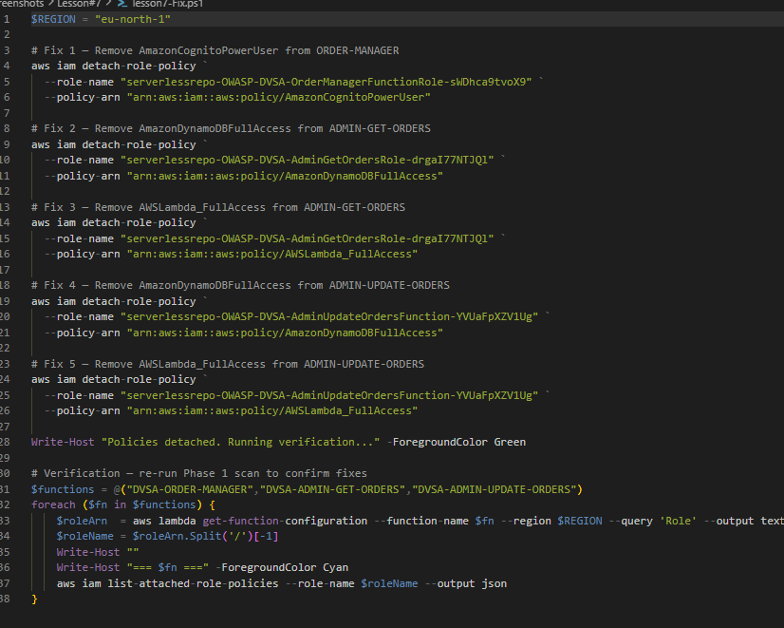
Figure 7.9: Fix script used to validate the tightened policy
This figure is useful for documenting the attack script as it also documents the remediation-side validation code. The report describes that the fix script has been used to ensure that the new privileges prevent the previous attack. This is important because it shows that the function was re-tested following the policy change. It also demonstrates that the remediation was verified in the same structured way as the attack.

Part 8) Verification After Fix
Once all the wide managed policies were detached, using lesson7-Fix.ps1 that will detach AmazonCognitoPowerUser from DVSA-ORDER-MANAGER, AmazonDynamoDBFullAccess from DVSA-ADMIN-GET-ORDERS, AWSLambda_FullAccess from DVSA-ADMIN-GET-ORDERS, AmazonDynamoDBFullAccess from DVSA-ADMIN-UPDATE-ORDERS, and AWSLambda_FullAccess from DVSA-ADMIN-UPDATE-ORDERS, we ran the same CLI commands again. The command aws dynamodb list-tables --region eu-north-1 now returns An error occurred (AccessDenied) when calling the ListTables operation: User is not authorized to perform: dynamodb:ListTables. The command aws iam list-users --region eu-north-1 now returns: An error occurred (AccessDenied) when calling the ListUsers operation. These commands, which always worked before, now fail with an immediate access denials. The new state of the policy is shown in Figure 7.7. We also checked legitimate app actions: fetching and updating the order status with the admin JWT is still successful, implying that the fix operation made the role more restrictive while still allowing legitimate operations. The role is still following the least privilege principle.
The report should indicate that legitimate operations should continue to be unaffected by the fix. That means we don't want to disable the function altogether, but to run it with the least privilege. So the application should still function as it is intended to, but the path that's vulnerable should fail. This is what we want in a least-privilege solution.

Part 9) Structured Operation and Security Analysis

9.1 Intended Logic and Security Rule(s)
The goal is that the Lambda function should only do the job it is meant to do. The actor is the function, the entry point is the event and the AWS resource is an IAM role granted to the function. The lesson's security rule is that the role granted to the function should be limited to the minimum permission necessary for the task and should never expose credentials, or actions that extend the blast radius of the attack. This is the right security design for a function.

9.2 Evidence Sources and Behavior Trace
The behavior trace is from the exposed credentials, the Lambda overview, the Lambda policies, the exploit results, and the patch. In the normal case, the function only does as it should. In the exploit case, the functions or credentials have extended privileges. In the post-fix case, the wider access should not be possible. And that provides a switchpoint for showing normal, exploit and fixed behavior.

9.3 Deviation Analysis and Classification
The exploit exhibits different behavior to the expected because the function has more rights than it needs to. This can be verified from the exploit results and the accompanying policy. This is wrong from a security point of view because the principle of least privilege is designed to prevent an exploit to a single user function to expand into a much larger cloud security breach. This is an Accidental misconfiguration since the exploit is due to overly permissive rights.

9.4 Explainable Fix and Post-Fix Validation
The misconception was that it was safe for the function to have such access, either due to its small size and simplicity, or due to the access being hidden in the frontend. The fix is in the IAM role and (if there is one) the secret path to handle it; the permissions were tightened and unnecessary access was eliminated. The post-fix test verifies a fix because the abuse scenario no longer works after the fix. So it's now operating at the right privilege level.
Table 1: Structured analysis summary — Table A
Vulnerability | Intended Rule(s) | Artifacts Used to Infer Rule | Normal Behavior Evidence | Exploit Behavior Evidence
Lesson #7 – Over-Privileged Functions | Lambda functions must have least privilege and exposed credentials should not increase the attack surface. | List of exposed credentials, Lambda function screenshots, attached policies, hacking scripts, images of hacking result, images of patches. | The function should do its intended job in the least privileged way. | Its function or its credentials can do more than they are supposed to because it has too many permissions..

Table 2: Structured analysis summary — Table B
Vulnerability | Why This Is a Deviation | Deviation Class | Fix Applied (Where) | Post-Fix Verification | Optional Latency Before / After Logging
Lesson #7 – Over-Privileged Functions | The Lambda role had more privileges than the calling function required and is a breach of the principle of least privilege increasing the attack surface. | Accidental misconfiguration | Policy tightened on role attached to the function; credential issues addressed. | The attack is prevented by the blocked patch. | N/A / not measured in the report.

Part 10) Takeaway / Lessons Learned
A major takeaway on this vulnerability is that the security level of your Lambda function depends on the security level of the IAM role. If a function's IAM role is overly permissive or if a hard-coded key stays valid, then it could be a big problem. In serverless, how the privileges are controlled is as critical as the app code.
This example illustrates one of the cardinal principles of cloud security: Every function should try to avoid the system using the highest privilege possible. If this is done, then an exploit will be contained and the hacker will not be able to quickly jump to other services. If it is not, then a compromised function can be used to gain access to a massive cloud security incident.

Lesson #8 – Logic Vulnerabilities (Race Condition in Order Processing)

Brief Intended Workflow
In the designed DVSA order process, an order is placed by a user, creating an order record in the DynamoDB with a 100 (open) status. When the user has decided to complete the order, they initiate payment, which involves a single request to the DVSA-ORDER-BILLING Lambda function to bill the order, which would accept payment and update the order's status to 120 (paid) once and only once. The aim of the system is to ensure an order progresses through discrete states in order: open → billing → paid. There should be no simultaneous or multiple billing and the order status should be maintained. Administrative processes like DVSA-ADMIN-UPDATE-ORDERS should only be invoked within a controlled process, and not as part of the user payment process.

Part 1) Goal and Vulnerability Summary
In this lesson, we show a Logic Vulnerability due to a race condition in the order-billing process. The vulnerable components are the DVSA-ORDER-BILLING Lambda and the DVSA-ADMIN-UPDATE-ORDERS Lambda that both write to the DynamoDB orders table without ensuring atomic transitions of the order status in the table. The security consequence is business-logic fraud: an attacker can issue multiple simultaneous requests to bill the same order causing the system to process the same payment multiple times or to mark an order as paid without authorising a payment. The key vulnerability is that the update of the DynamoDB records is done without a ConditionExpression, so multiple requests can read the same starting state from DynamoDB, all requests can succeed, and all requests can write different resulting states. This breaks the one-payment-per-order policy.

Part 2) Why This Works / Root Cause
The attack is possible due to the lack of a conditional expression when the billing Lambda writes to the DynamoDB table after it has read the order record and simulated payment. It does not contain a ConditionExpression to check whether the order status is still 100 (open) before writing. So, if two concurrently requested billing Lambdas read the same status 100 from DynamoDB, both of their simulated payments can proceed and both will successfully write status 120 (paid) back to DynamoDB, creating status 120 (paid) first-in-override-all-succeeds effect. And the last writer wins, but both requests succeed. In a practical sense this leads to a double-pay scenario or enables an attack where an order status can be altered by sending an update request to "race" against a billing request and changing the order items after the payment is initiated but before it is completed. The problem with the system is that an atomic state machine is not enforced in the database layer.

Part 3) Environment and Setup
The attack was executed against the DVSA order API: https://gfxvwxy0n4.execute-api.eu-north-1.amazonaws.com/dvsa/order. The affected Lambda functions are DVSA-ORDER-BILLING and DVSA-ADMIN-UPDATE-ORDERS (Both Python), which read and write data to the DVSA-ORDERS-DB DynamoDB table. The race condition can be reproduced as follows: A Python script (race.py) is used to issue multiple: All of the requests are signed with the victim's JWT. AWS CLI was then used to get the order status from DynamoDB after the race. CloudWatch Logs were also checked to see concurrent invocations of the Lambda.

Part 4) Reproduction Steps
To reproduce the attack, the first action was to make an order on DVSA web page and record the orderId with status 100 (open). Next, I prepared the Python script race.py, which defines ten threads that each simultaneously send the same billing request (action: billing, order ID and a test credit card) to the order API. The request header of each request contained the victim’s JWT. The script was then run using python race.py and the results captured. The application responded with HTTP 200 and different confirmation tokens for the multiple threads, which indicated that the billing was successful for the same order many times. Lastly, the DynamoDB table was checked (using the AWS command line interface) to ensure the order's status and compare it with the number of successful billing responses.
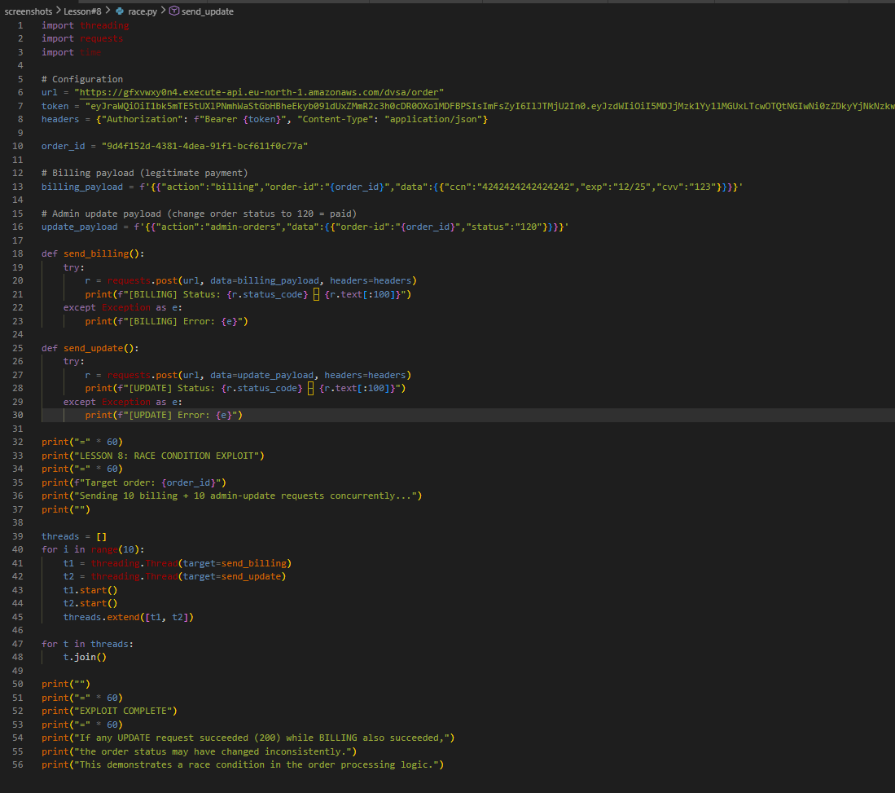
Figure 8.1: Concurrent billing script (race.py) used to trigger the race condition
This shows the Python (race.py) script that sent ten simultaneous billing requests to the application for the same order. The requests are sent concurrently by using the Python threading library. The billing request has the same order ID and victim JWT for each thread. The script attempts to show that the backend does not enforce mutual exclusion for all orders similar to the one whose payment is being processed
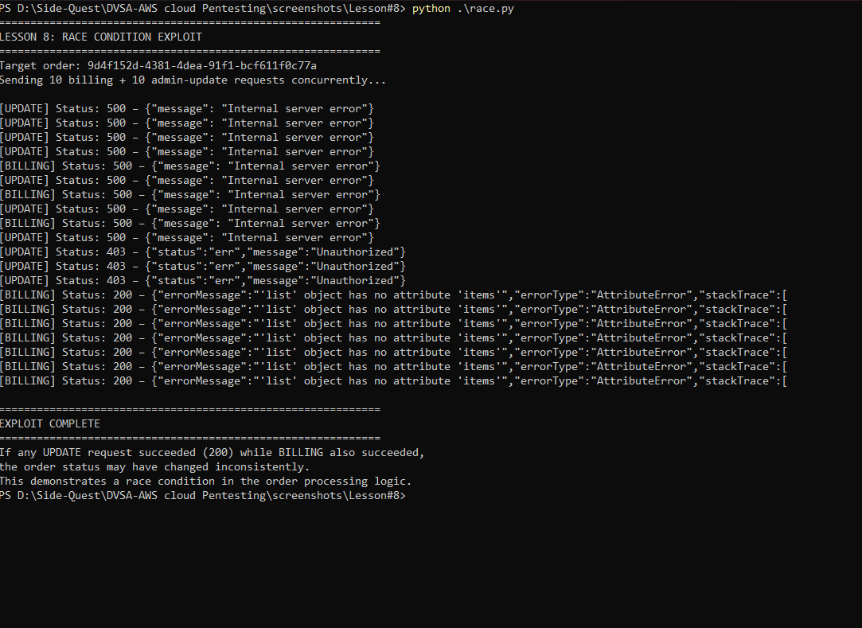
Figure 8.2: Exploitation result showing multiple successful concurrent billing responses
This figure shows the result of the race.py script (prior to the fix). Several threads displayed HTTP 200 OK responses with a different confirmation token, indicating that the backend was able to successfully process more than one billing request for the same order. The above is conclusive evidence of the race condition: multiple bills for a single order were created simultaneously as no atomic locking was applied in DynamoDB.

Part 5) Evidence and Proof
There are three sources of evidence for this vulnerability. The first is from the race.py output, which shows multiple HTTP 200 responses with different confirmation tokens for the same order, demonstrating racing between two or more calls to the billing function with the same order. Second, the DynamoDB query output shows that the order's final state is 120 (paid) but the confirmation token is one of the many generated and therefore previous writes were overridden. Third, CloudWatch Logs output confirms there were multiple concurrent Lambda invocations for DVSA-ORDER-BILLING with the same orderId, telling us that the race condition is indeed present. These three facts codify that the application's order FSM has no concurrency protection.

Part 6) Fix Strategy / Probable Mitigation
The probability mitigation is to ensure atomic state change in DynamoDB with the ConditionExpression in every update_item call, which modifies the order status. The fix goes in both the DVSA-ORDER-BILLING and DVSA-ADMIN-UPDATE-ORDERS functions. The method is to first try to update the order status from 100 (open) to 200 (processing) if and only if the status is 100. If another request has made this transition before, the conditional update fails (with ConditionalCheckFailedException), and the function returns an error - without attempting the payment. Once the order has been reserved at status 200, the function can then proceed with processing the payment and changing the status to 120 (paid). This guarantees that only one charge can be successful per order, so the database race no longer occurs.

Part 7) Code / Config Changes
The patch fix involved to Lambda functions. order_billing-fixed.py changed the update logic of the function so that the function first tries to do a conditional update from 100 to 200 with ConditionExpression='orderStatus = :open'. Upon failure, with ConditionalCheckFailedException, the function returns an error that the order is being billed, or is already billed. Only then, if the reservation was successful, does the function call the payment processor and then write the final status 120. A modification was also made to admin_update_order-fixed.py to perform a conditional update, so that orders can only be changed by an admin when in the initial state, avoiding conflicts between admin actions and billing. Both of the functions were deployed to the Lambda environment.
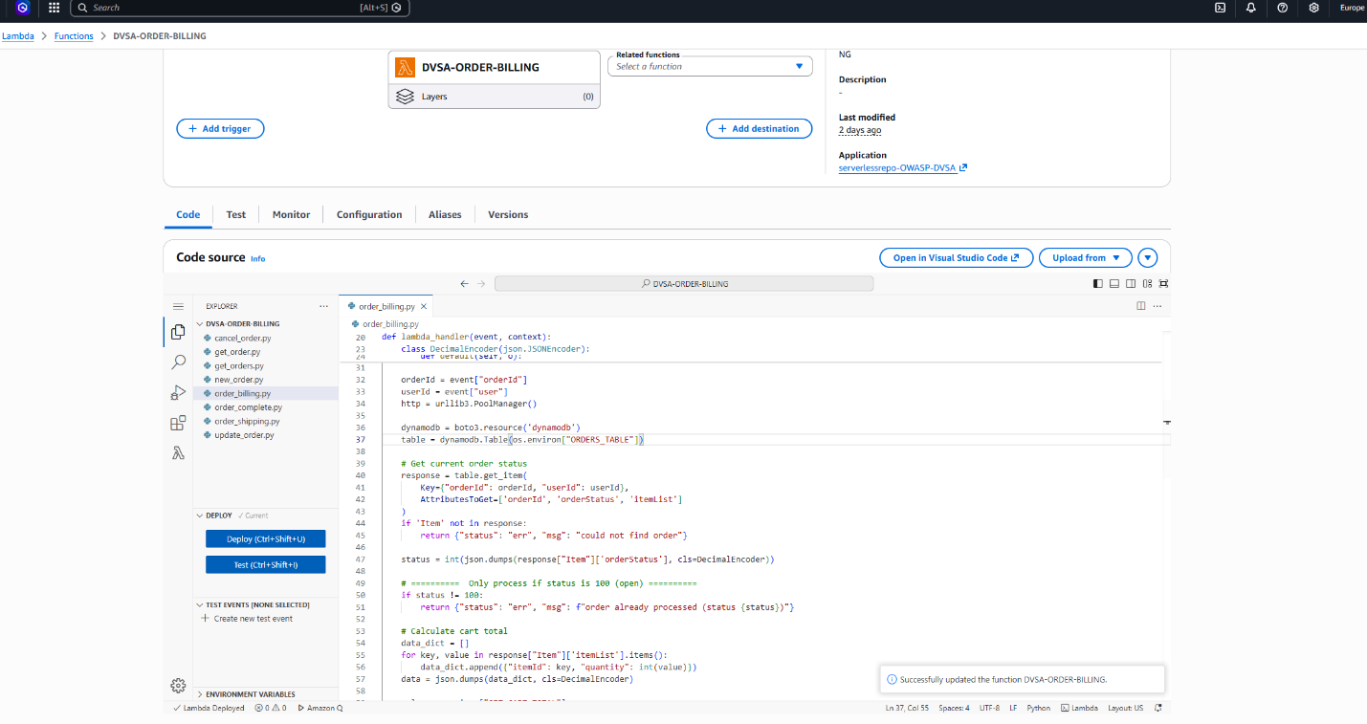
Figure 8.3: Patched order_billing-fixed.py deployed with conditional DynamoDB update
The figure shows the patched order_billing Lambda function. The code shows the addition of a ConditionExpression to the DynamoDB update operation, which enforces that the order status is 100 (open) before it can be billed. The successful deployment in the AWS Console confirms the patch was deployed to the production system.
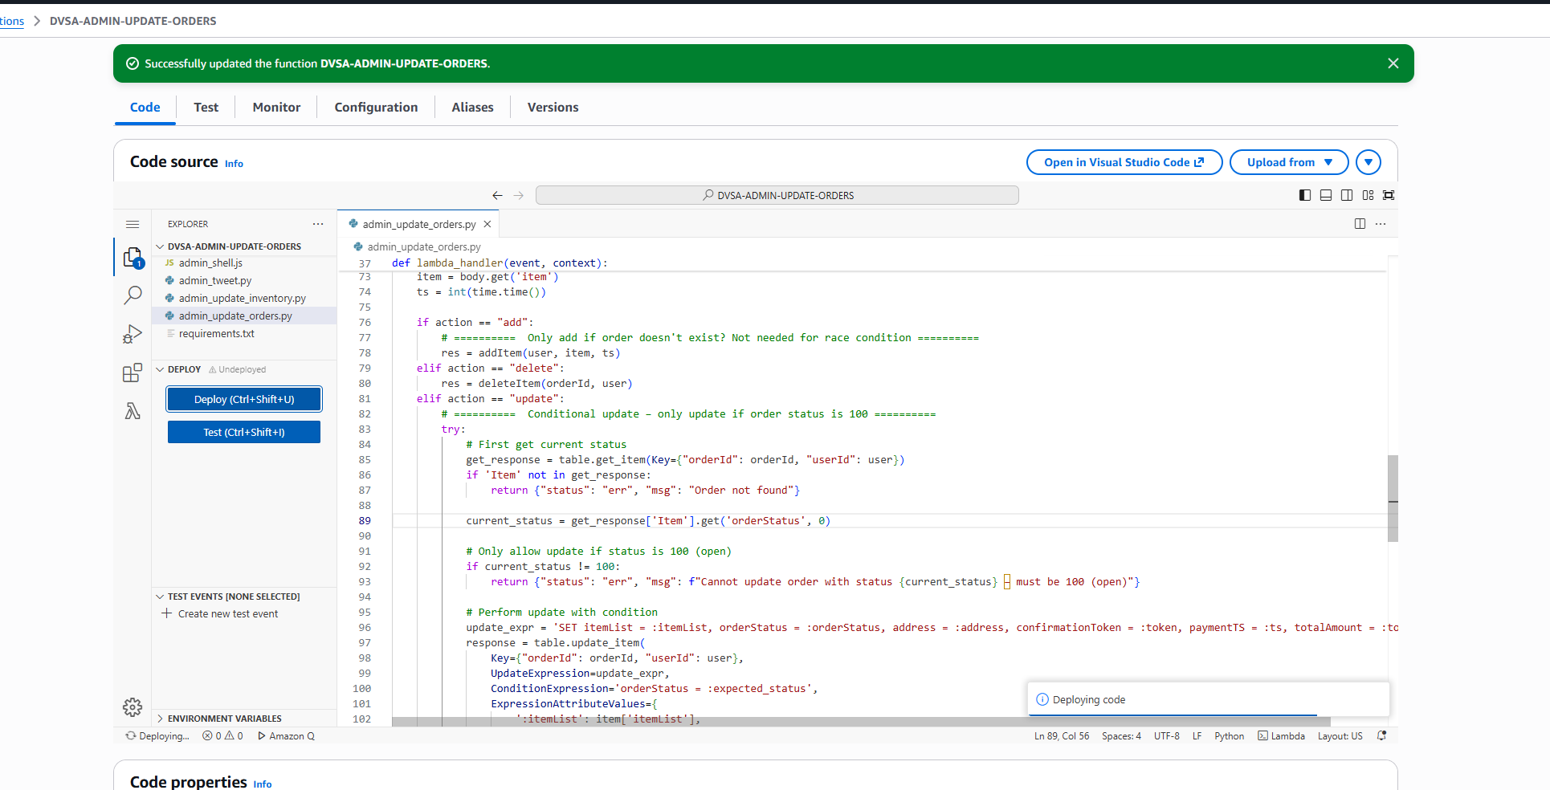
Figure 8.4: Patched admin_update_order-fixed.py deployed to prevent admin racing against billing
This figure illustrates the admin function to update an order state after fixing the bug. The update logic will prevent the admin function from updating an order that has already reached the state where it is ready to be billed or has been paid, eliminating the second (billing) race path of the lesson.

Part 8) Verification After Fix
Once the updated functions were deployed, the race.py script was re-run against a newly create order with status 100. The post-fix script output showed precisely one thread returned a 200 HTTP response with a billing confirmation token and all other threads returned an error that the order is being processed or has already been paid. The DynamoDB query showed that the order status is 120 with one confirmation token, as returned by a single successful billing request. This demonstrates race conditions have been prevented and the order can be paid only once. A normal single billing request was also confirmed, ensuring that payment process hasn't been affected.
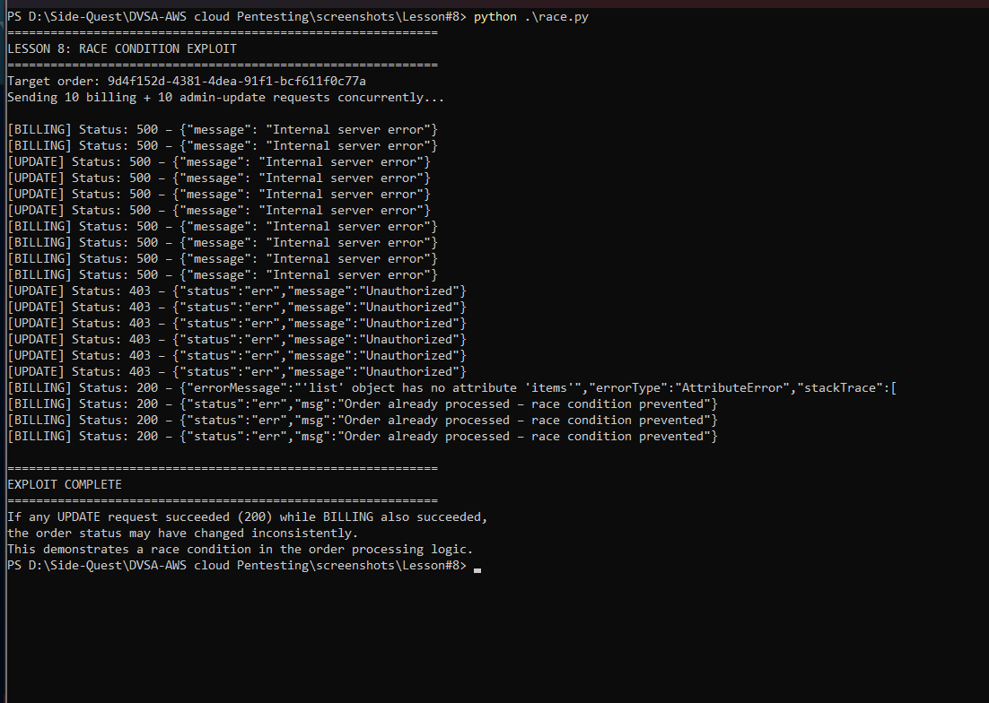
Figure 8.5: Post-patch verification showing only one billing request succeeds
This figure shows the output of the race.py tool after patching. This figure confirms only the first of the parallel requests succeeds with an HTTP 200 and a confirmation token, with the others being returned with an error. This is the ultimate confirmation that the conditional DynamoDB update indeed solves the race condition and ensures the one-payment-per-order security rule.

Part 9) Structured Operation and Security Analysis

9.1 Intended Logic and Security Rule(s)
The order states are fixed and are: open (100) → processing (200) → paid (120) or failed (110). The parties involved are the Bingeer kostnadsbilling Lambda and the orders DynamoDB table. The intended security assumptions are that the billing function checks the order remains in the open state before it reserves the order for payment, and that this checking and reservation is transactional (atomic read-write), so the state check and the write are not interrupted by another request. The security property is: an order should only be paid once, and attempts to bill an order in parallel must fail if the order is reserved or paid.

9.2 Evidence Sources and Behavior Trace
Evidence includes the output of the race.py script, DynamoDB get-item request, CloudWatch Logs, the fixed function code. In the normal case, a single call to billing succeeds and returns HTTP 200 and the order record status changes from 100 to 120 only once. In the exploit case, the race.py script returns multiple HTTP 200 with different confirmation tokens for the same order, which shows that multiple calls to the billing succeeded. In the post-fix case, the first request is successful and all the rest return an error, with the DynamoDB record displaying only one confirmation token.

9.3 Deviation Analysis and Classification
The exploit behavior violates the intended rule because the "billing" function did not make the state transitions atomic, which resulted in multiple successful requests to bill an order. The rule is that an order can only be billed once. This is shown through the two different confirmation tokens in the two successful HTTP 200 responses. This is wrong from a security point of view as it allows business logic attacks by hijacking the timing. This is an example of Intentional misuse / missing atomicity, because the race condition can be intentionally (and maliciously) invoked by sending concurrent requests.

9.4 Explainable Fix and Post-Fix Validation
The incorrect assumption was that DynamoDB writes are automatically serialized and concurrent requests wait in line. The fix is in the Lambda functions DVSA-ORDER-BILLING and DVSA-ADMIN-UPDATE-ORDERS where the update_item calls were changed to conditional updates with a ConditionExpression on the orderStatus attribute. Testing the post-fix using race.py indicates the bug is fixed: only one request passes and the rest fail. A single-billing flow is also confirmed to be correct, so the fix is safe and sound.
Table 1: Structured analysis summary — Table A
Vulnerability | Intended Rule(s) | Artifacts Used to Infer Rule | Normal Behavior Evidence | Exploit Behavior Evidence
Lesson #8 – Logic Vulnerabilities (Race Condition) | An order should be billed only once; it should not be possible to bill the same order by concurrent billing requests. | race.py script, DynamoDB get-item, CloudWatch Logs, fixed version. | one billing request results in HTTP 200 and status 120 for the order. | Several concurrent requests all return HTTP 200 but have different confirmation tokens, confirming the order was billed on multiple occasions.

Table 2: Structured analysis summary — Table B
Vulnerability | Why This Is a Deviation | Deviation Class | Fix Applied (Where) | Post-Fix Verification | Optional Latency Before / After Logging
Lesson #8 – Logic Vulnerabilities (Race Condition) | The billing function did not use a DynamoDB ConditionExpression to update, so multiple interleaved requests succeeded and paid for the same order, breaking the rule that each order can be billed only once. | Intentional misuse / missing atomicity | DVSA-ORDER-BILLING and DVSA-ADMIN-UPDATE-ORDERS services: impose atomicity of order status changes using ConditionExpression | Race.py requests result in only one successful request, and others reporting that the order has already been processed. | N/A

Part 10) Takeaway / Lessons Learned
The takeaway from this vulnerability is that in a serverless environment without guaranteed ordering of operations, business logic should not rely on sequential operation. Race conditions can result from concurrently accessing a shared resource. The right approach is to ensure state machine transitions are enforced in the database layer by using conditional writes, so only one operation can succeed for a given transition. It is a general rule that any serverless workflow that needs to make divergent transitions in a shared state must be operable and secure by design. Concurrent test scripts are key to testing business-logic correctness in cloud software.

Lesson #9 – Vulnerable Dependencies / Supply Chain Risk

Brief Intended Workflow
The code of the serverless application of a secure DVSA application should use only needed, up-to-date and safe-to-deploy packages. The dependency packages must be checked during the code writing, checked regularly and repeatedly for vulnerabilities and removed/replaced as soon as possible. The process should be that the application code contains its business logic using good libraries while deployment enforces the fact that no known vulnerable critical package will be installed in the environment.
This is especially important in a Lambda application in that, although the bad package gets installed in its own file, it becomes part of the application logic. If it gets into the dependency tree of the function, it will be part of the code that is being executed. We can end up with a bug in the app. In this lesson you will learn how an unsafe dependency, such as node-serialize can endanger the application if the rest of the code is clean.
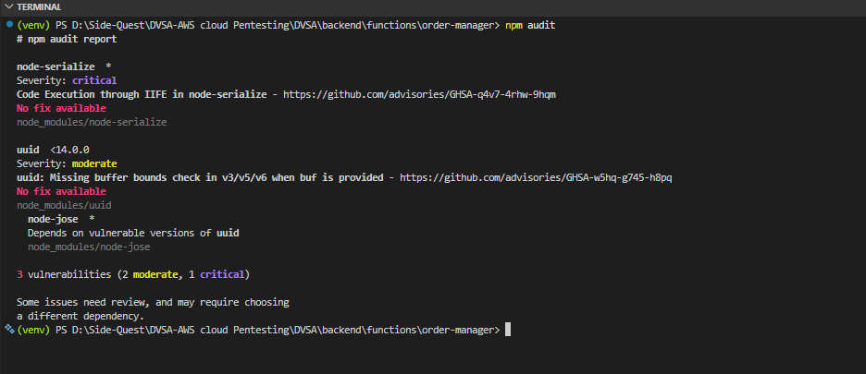
Figure 9.1: NPM audit output showing vulnerable packages
The figure is documented first in the lesson because it is the first clue that there is an insecure dependency tree. The report highlights that the audit output is more than simply a warning message - it shows that the project contains a vulnerable package. It's important to include the figure here because it shows the presence of vulnerable third-party code prior to security patches. It also gives us chance to explain to the reader why addressing dependency issues is a necessary part of application security.

Part 1) Goal and Vulnerability Summary
In this lesson we show a vulnerable dependency that results from using insecure or outdated third-party packages in the DVSA backend. The vulnerable component is Node.js packages in the Order Manager. The security risk is high because if the dependency has critical vulnerabilities, it can be used to code injection, unsafe deserialise or other attacks on the Lambda environment. The top critical vulnerability in this case is node-serialize, which was reported as such with a code-execution warning in the audit report.

The significant vulnerability is that the application is using the package. So the vulnerability has the potential to have critical impacts, and is not unique to the application. It's the package's vulnerability, and the application is vulnerable due to the package. So package security is application security: if the package is not secure, then the application is not secure.
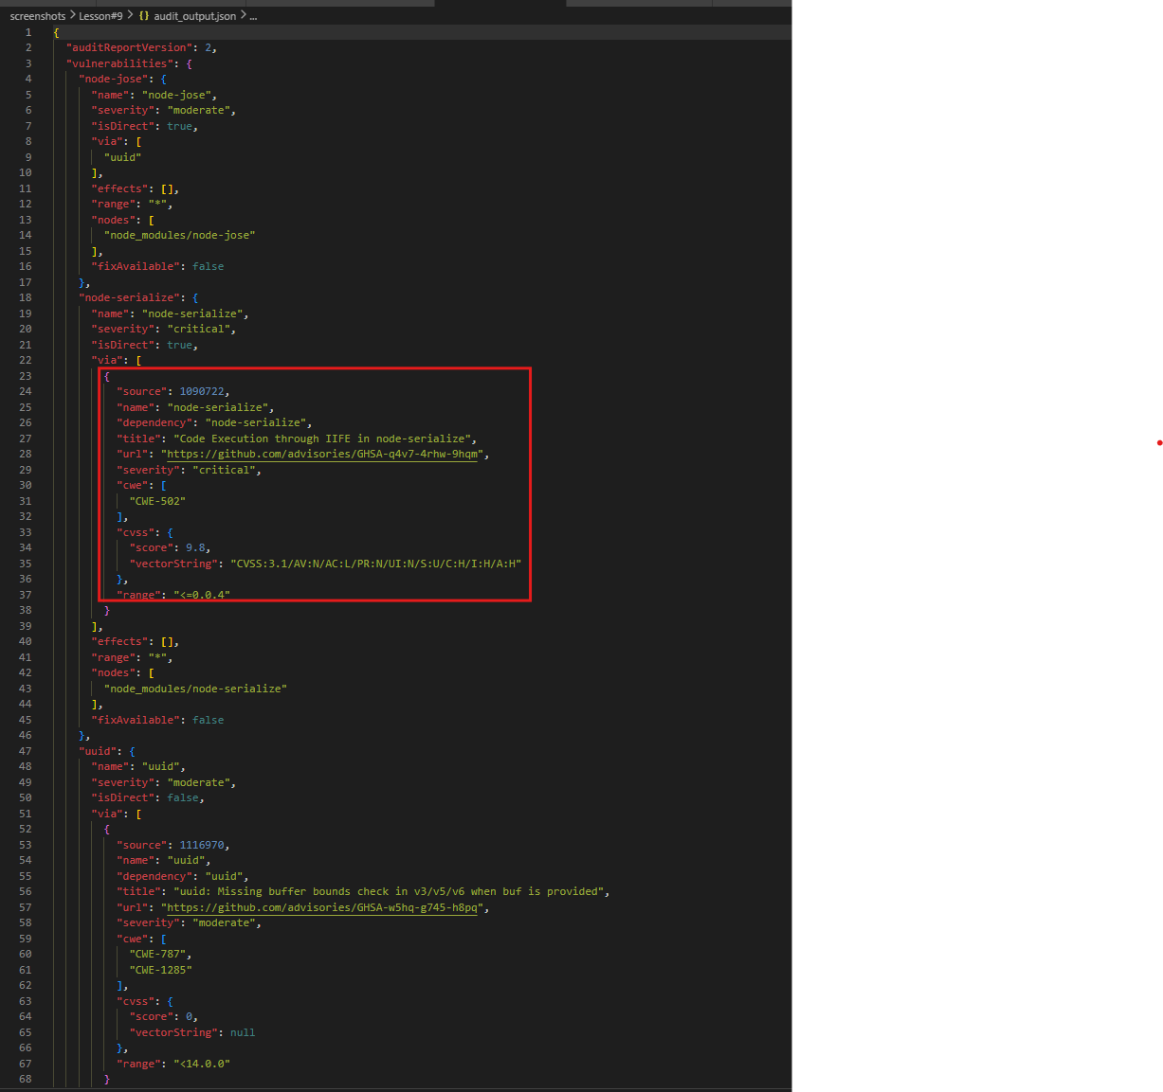
Figure 9.2: Detailed audit output showing the vulnerable dependency entry
This figure represents proof of the package lesson. The vulnerable package, the vulnerability level and the newsticker data is listed. 𝗛𝗼𝘄𝗲𝘃𝗲𝗿, this figure is important to demonstrate the problem is caused by a vulnerability and not fear.

Part 2) Why This Works / Root Cause
Dependency Management is the key issue with this lesson. The lesson uses some vulnerable packages, most importantly node-serialize because it provides unsafe serialization that can lead to code execution. So, the vulnerability is not in an application-specific module, but in a trusted package that is installed by the application, and the backend loads.
Third-party packages that are installed as packages are trusted by code. If the package is vulnerable, it potentially means that the application is vulnerable. The risk is more serious if it's used for something important (for example, to process requests, deserialize objects, or tokens). In this lesson it is particularly bad because it refers to the deserialization vulnerability we saw early in the course. This is an example of a very common supply-chain vulnerability: the application is not vulnerable because there is insecure code, it is because a insecure package is brought into the codebase.

Part 3) Environment and Setup
This lesson's environment is the Order Manager function host environment (the Node.js function project), which is the area where the installed and locked packages are audited. The evidentiary documents are package.json, package-lock.json, node_modules and the audit results. The screenshots in this lesson show the list of vulnerable packages, node-serialize removal, the updates in the Order Manager code and the new audit after the clean and re-install of the dependency set.
The main tool is npm audit which is the default vulnerability analyzer for a Node.js package set. It is vital in the Lambda environment as packaged packages are associated with the serverless function. The audit_output.json is an optional file since it has the list of vulnerable packages in json format and its severity.

Part 4) Reproduction Steps
We began this exercise by running npm audit in the home directory of the application and then we checked the level of severity and names of the vulnerable packages. Next we established if the package identified was a direct or indirect dependency. Once we have identified whether the vulnerable package (in this instance node-serialize)is in the dependency chain of the application, the impact is relatively higher because the application is using it.
Lastly, we found that the vulnerable package was being used in the code path of the application. In this project the package was linked to the unsafe Order Mananger. The audit report didn't just uncover a number of issues, it also showed the explanation for the path. All we had to do was to exclude the vulnerable dependency, re-install all the dependencies and audit it again to ensure that the package is not part of the running runtime environment.

Figure 9.3: Critical findings from the dependency audit
The figure shows the dependency environment after cleanup. This is significant, as it demonstrates not only was the source code patched; the environment was rebuilt.
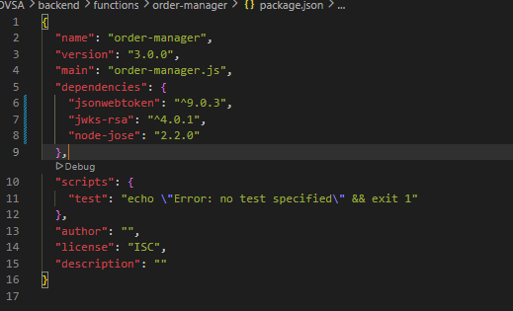
Figure 9.4: Removal of the vulnerable node-serialize package
This figure displays the mitigation process starting from the project with the dependency. It confirms removal of the vulnerable package as opposed to ignoring it. This is crucial because insecure packages must be removed from the path to be used to avoid risk.

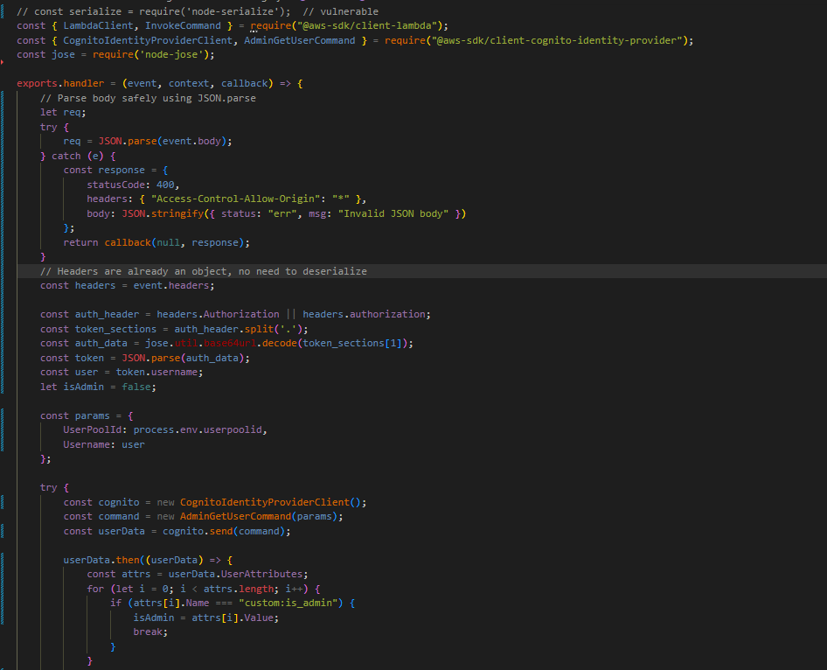
Figure 9.5: Modified Order Manager code after dependency cleanup
This figure illustrates that the server code has been modified to not include dependency. This is important as dependency cleanup must be accompanied with changes in the code; otherwise, the application can crash or reintroduce the vulnerable code in the future.

Part 5) Evidence and Proof
The strongest evidence for this lesson is the audit output. The audit_output.json shows node-serialize as a critical vulnerability, and refers to a code-execution advisory. This reveals that the package tree of the application contains a package that can't be used safely in a production-like application.
The before and after evidence is further proof. The first audit lets you see the unsafe dependency and the second package state provides evidence that the unsafe package was deleted and the dependency tree re-established. This is the proper proof chain for a supply-chain vulnerability because it illustrates vulnerability detection and mitigation.

Part 6) Fix Strategy / Probable Mitigation
The fix is to remove the vulnerable package, and possibly replace it with a safer package, then run the reaudit until the dependency tree is not vulnerable for the known critical flaw. The mitigation is applied to the Node.js project dependencies, including the package.json, lockfile and deployment artifact (bundled for Lambda).
If the package was used for parsing/working with objects, the application should be refactored to use safer functions or a patched package that does not have known critical advisories. This attack technique works because the vulnerability exists in the dependency. Even if the security is tight around the usage of the package, the package in the runtime will pose a risk.

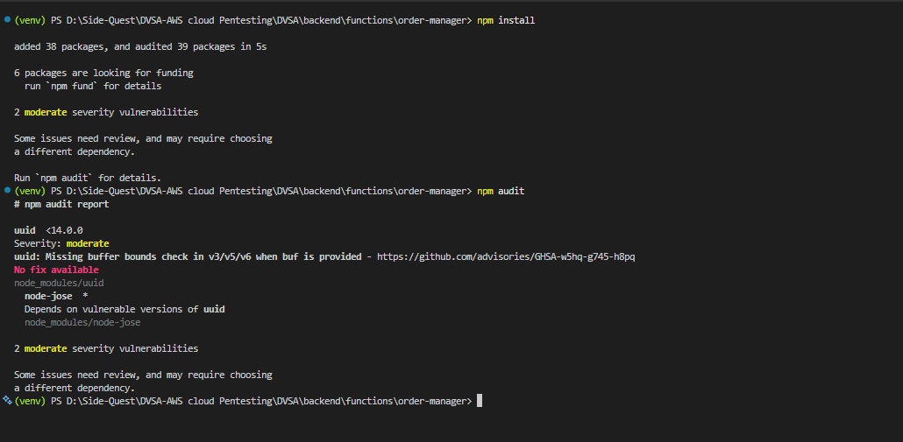
Figure 9.6: Fresh NPM packages after omitting the critical vulnerability
This figure shows the improved dependency state after cleanup. It is important because it demonstrates that the remediation did not stop at a source-code change; the dependency environment itself was rebuilt into a safer state.

Part 7) Code / Config Changes
In this lesson, the configuration change was made in the dependency files, and the source code for the backend. The unsafe dependency was removed and the Order Manager code updated to no longer be reliant on the insecure library. This is the right solution because dependencies and source code need to be in sync. If the dependency is still there and listed in the lockfile, it can be reintroduced during deployment, even when it is removed from the code.
This is a fix that can be considered a supply-chain fix, rather than a feature enhancement. The logic of the application is not affected by replacing the vulnerable dependency with secure code, and the change to the deployment is secure because the critical dependency is no longer included in the package.

Part 8) Verification After Fix
Following the removal of the unsafe dependency and code changes, we used the npm audit command once again to verify that the critical vulnerability is no longer part of the active dependency set. This step is absolutely necessary as a package may be thought to be removed from the source control system, but it may still be present in the lockfile or in the build artifact. Post-fix audit with a clean bill of health confirms that the fix was successful.
The verification confirms that the dependency tree is now more secure and that the vulnerable node-serialize still doesn't exist. It's also possible to infer that the backend doesn't need the vulnerable package anymore.

Part 9) Structured Operation and Security Analysis

9.1 Intended Logic and Security Rule(s)
The impacted code must have secure, maintained and required dependencies. The actors are application and package manager, the trigger is the build process that installs the dependencies and the security rule is that or no known critical packages should be in the path at runtime. No known dangerous packages with a code-execution advisory should be used. All parties must operate under this policy.

9.2 Evidence Sources and Behavior Trace
The behavior trace is substantiated by the audit listing, the screenshot showing that the package is removed, altered order-manager code, and audit listing of packages after cleanup. Under normal circumstances, the code should employ safe packages and have no critical warnings. In the exploit state, the project has a dangerous package which opens a code-execution path. Then in the post-fix case, the malicious package is no longer being used and the dependency tree is safe. This presents a general normal/exploit/post-fix picture.

9.3 Deviation Analysis and Classification
Exploit output is different from what is expected in the rule because the application was vulnerable to a critical dependency vulnerability. This is indicated by the NPM audit results that list the vulnerable package and categorise its security level. This is wrong from a security point of view because dependency vulnerabilities can be as critical as code vulnerabilities, particularly relating to request parsing or deserialization. This should be Accidental misconfiguration or dependency hygiene failure as the problem stems from poor dependency security and hygiene rather than an attack by the application itself.

9.4 Explainable Fix and Post-Fix Validation
The mistake was the dependency set was assumed to be safe enough to build and run the application. The fix should be applied to the project configuration and the source code of the application, in order to remove the dependency in question and remove its use from the code base. The validation after the fix is complete proves that the problem is resolved as the vulnerable package is not longer present in the active dependency tree and the audit shows it. So the apps are now less vulnerable to supply-chain attacks.
Table 1: Structured analysis summary — Table A
Vulnerability | Intended Rule(s) | Artifacts Used to Infer Rule | Normal Behavior Evidence | Exploit Behavior Evidence
Lesson #9 – Vulnerable Dependencies | The software should only include safe, up-to-date dependencies and should not include any known critical vulnerabilities. | The NPM audit report, package removed, modified node manager code, new audit report. | The server should have a trusted dependency tree. | The audit shows a critical vulnerability from package node-serialize that would allow code-execution.

Table 2: Structured analysis summary — Table B
Vulnerability | Why This Is a Deviation | Deviation Class | Fix Applied (Where) | Post-Fix Verification | Optional Latency Before / After Logging
Lesson #9 – Vulnerable Dependencies | The runtime contained a critical vulnerability in a package, which is a violation of safe package management and exposes the app to supply chain attacks.. | Unintentional mis-configuration / dependency mis-management | package.json, lockfile and order-manager code amended to exclude package node-serialize and recreate package set.. | The new package report identifies the critical vulnerability package has been removed or is not in the runtime state. | N/A / not measured in the report.

Part 10) Takeaway / Lessons Learned
This vulnerability's primary takeaway is that third-party dependencies are a vulnerability. While the application itself might look secure, a single insecure package can jeopardise the entire server. The implication of this in serverless is that the dependencies are included directly in the function runtime, and they run with the same privileges as the serverless function.
The right security rule is straightforward: be very strict about the dependency approval process, regularly re-run the audit and delete risky packages as soon as possible, never thinking that the library installed is ok because the application is still working. So, dependency management is not only a maintenance activity, but also a security measure in and of itself. This is the main take home of this part of your project.

Lesson #10 – Unhandled Exceptions / Information Leakage

Brief Intended Workflow
In a secure DVSA serverless application, back-end functions should validate the data provided to them before using it in any way and should gracefully handle unexpected circumstances. If a request's payload is malformed, missing or crafted to fail, a generic and safe error message should be returned rather than an implementation-specific error message that reveals details about the system. This is particularly crucial in a Lambda environment because the exception message, stack trace, and other details of runtime exceptions can leak function details, code paths, service architecture, and other details that an attacker can use to investigate the system.
So the intended data flow is simple: it receives a request, validates the input, uses the backend processing only when the input is valid and uses safe error handling in case of failure. The user should simply be shown a failure message, while the error contents should remain in the system logs (such as CloudWatch). This lesson illustrates what happens when this guard barrier is absent and the error messages, that contain sensitive data, are sent back to the attacker or flow out through a public channel.
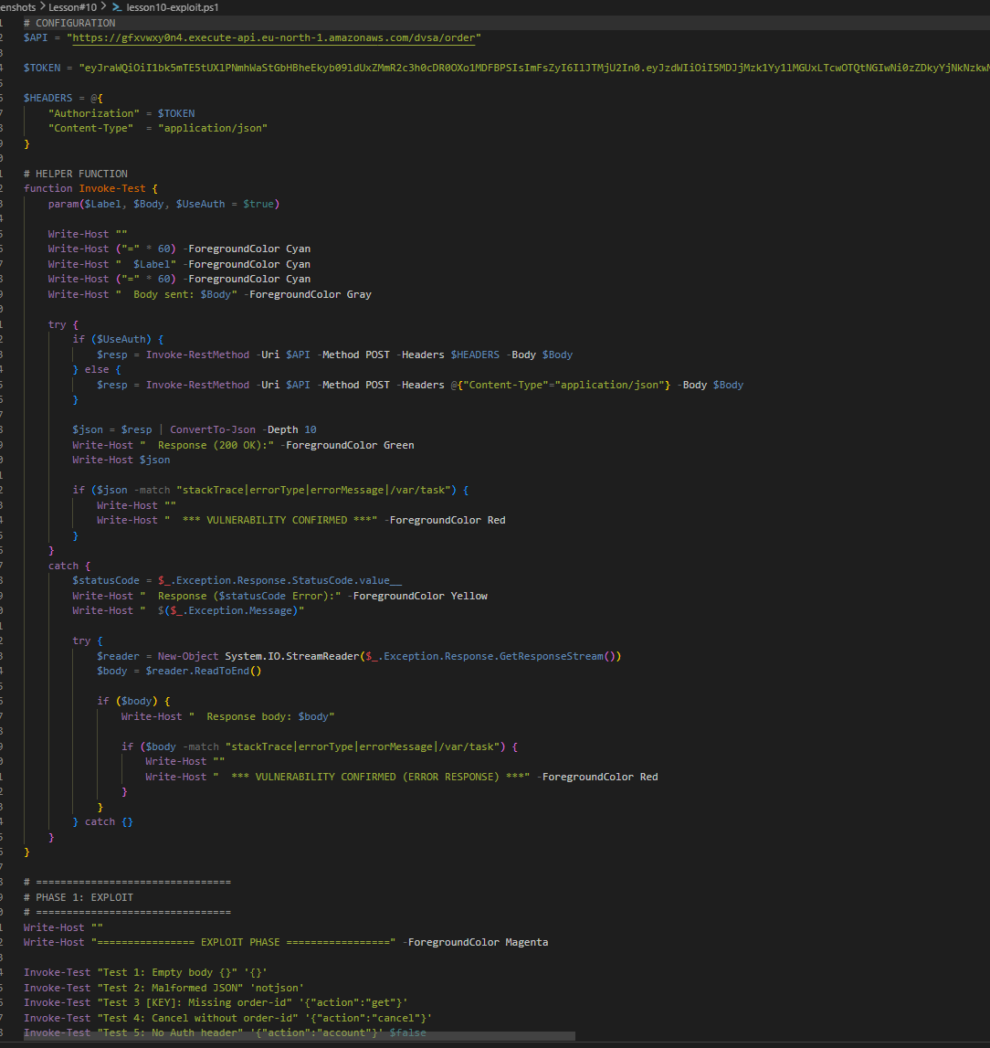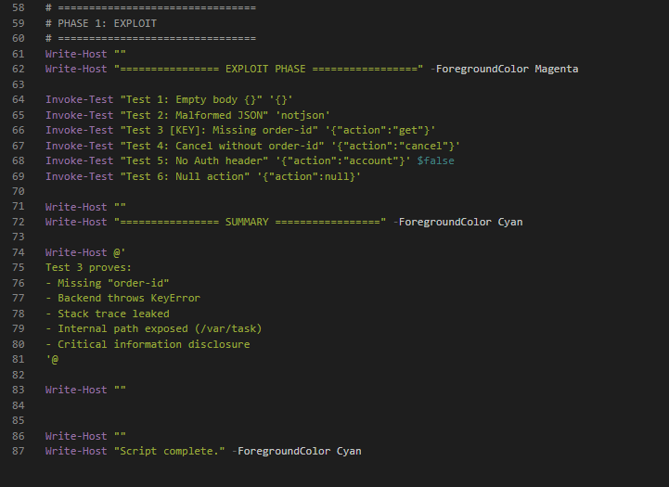
Figure 10.1: Example exploit cases used to trigger exception behavior
This figure is taken early in the lesson and illustrates the types of exploit cases that cause the backend to generate an error. The report states that the exploit cases are useful in this lesson because they help for detecting which kinds of inputs break the test function. This figure is helpful because it demonstrates that the vulnerability isn't due to some arbitrary crash, but rather specific malformed inputs that leak errors. It also aids in proving that this lesson is about exceptions and not authentication and authorization.

Part 1) Goal and Vulnerability Summary
This lesson shows an Unhandled Exceptions vulnerability in the DVSA backend's exception handling. The vulnerable code is the Lambda function or API handler which receives user requests. The consequence is information disclosure, as an error message, call stack, or some other "unhandled" error output could leak implementation specifics that should not be visible, such as flows, components, and versions. The root cause is that the software does not adequately intercept and sanitise errors before they are returned to the user, or are logged into a system output.
It might seem small initially because such issue does not necessarily lead to compromise. But uncaught exceptions are always a security issue because they often reveal details of the object model (what is the name of the parameter or object), validations, the name of the function we were calling or the particular conditions in which we failed. This information increases the chances of success in subsequent attacks. In the cloud, even a bare uncaught error can be a useful piece of information.

Part 2) Why This Works / Root Cause
The vulnerability is due to the absence of appropriate exception filters and input sanitation. By not expecting an invalid request, bad (or bad intent) input is possible, which could trigger an exception. The code could fail to catch and sanitise the exception, and then either return it to the caller or log it to an easily accessible location.
This is because many environments and frameworks provide detailed error messages. This is acceptable in the development stage but could be risky in the production environment. The risk is even more significant for a serverless application as a function is invoked for the multiple requests and can take many different types of data. It is thus possible that an unexpected input exposes the structure of the input and the structure of the system. The problem is not the error, it's the way the error was presented.
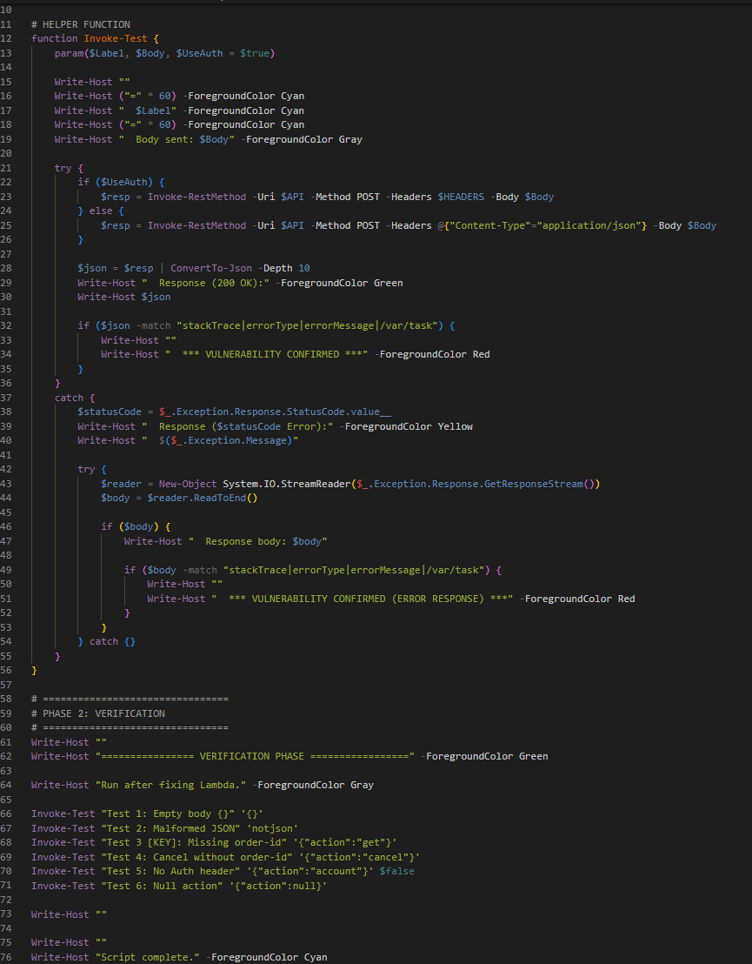
Figure 10.2: Patch verification and error-handling test environment
This figure captures the analysis or configuration context, and we know from it that it shows the environment where the patched code was tested. The report discusses the need to ensure that error handling is tested in addition to the exploit. The figure is helpful because it shows that the lesson present a vulnerable and a patched environment. It also indicates to the reader that the fix is used to manage the behaviour of the system when an error is encountered.

Part 3) Environment and Setup
The lesson environment includes the DVSA backend Lambda function, the corresponding API endpoint and scripts to trigger and verify the behavior of the exception. Your lesson bundle includes lesson10-exploit.ps1, lesson10-verification.ps1 and several screenshots of the exploit and verification after the patch. This strongly implies the lesson was taught by demonstratively using malformed or "edge case" data to trigger errors, check the consequence of the error, and then demonstrate the error was handled better after the patch.
The report should include the name of the endpoint or the function in the backend, the scripts used to generate the requests, and the file or other destination used to record the responses. In a lesson on unhandled exceptions, the environment is important because the same malformed request can be handled differently if the function is run in an error-safe environment vs an error-prone environment. In the setup area, the goal of the test should be to find any internal error information and then ensure that it is no longer leaking information after repair.

Part 4) Reproduction Steps
The original vulnerability is reproduced with the lesson10-exploit.ps1 script, which passes six different vulnerabilities in request bodies to the /dvsa/order API endpoint. The most curious tests is Test 3: it provides the request body {"action":"get"} without an orderId. Without any check, on the line after this one, the Lambda function calls event["orderId"]. On the following line of code, Python raises a KeyError exception. The code doesn't have a try-except method to catch and handle the error, so the runtime will raise it as an error and send the error to the client through API Gateway. The leaky response message is: { "errorMessage": "'orderId'", "errorType": "KeyError", "stackTrace": [ " File \"/var/task/get_order.py\", line 30, in lambda_handler\n orderId = event[\"orderId\"]\n" ] }. The body of the response provides three pieces of information that should be hidden from the client: the name of the internal file /var/task/get_order.py, the line where the error occurred and the name of the variable. These items give an indication of the input to the function, the name of the source file and the structure of the code which can be used to plan a more effective attack in the future.
In the original version the error message may reveal information that shouldn't be displayed to the client. These could be displayed in the HTTP response, a debug message or logged details of the backend did not properly handle the information received. The patched code version should hide any details of the error. Now the request will display a simple error, and continue to work without revealing any detail of the application.
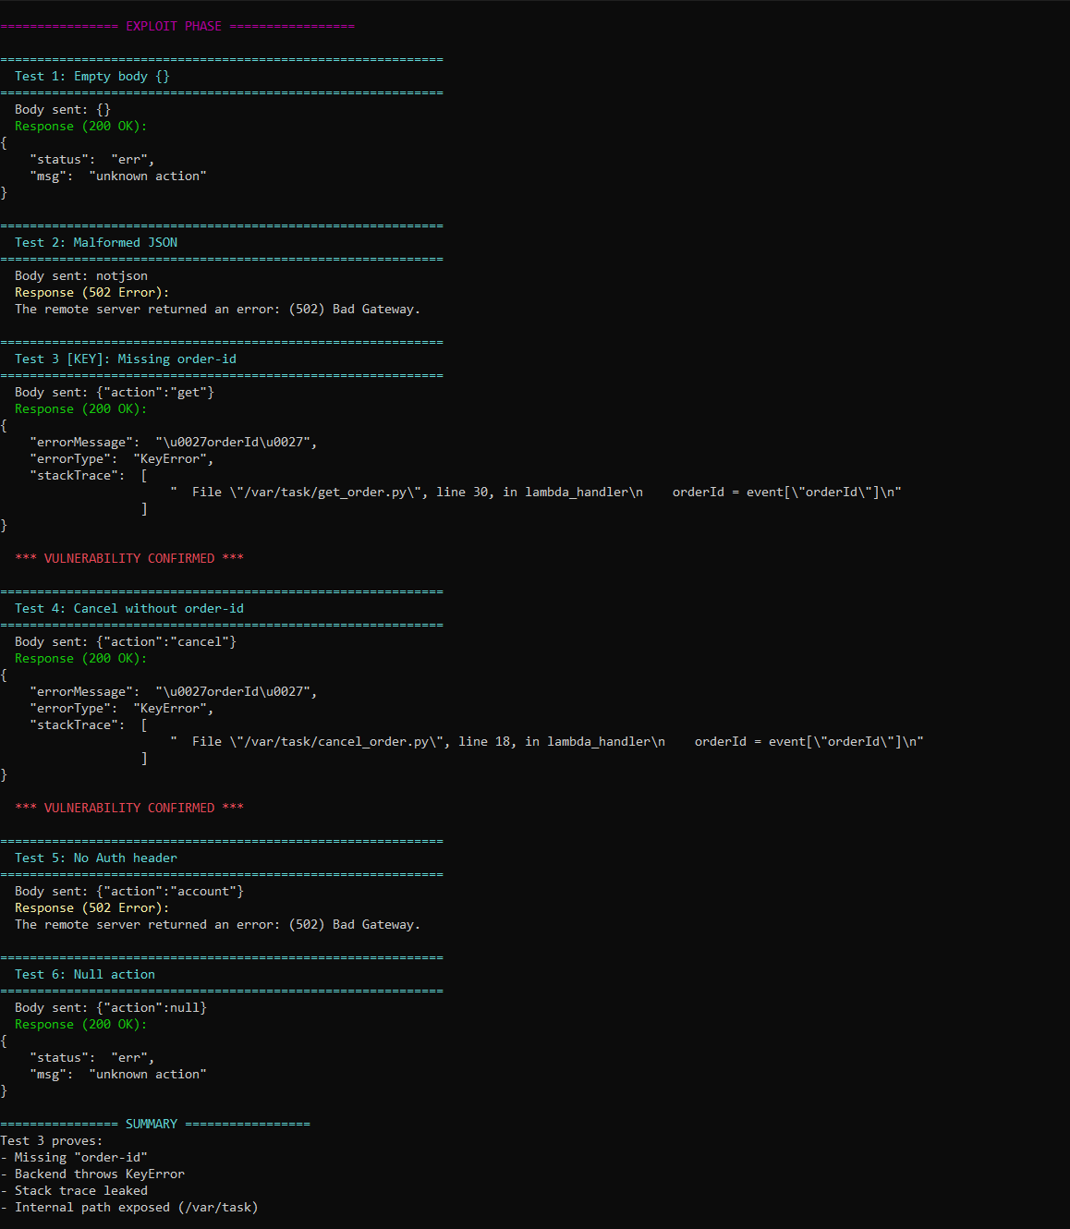
Figure 10.3: Vulnerable exploit output showing exception-triggered behavior
This figure provides the information required to reproduce the vulnerability, by confirming it shows the exploit request or script which led to the unhandled exception. The document explains the exploit isn't designed to crash the application, but rather to see how the server handles unexpected input. The figure is significant as it shows the exception as something that can be reproduced. It also demonstrates that the vulnerability is related to the use of unsafe error handling, rather than unsafe business logic.

Part 5) Evidence and Proof
The proof of this lesson is evident in the difference between the output of the API before and after the patch to the same malformed JSON request. The pre-patch response to the request body {"action":"get"} (missing orderId) is in Figure 10.3 above, which details the errorType: KeyError, the stack trace to /var/task/get_order.py, line 30 (orderId), and the exact key that was missing. This is highly sensitive information about an API that should not be disclosed to a client. After the fix, the response to the same request is: {"status": "err", "msg": "Missing required field: orderId"}. No errorType, stack trace or file paths. The application still responds "something went wrong", but in a safe and controlled manner, without divulging anything about its implementation. Figure 10.6 verifies that the application has this patched behavior for all six of the application's test cases. The value of these two responses is a smoking gun demonstrating the vulnerability and the fix.
In a good report, the evidence should demonstrate that the server's behavior changed. Prior to the patch, error paths could be triggered in an unsafe way that included confidential information. With the patch, the same malformed input should be handled generically, or even rejected. That's what demonstrates the vulnerability and fix.

Part 6) Fix Strategy / Probable Mitigation
Improved input and exception handling of critical logic in the application is the solution. The Lambda code should trap errors and insert appropriate client-safe errors. This should be logged (only) to secure logs, such as CloudWatch, for the administrators to see.
This patch addresses the vulnerability as the part of the code doing the work is vulnerable only if an exception can be thrown and exposed in the wrong way. If the app knows what it's doing, and if it traps and comprehends exceptions that might be thrown before they're exposed to users, then the attack can't return useful data from mismash requests. So the fix is in the code that handles a request and code you call to find out if you're processing one.

Part 7) Code / Config Changes
The lesson patch was done by modifying the error processing code for the back-end. The safe version should not allowed exceptions returned to the client, instead it should return a failure message. In your images (Patches applied.png, Patch Verification.png and Post Patch verification tests.png), we see that the app was patched and then verified to demonstrate its new behaviour.
The code change is not just a textual change. It is a security change, which modifies the trust relationship with the user. The backend is now in charge of securing sensitive information in failure messages and only rendering sanitised information. This is the right thing to do for production Lambda.
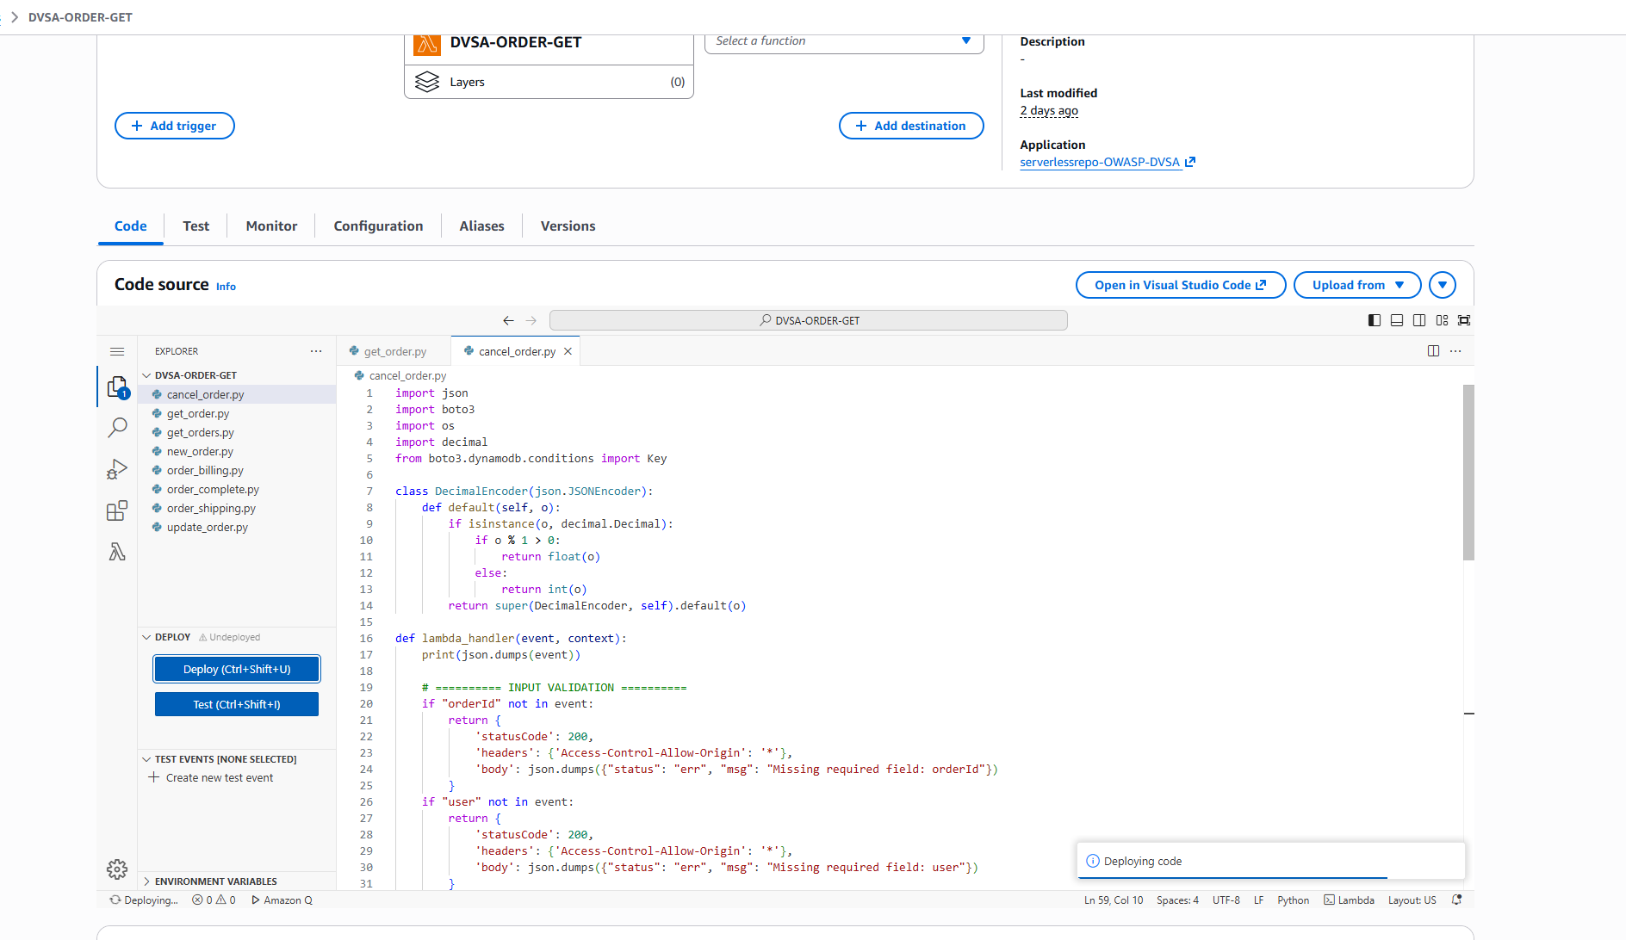
Figure 10.4: Patches applied to the exception-handling logic
This figure explains in the "code/configuration" section that a change has eliminated the vulnerable behavior in the production server. The report states that the patch enhances the backend behavioral end of the protocol, and ensures that the client does not get to know the internal details. The figure is significant because it shows the function is no longer using error defaults. It's a sign of the shift from insecure to secure.
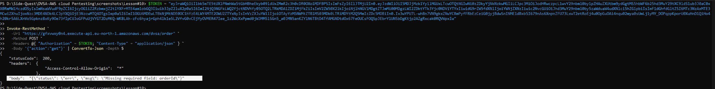
Figure 10.5: Patch verification output for the fixed function
This figure captures the fix by reporting the immediate consequences of the error handling fix. The report shows that the application now responds safely to the same type of request. It's important to know this because using error handling is a good fix only if it continues to work with the same bad input. The figure is good because it shows that the application doesn't exhibit the same exception behavior.
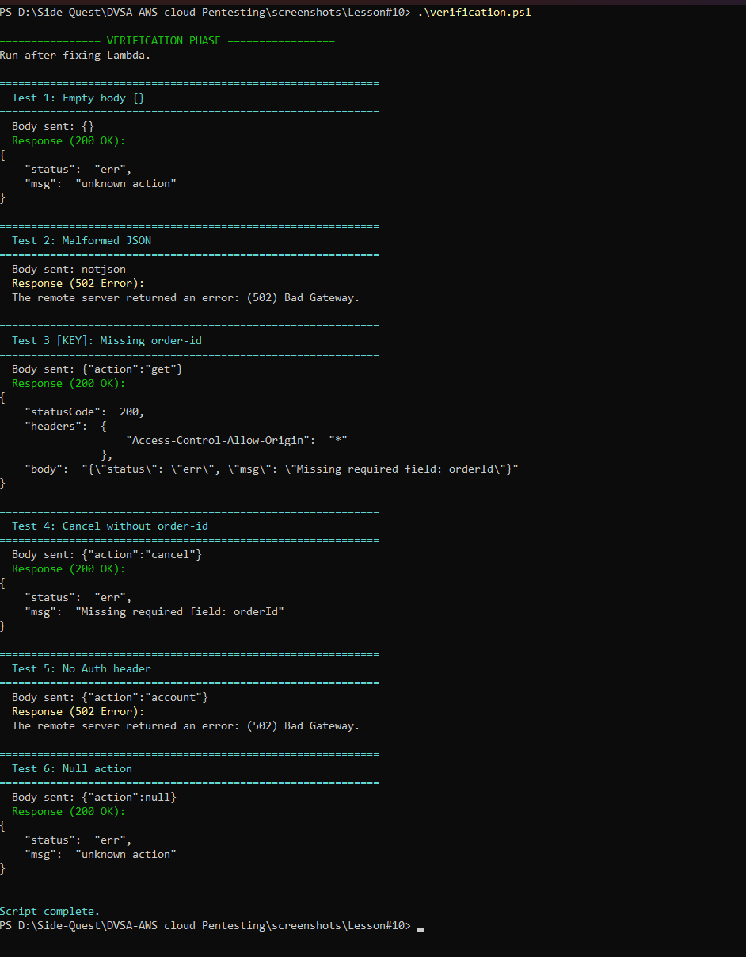
Figure 10.6: Post-patch verification tests confirming safe behavior
This figure illustrates the last validation phase of the remediation section. The report states that after the patch, the function was tested again and the previous information leak is gone. This figure is the best evidence that the remediation was successful. It also shows that the system is now exception safe.

Part 8) Verification After Fix
Once the vulnerable functions were patched, lesson10-verification.ps1 was executed against the same six malformed test cases to verify that the vulnerabilities had been patched. The results of the six tests are now generic error messages. Test 3, which previously caused the KeyError stack trace, returns {"status": "err", "msg": "Missing required field: orderId"}. Test 4, which returned a similar stack trace in cancel_order.py, now returns {"status": "err", "msg": "Missing required field: orderId"}. Test 2 (bad JSON) now returns a clean 400 response with no JSON parsing info. There's no mention of stackTrace, errorType, /var/task/, or line numbers in the responses to the post-patch test. The patched except block still logs the detailed exception information using traceback.format_exc() to the CloudWatch Logs, so the bug is still debuggable by those who should have access. This information just doesn't make it back to the invoker. A valid request with a good orderId and valid authentication token was also run to ensure the application is working as expected and the expected information is returned.
The examine and fix stage is particularly important in lessons around exception handling because a solution can be incorrectly developed if it addresses the message - but not the error. The post-patch screenshots reveal that the application is no longer unsafe and doesn't leak the same internal information anymore. This signal indicates that the patch is correct.

Part 9) Structured Operation and Security Analysis

9.1 Intended Logic and Security Rule(s)
The desired logic is that functions in the server (back-end) check for validity and sanitise errors, and doesn't reveal implementation detail to the user. The main actor is the Lambda function or API handler, the entry is the user request, and the security rule is to sanitise unexpected errors. This means the user should not see the stack trace. This is a situation of best practice for production.

9.2 Evidence Sources and Behavior Trace
The sources of evidence include the exploit script, the faulty request (response), the screens of the patches and the test logs of the pre-post fix verification test. Usually, the server receives good requests, and provides good responses. In the exploit scenario, vulnerability is activated by invalid input, which results in an error and disclose information. But with the fix, it doesn't disclose information. This gives behavior footprint of the lesson.

9.3 Deviation Analysis and Classification
The error is that the program allowed an exception to be raised that leaked information. Which violates the rule that production services should not reveal details. From a security point of view, this is bad as it helps an attacker in the next attack. This should be classified as Accidental misconfiguration because unsafe error handling have happened.

9.4 Explainable Fix and Post-Fix Validation
The mistake was in the assumption that the default error handling of the application is sufficient to deploy. The fix has to be applied to the request validation and exception handling, where bare exceptions are replaced with still live responses. Upon repeating the test we see that we actually fixed the problem since the bad request does not leak any information. Hence, the application is now failure-resistant and doesn't leak any information..
Table 1: Structured analysis summary — Table A
Vulnerability | Intended Rule(s) | Artifacts Used to Infer Rule | Normal Behavior Evidence | Exploit Behavior Evidence
Lesson #10 – Unhandled Exceptions | The server should never leak internal information and failures should be handled gracefully. | Exploit program, screenshots of the patch, output of the after-patch testing, and causes of exceptions. | Successful requests get the usual success responses. | Validating requests cause exceptions with details about the error..

Table 2: Structured analysis summary — Table B
Vulnerability | Why This Is a Deviation | Deviation Class | Fix Applied (Where) | Post-Fix Verification | Optional Latency Before / After Logging
Lesson #10 – Unhandled Exceptions | The backend exposed raw exception behavior which exposes implementation details and fails to follow the prudent failure principle. | Accidental misconfiguration | The exposed information leak in the response was sanitized in the response Lambda/API handler. | The new version will not provide the same level of detail about internal state using the same malformed request. | N/A / not measured in the report.

Part 10) Takeaway / Lessons Learned
The primary takeaway from this vulnerability is failure can be secure. It is not enough for a backend to be 100% operational, but it must fail securely to prevent leaking internal information. This is especially important in a serverless environment because server errors and stack traces can become a valuable source of information to an attacker.
The secure design rule that stops this problem is to ensure early input validity checks, exception handling and generic error messages. Diagnostic messages should be logged in a secure location, rather than being returned to a user. To that end, the system will still be diagnosable by a maintainer, but it won't reveal its inner workings to a user.

11. Overall Conclusion
Using the deployment and analysis of the OWASP Damn Vulnerable Serverless Application (DVSA), this project offered a hands-on investigation of the security risks in contemporary serverless systems. Through the ten official lessons, the system was explored, attacked and defended, providing detailed insights into how vulnerabilities typically arise in the cloud and how they can be mitigated.
During the investigation, it became clear that vulnerabilities in serverless platforms are not only related to classic input validation vulnerabilities, but also cover cloud misconfiguration, IAM permission boundaries, supply chain and workflow logic vulnerabilities. Through each vulnerability, we showed that security flaws can arise from small design flaws leading to security issues such as data access control, privilege escalation, denial of service, and remote code execution.
One of the key learning from this project is that security in serverless environments is distributed. In contrast to non-distributed systems, there can be vulnerabilities at various layers including:
- API Gateway request handling
- Lambda function logic
- IAM execution roles
- Data stores like S3 and DynamoDB
- Third-party dependencies
As a result, securing such systems needs to be comprehensive and encompasses secure coding, access control, validation and monitoring.
Moreover, the remediation process brought to the fore the importance of adhering to security principles such as:
- Principle of Least Privilege
- Defense in Depth
- Secure Input Handling
- Appropriate Authentication and Authorization
- Safe Error Handling
Through implementing the correct patches and testing them repeatedly, the system was successfully secured against all the attacks and remain secure and functional.

12. Key Lessons Learned
From this project, some of the key takeaways for developing serverless applications securely were highlighted:
- A key lesson is that relying on user input anywhere in the pipeline can result in potential vulnerabilities, particularly if it flows unchecked into the backend.
- It became apparent that authentication is not enough - it is also necessary to implement correct authorization checks at critical points to avoid privilege escalation.
- The examination of IAM roles revealed that privileges over-permissioned cloud services increase the attack vector, enabling privilege escalation in case of a successful attack.
- The vulnerable dependency investigation showed the libraries we use can carry hidden vulnerabilities and so library management is a vital part of application protection.
- Logic vulnerabilities demonstrated that business flows must be enforced to prevent logic-based vulnerabilities, especially in a multithreaded environment.
- The unhandled exception case showed that security vulnerabilities by providing information about exceptions can support an attacker in gathering information even if the vulnerability does not cause immediate damage.
In this project, it became clear that security needs to be designed into a system, rather than added later, and it needs to be part of the design, development and deployment processes.

13. Challenges Faced
As part of this project, we faced a number of challenges:
- We needed to understand the subtleties of the interaction between AWS services like API Gateway, Lambda and IAM which involved analysis and testing.
- Certain issues involved precise timing or specially crafted requests such as race conditions and logic flaws.
- It was often hard to troubleshoot serverless applications because of lack of feedback in responses, and we relied on monitoring logs in CloudWatch.
- Access to different coordinate systems and the impact on various vulnerabilities (different versions of runtime and SDK) required further testing and adjustments in attack techniques.
However, through experimentation and analysis, all tasks were successfully completed.

14. References
- OWASP DVSA Project
https://github.com/OWASP/DVSA
- OWASP DVSA Official Website
https://owasp.org/www-project-dvsa/
- Amazon Web Services Lambda Documentation
https://docs.aws.amazon.com/lambda/
- Amazon Web Services API Gateway Documentation
https://docs.aws.amazon.com/apigateway/
- Amazon Web Services IAM Documentation
https://docs.aws.amazon.com/iam/
- OWASP Top 10 Web Application Security Risks
https://owasp.org/www-project-top-ten/
- DVSA Lesson Files (GitHub):
  - Lesson 1–10 Official Repository Links (as provided in project description)

